# Learning Outcome

# After completing this module, the student should be Able to Build a web application on modern cloud-based architectures and services.

To meet the learning outcome, a student has to complete the following activities

1. Create containerized application over AWS ECS service using docker images
2. Scale container application using Kubernetes AWS EKS service

# Activity 1

## Aim: Create containerized application over AWS ECS service using docker images.

**Learning outcome:** Able to Build a web application on modern cloud-based architectures and services.

**Duration:** 5 hour

**List of Hardware/Software requirements:**

1. Laptop/Computer with Windows OS/Ubuntu
2. User account on AWS Cloud
3. AWS CLI for Windows/Linux

**Code/Program/Procedure (with comments):**

**To install Docker on an Amazon EC2 instance**

Launch an instance with the Amazon Linux 2 AMI.

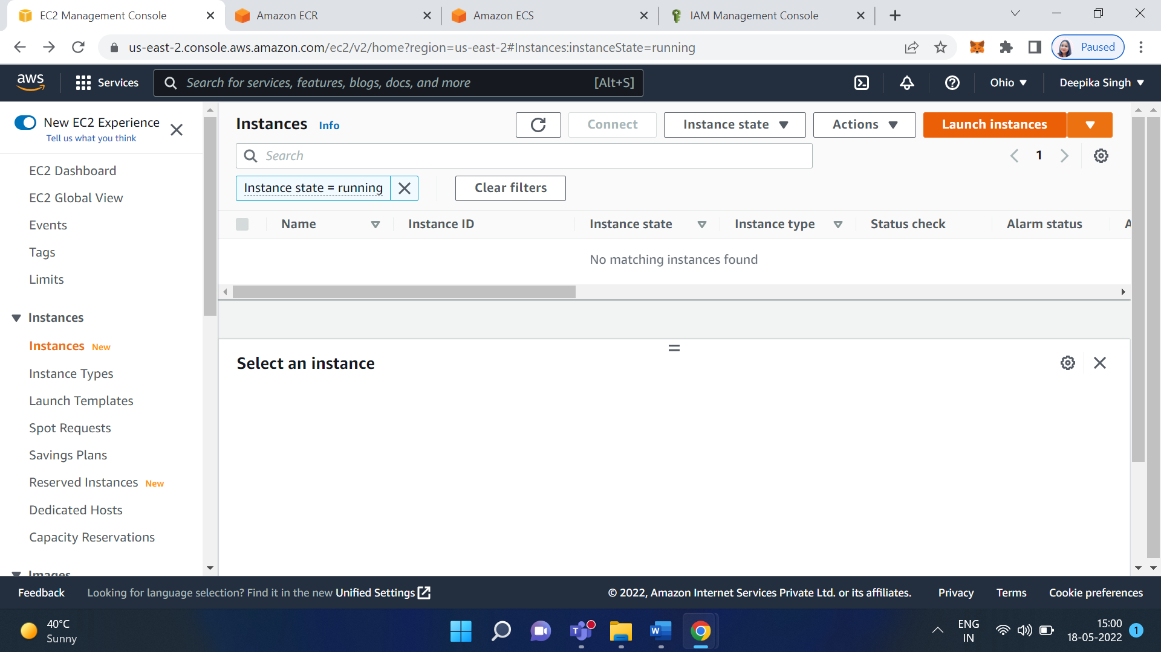

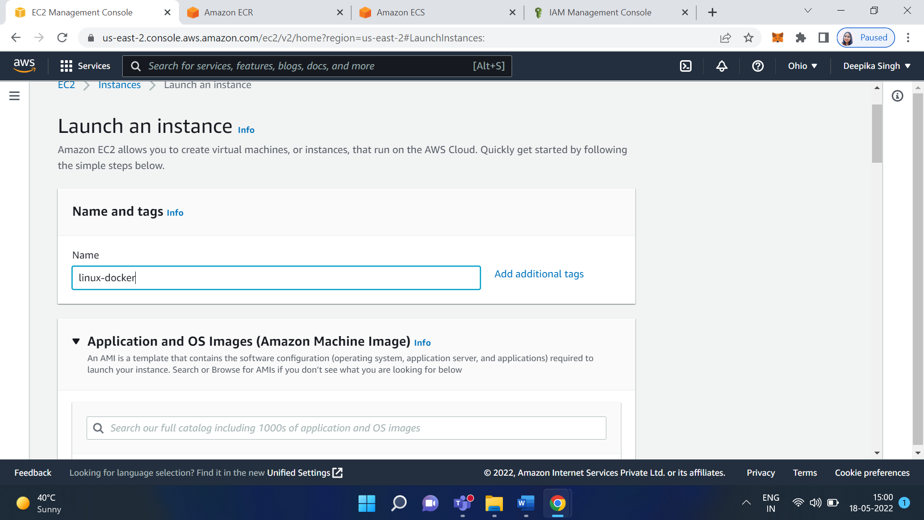

Select the machine - Amazon Linux 2 AMI

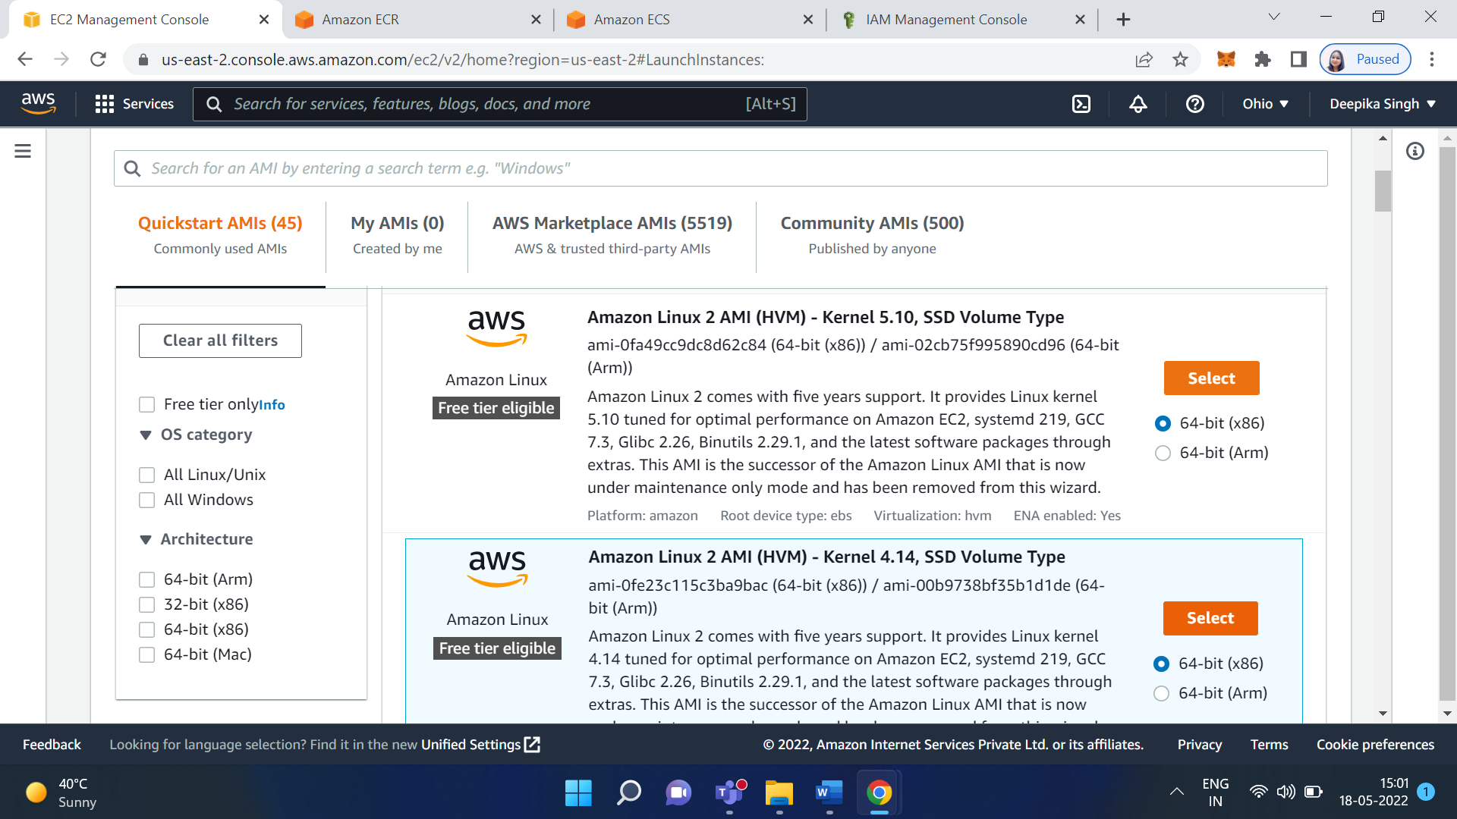

create new keypair - give name as per choice, download it on a local machine (key pair require to login to machine )

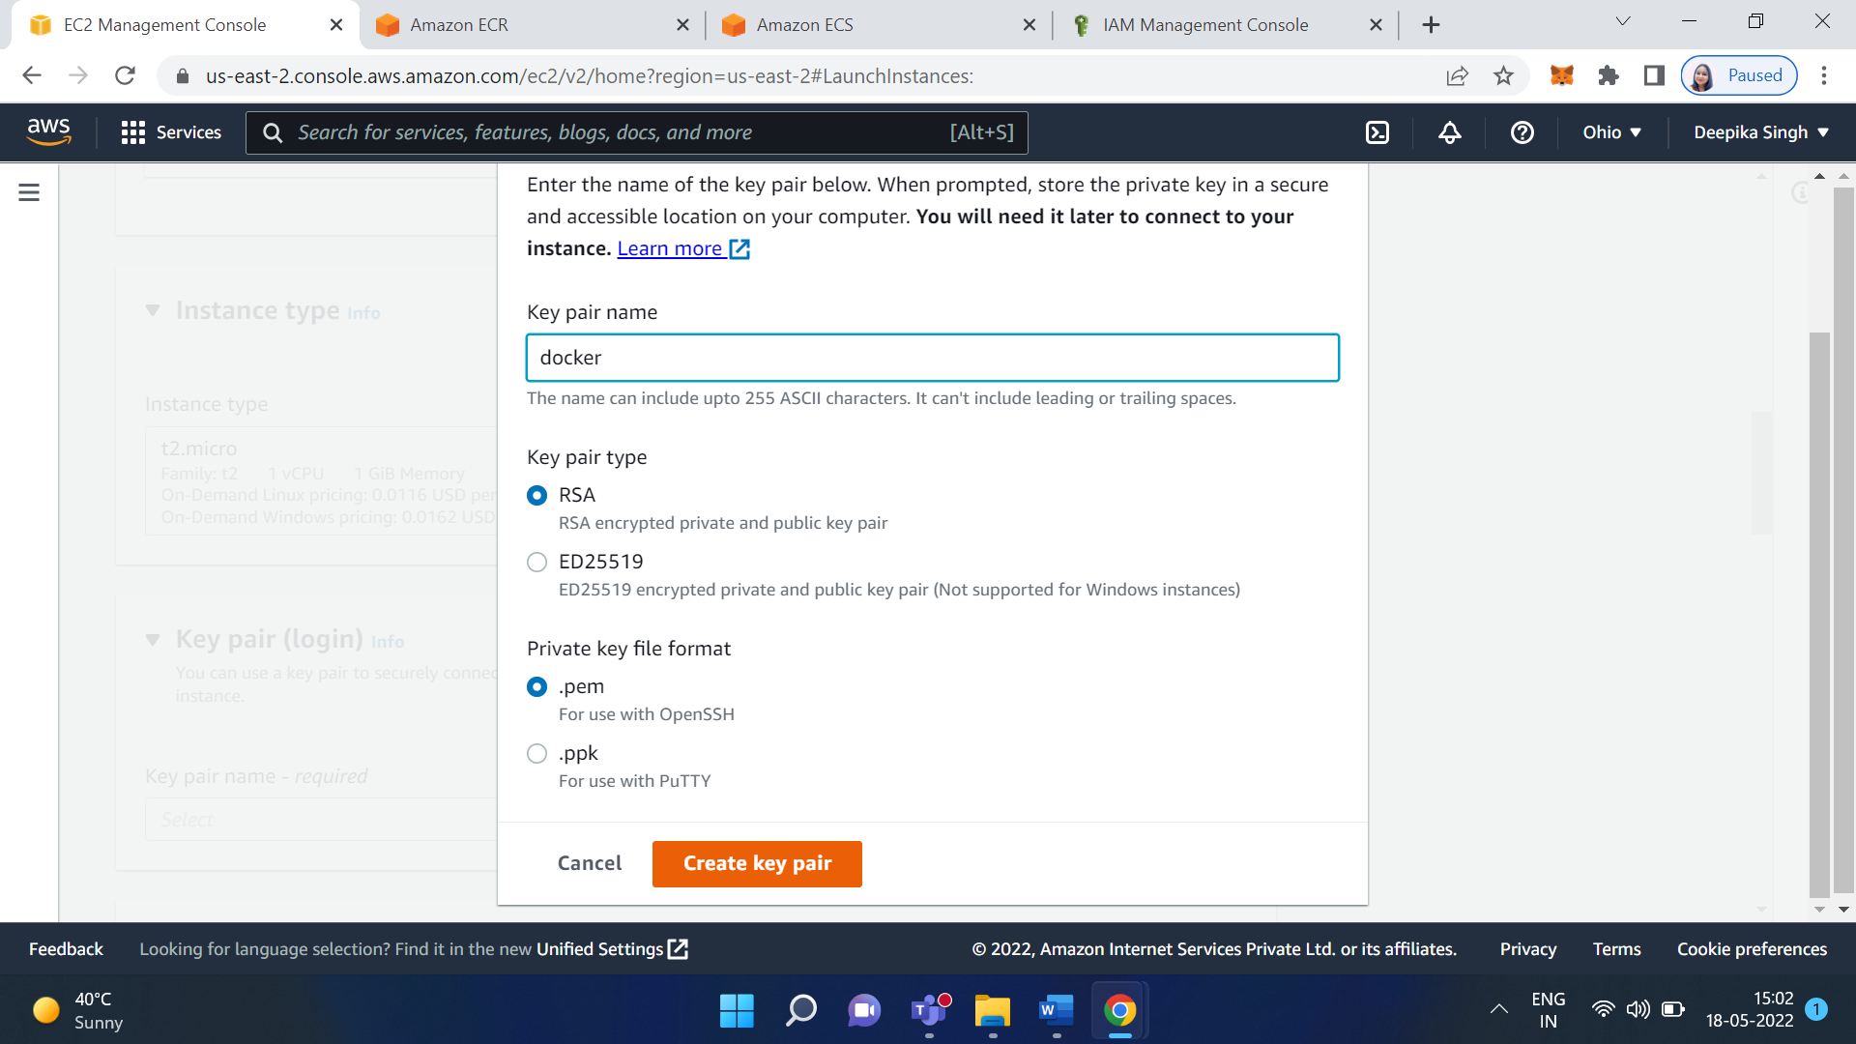

Save the PEM file

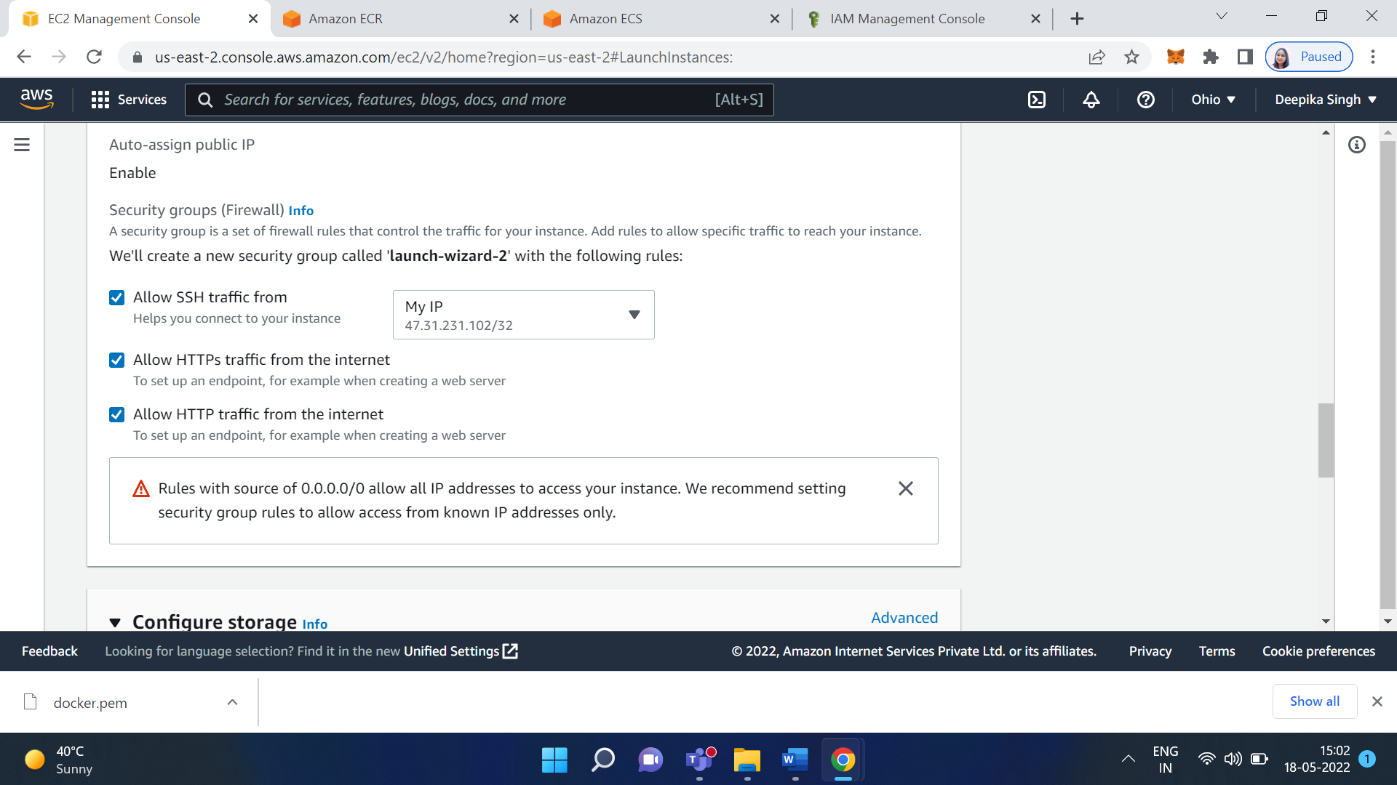

Click on Launch Instance

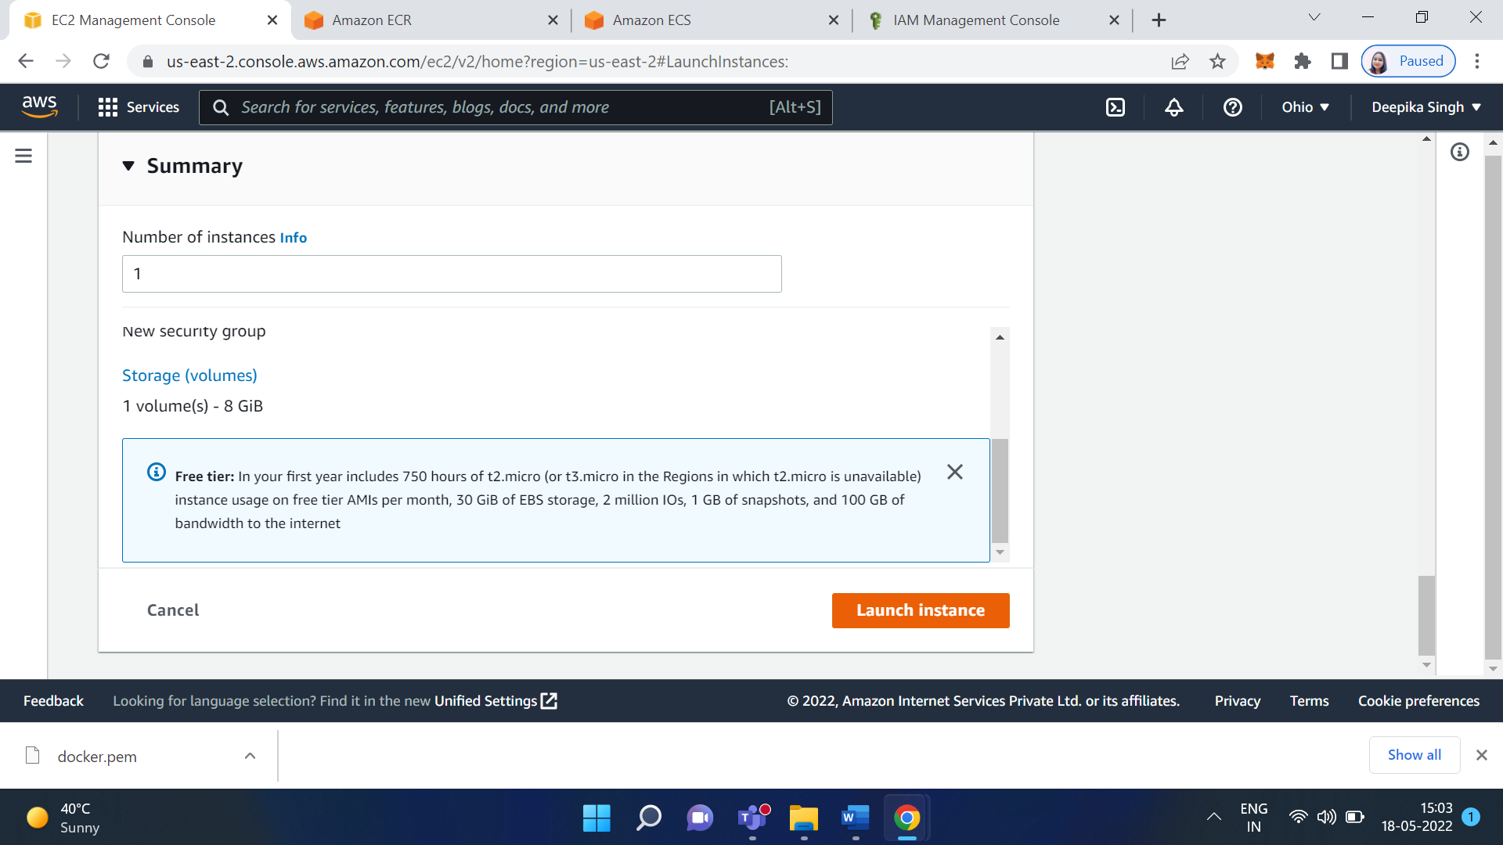

Click on the next review and launch

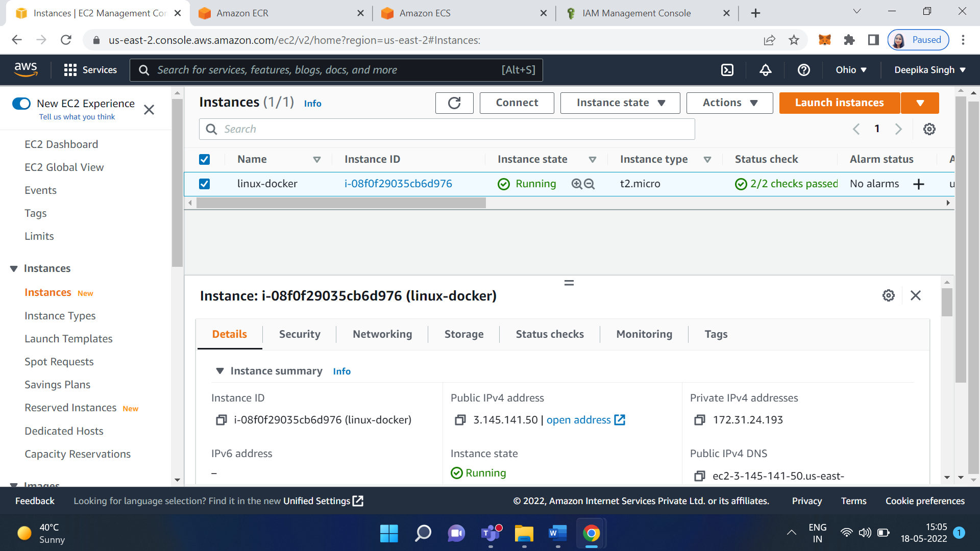

Select your instance and click on Connect

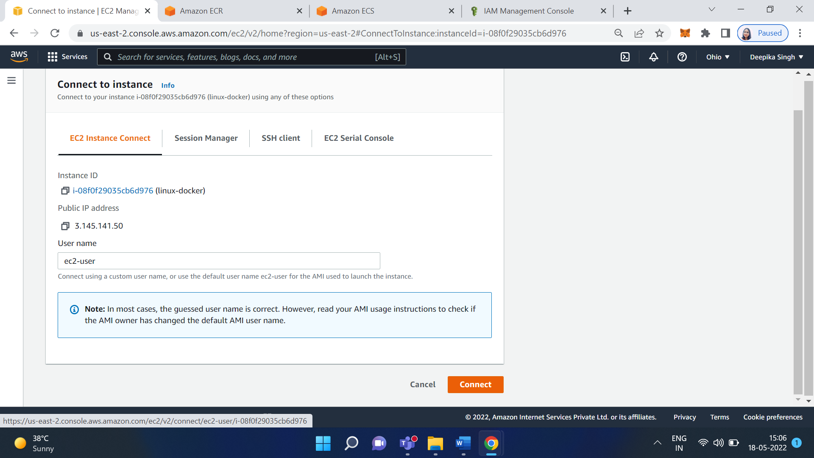

Open puttygen to generate the private key from pem file.

Load PEM file.

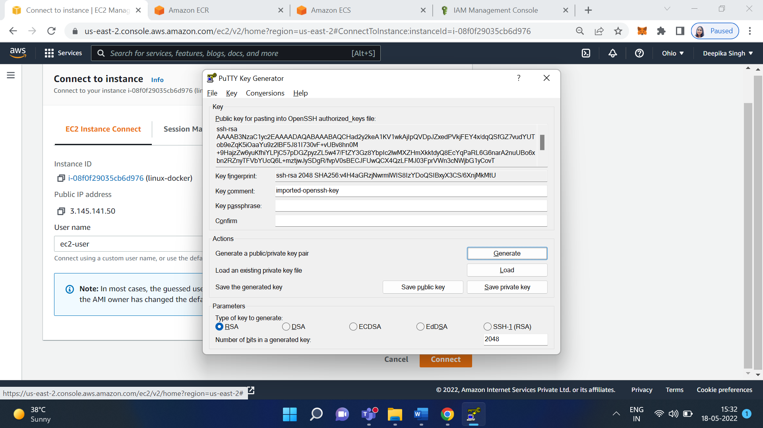

Save private key.

Now open putty

Copy the Public DNS and paste it on Putty

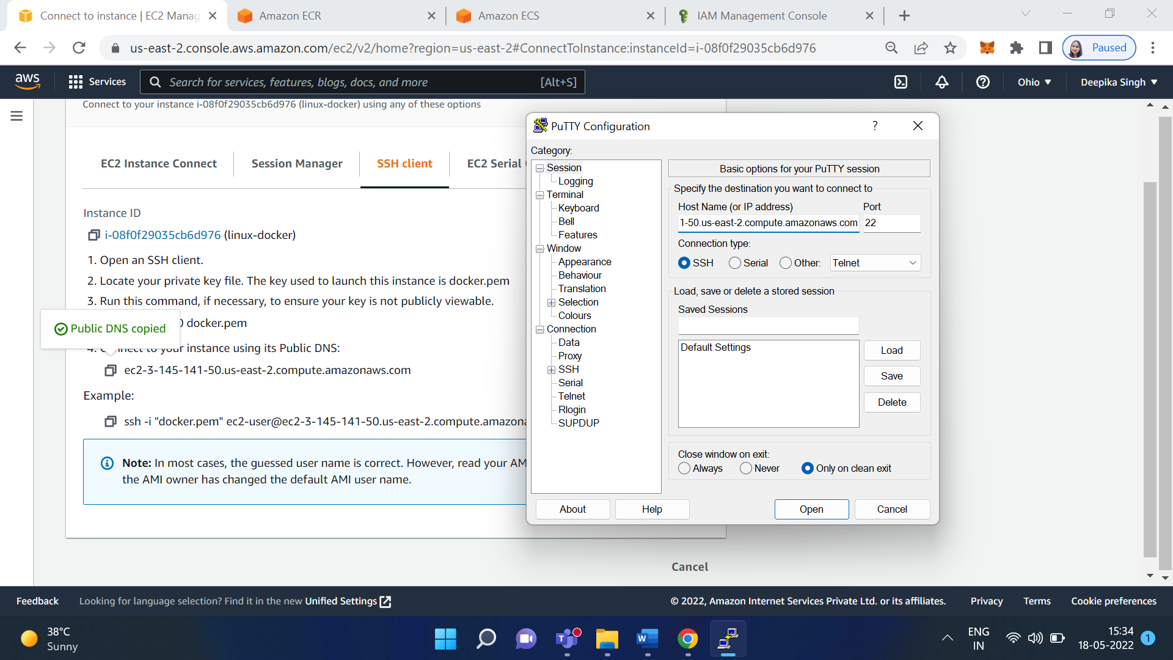

From category-> Expand SSH

Then click on Auth

Browse private key file for authentication

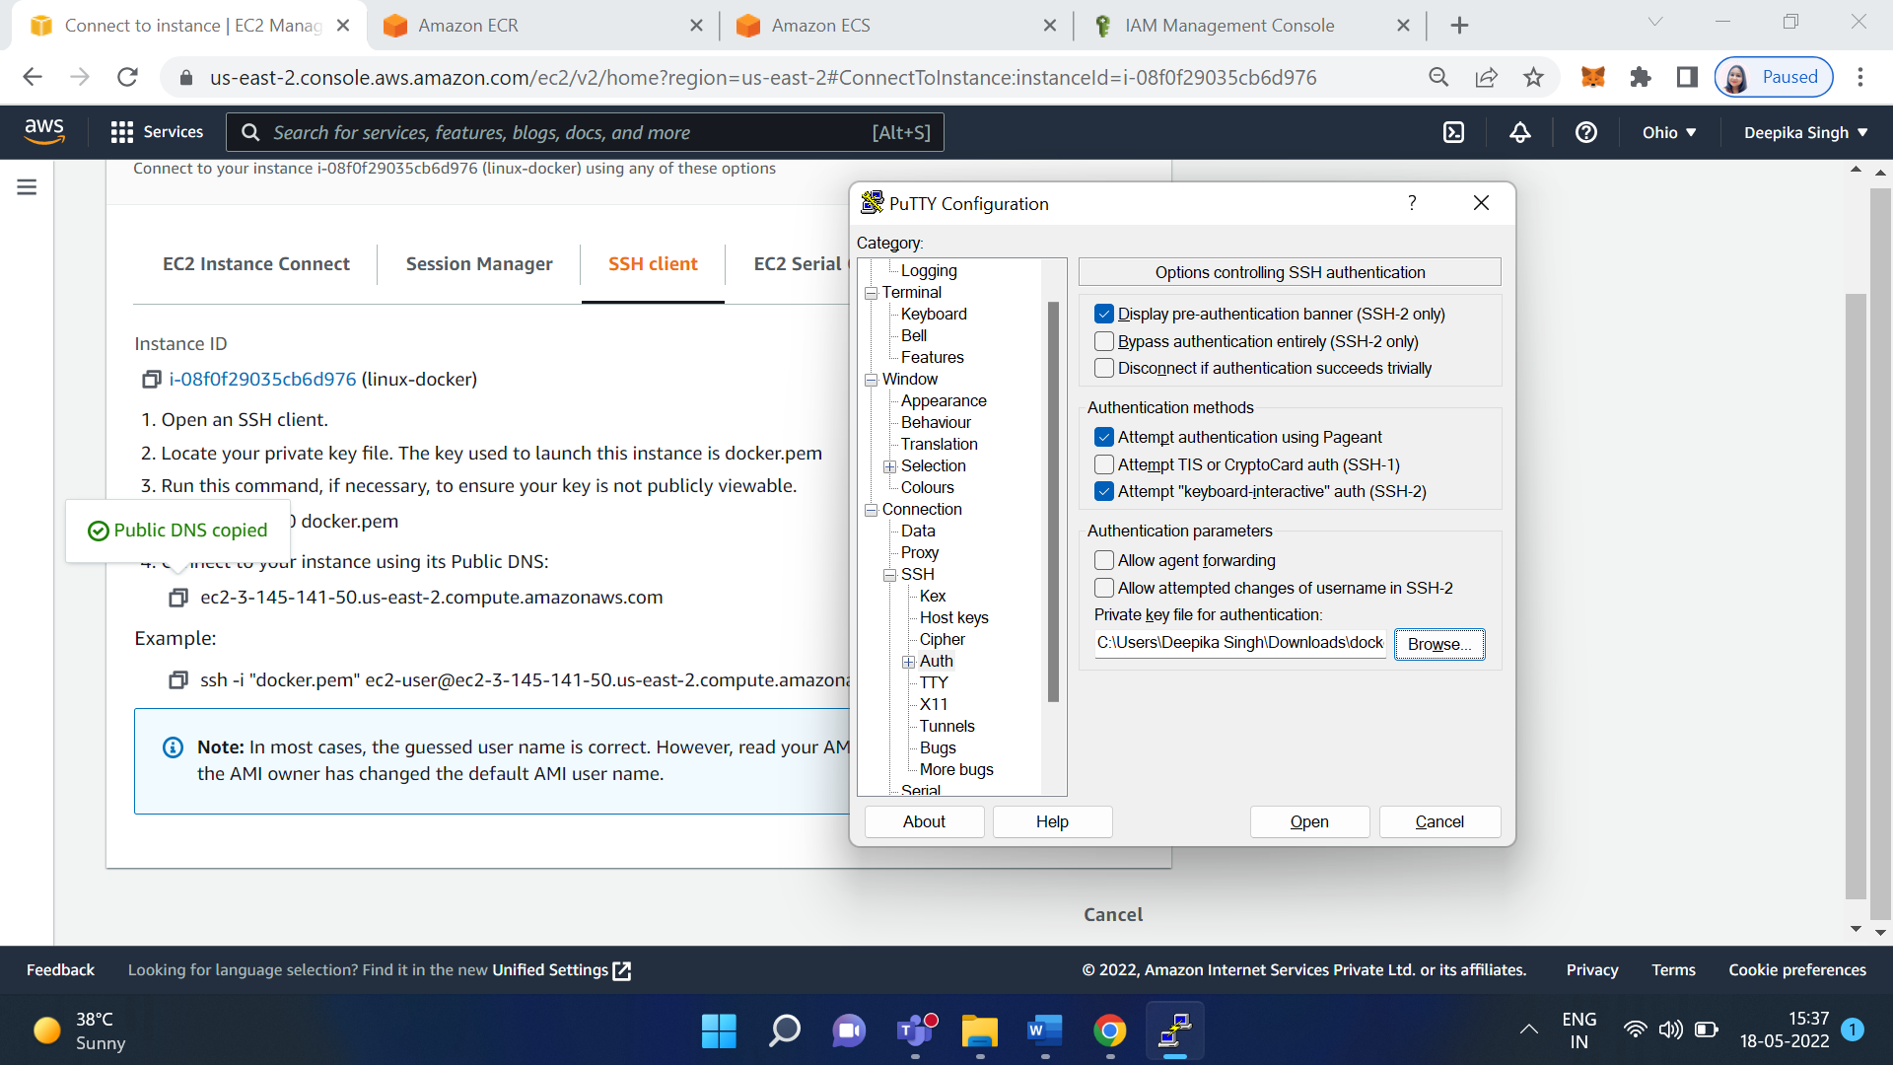

Then click on Open

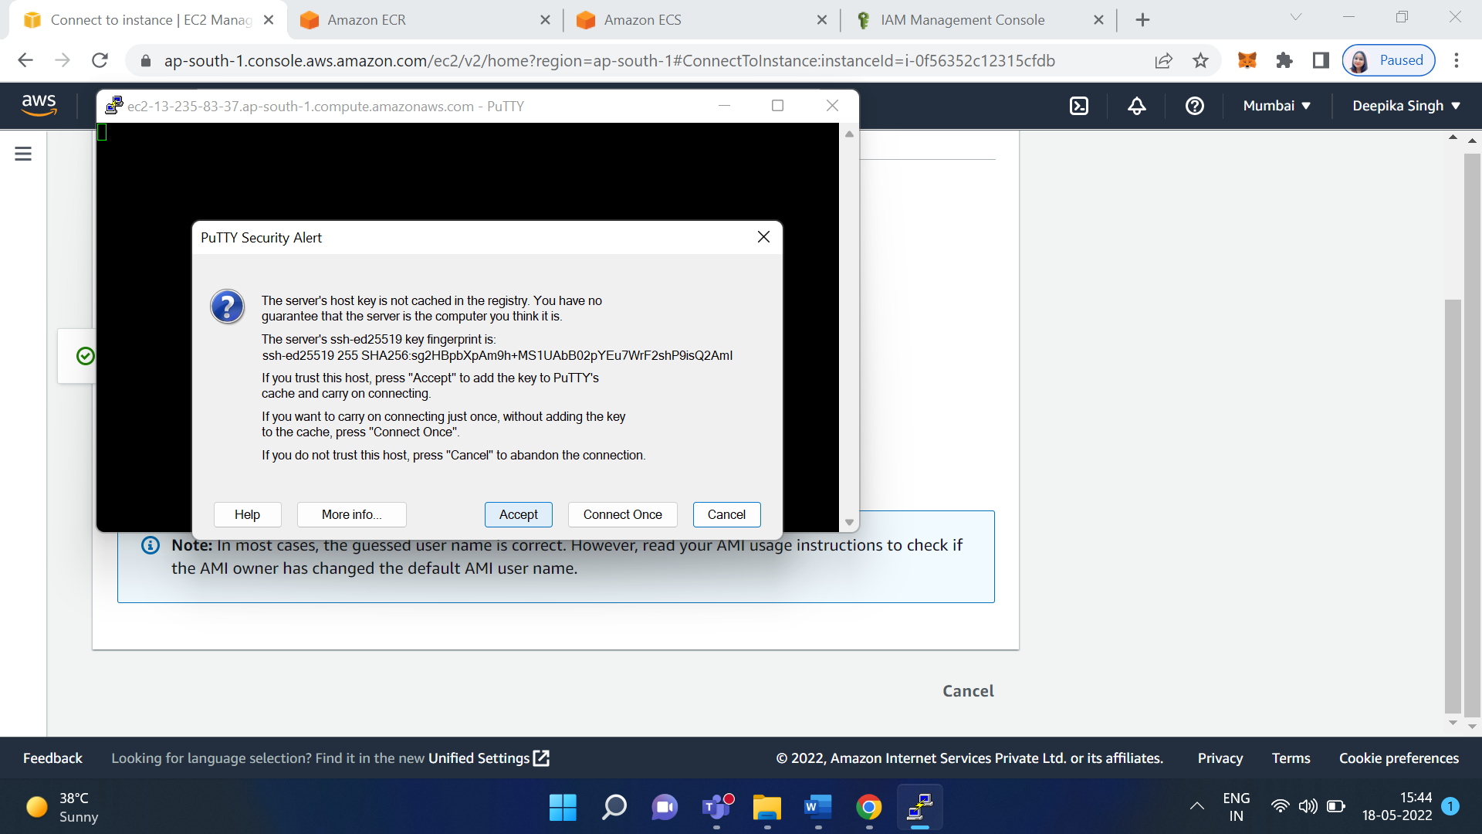

Click on Accept

Then login as ec2-user

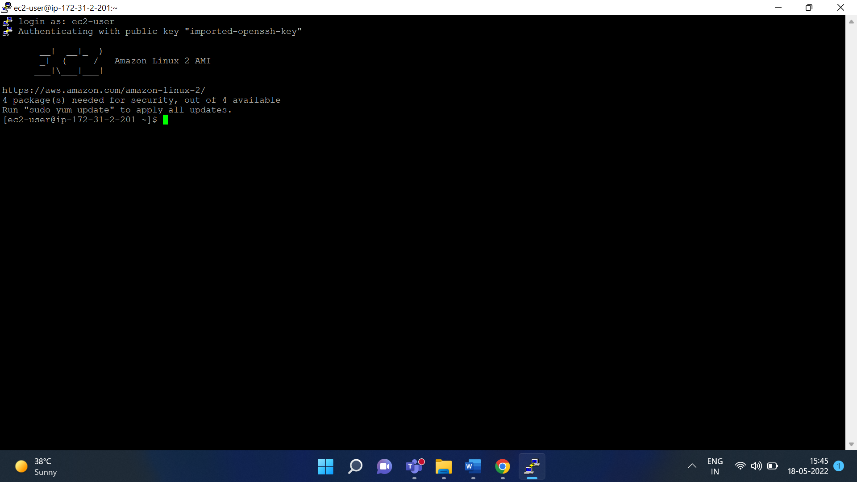

install docker on aws linux machine 2

sudo yum update -y

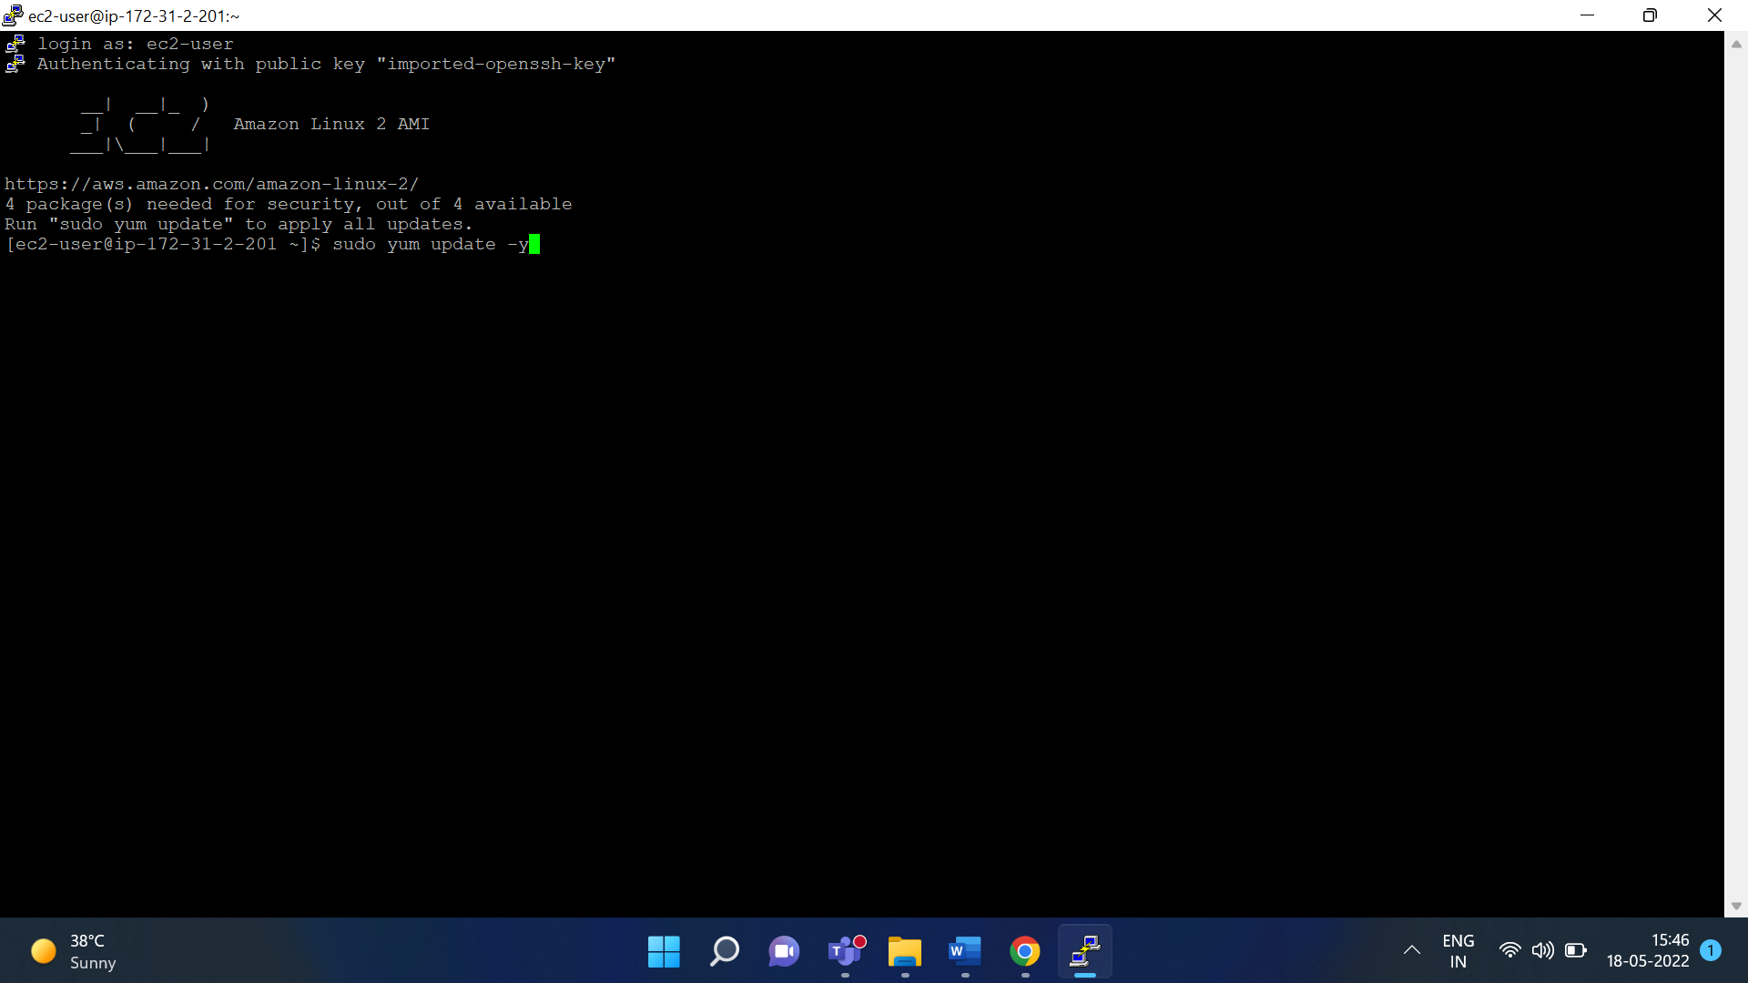

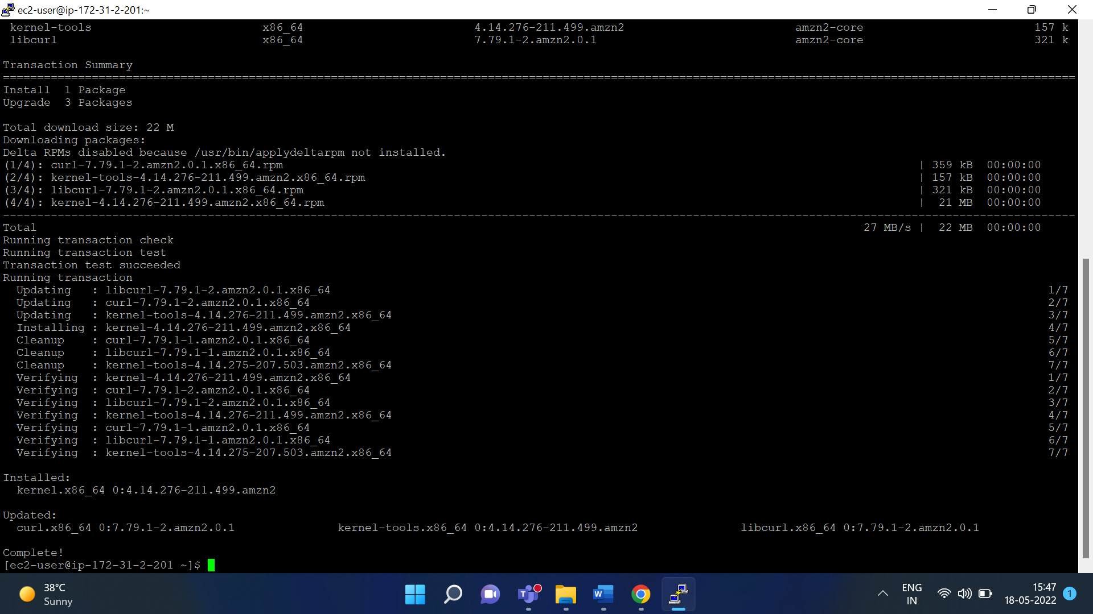

sudo amazon-linux-extras install docker

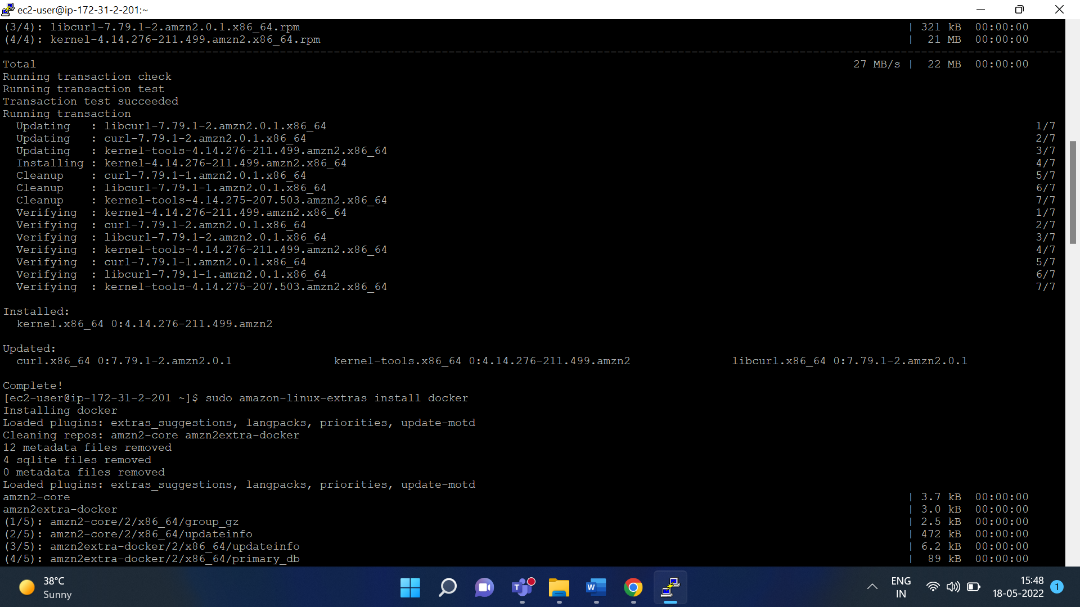

sudo yum install docker

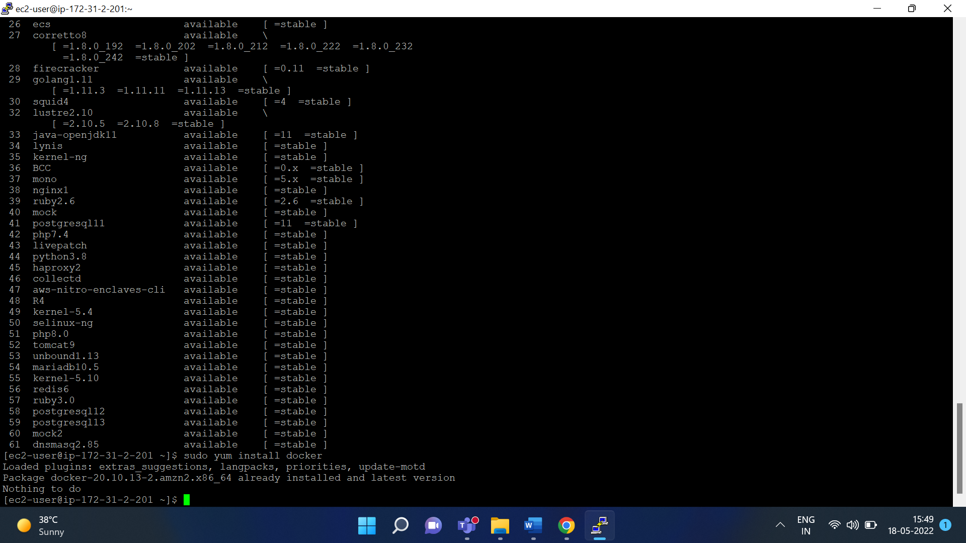

sudo service docker start

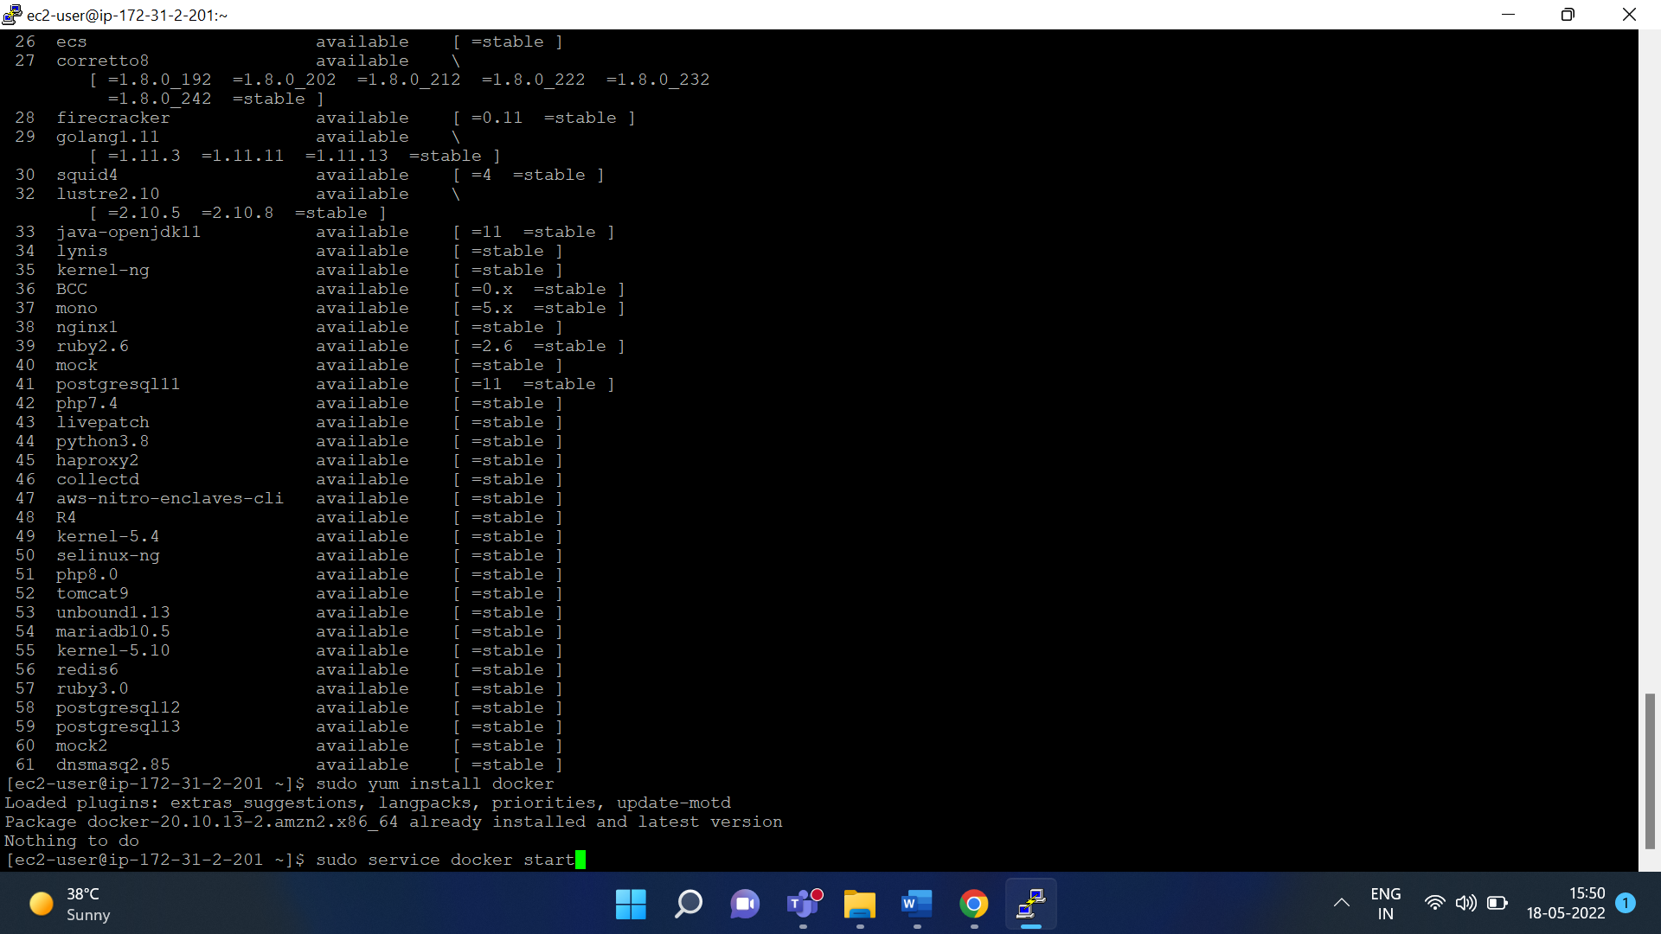

sudo usermod -a -G docker ec2-user

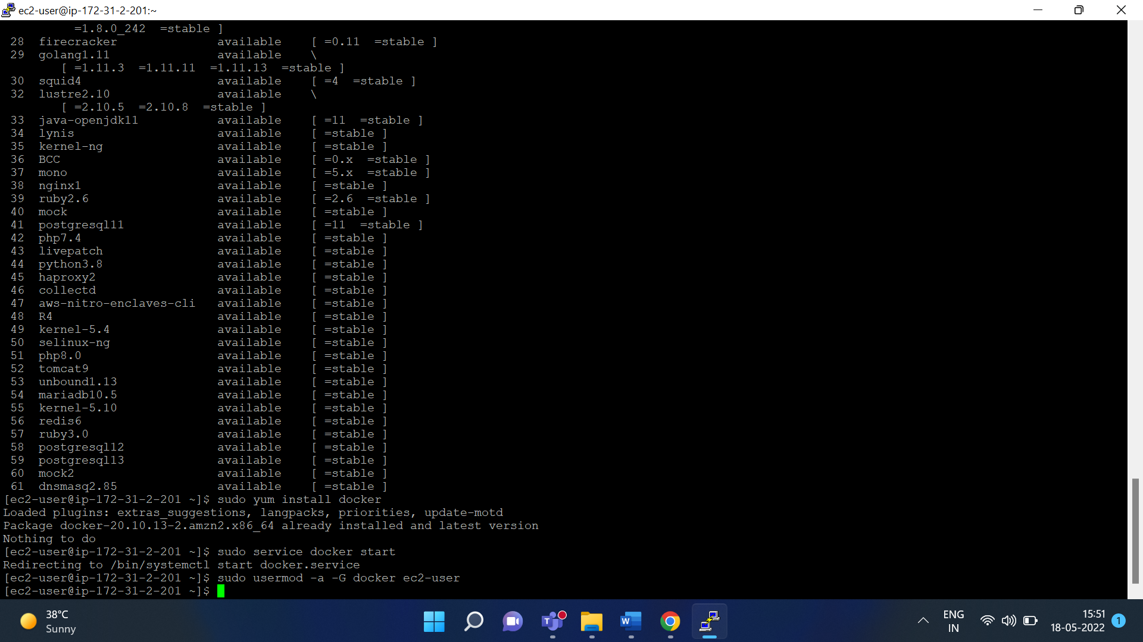

create docker image

create one file - touch Dockerfile

mkdir docker

then cd docker

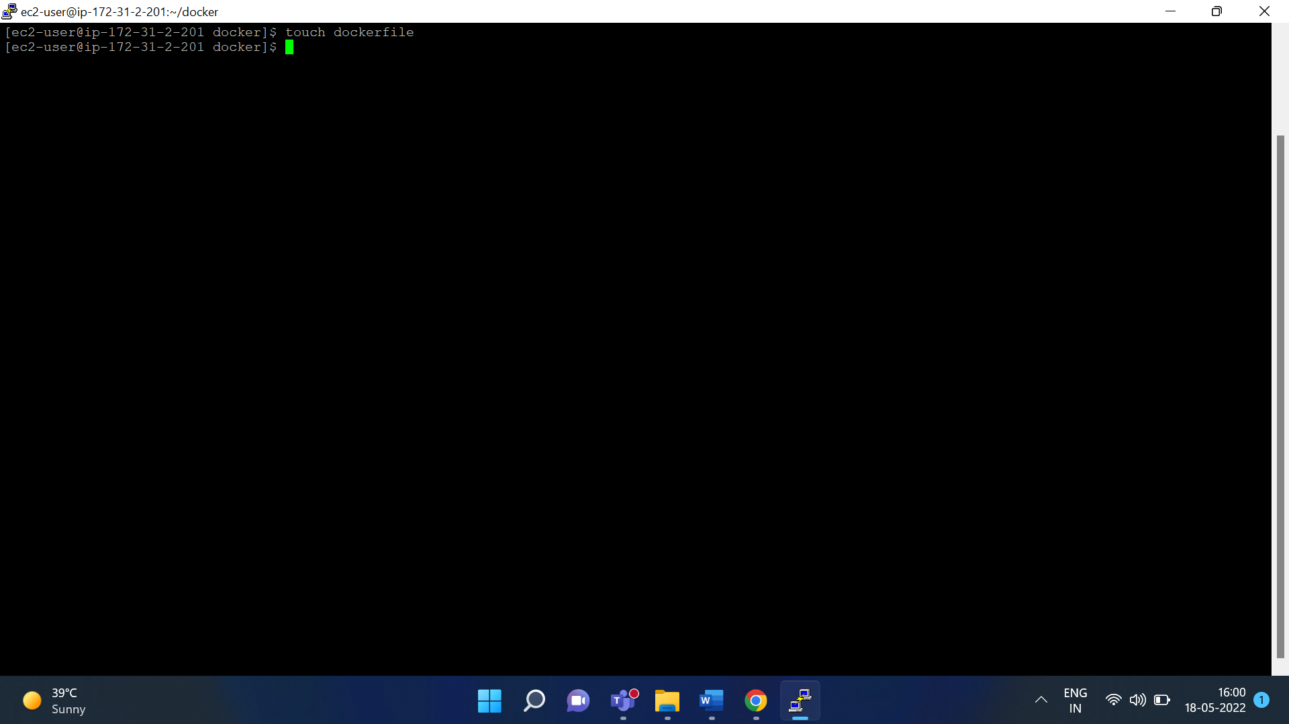

nano dockerfile

**paste below content in the Dockerfile create in above step**

FROM ubuntu:18.04

# Install dependencies

RUN apt-get update && \

apt-get -y install apache2

# Install apache and write hello world message

RUN echo 'Hello World!' > /var/www/html/index.html

# Configure apache

RUN echo '. /etc/apache2/envvars' > /root/run_apache.sh && \

echo 'mkdir -p /var/run/apache2' >> /root/run_apache.sh && \

echo 'mkdir -p /var/lock/apache2' >> /root/run_apache.sh && \

echo '/usr/sbin/apache2 -D FOREGROUND' >> /root/run_apache.sh && \

chmod 755 /root/run_apache.sh

EXPOSE 80

CMD /root/run_apache.sh

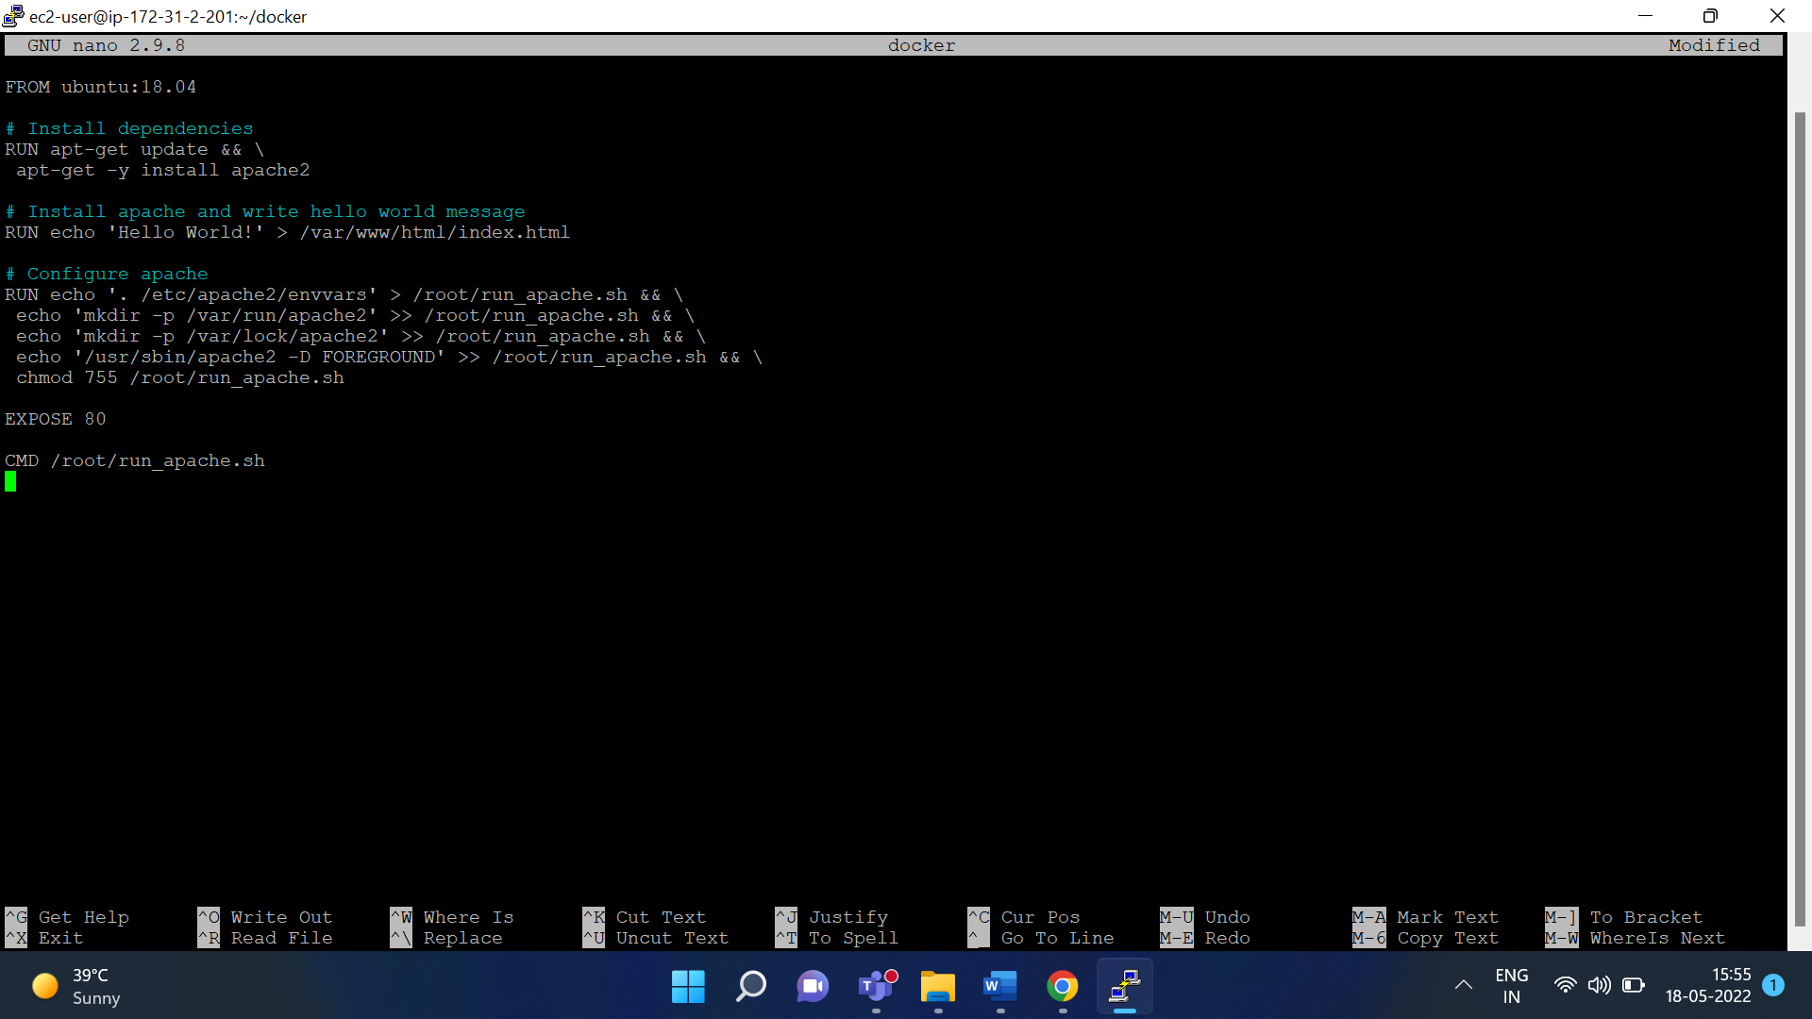

Save this file

cat dockerfile

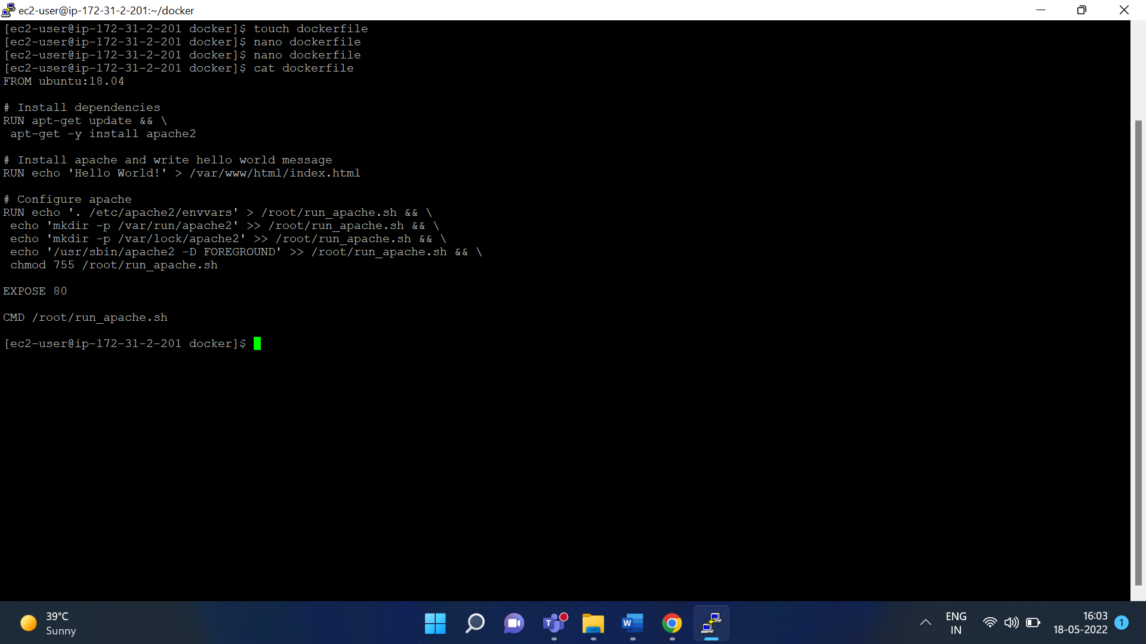

Now create image

docker build -t hello-world .

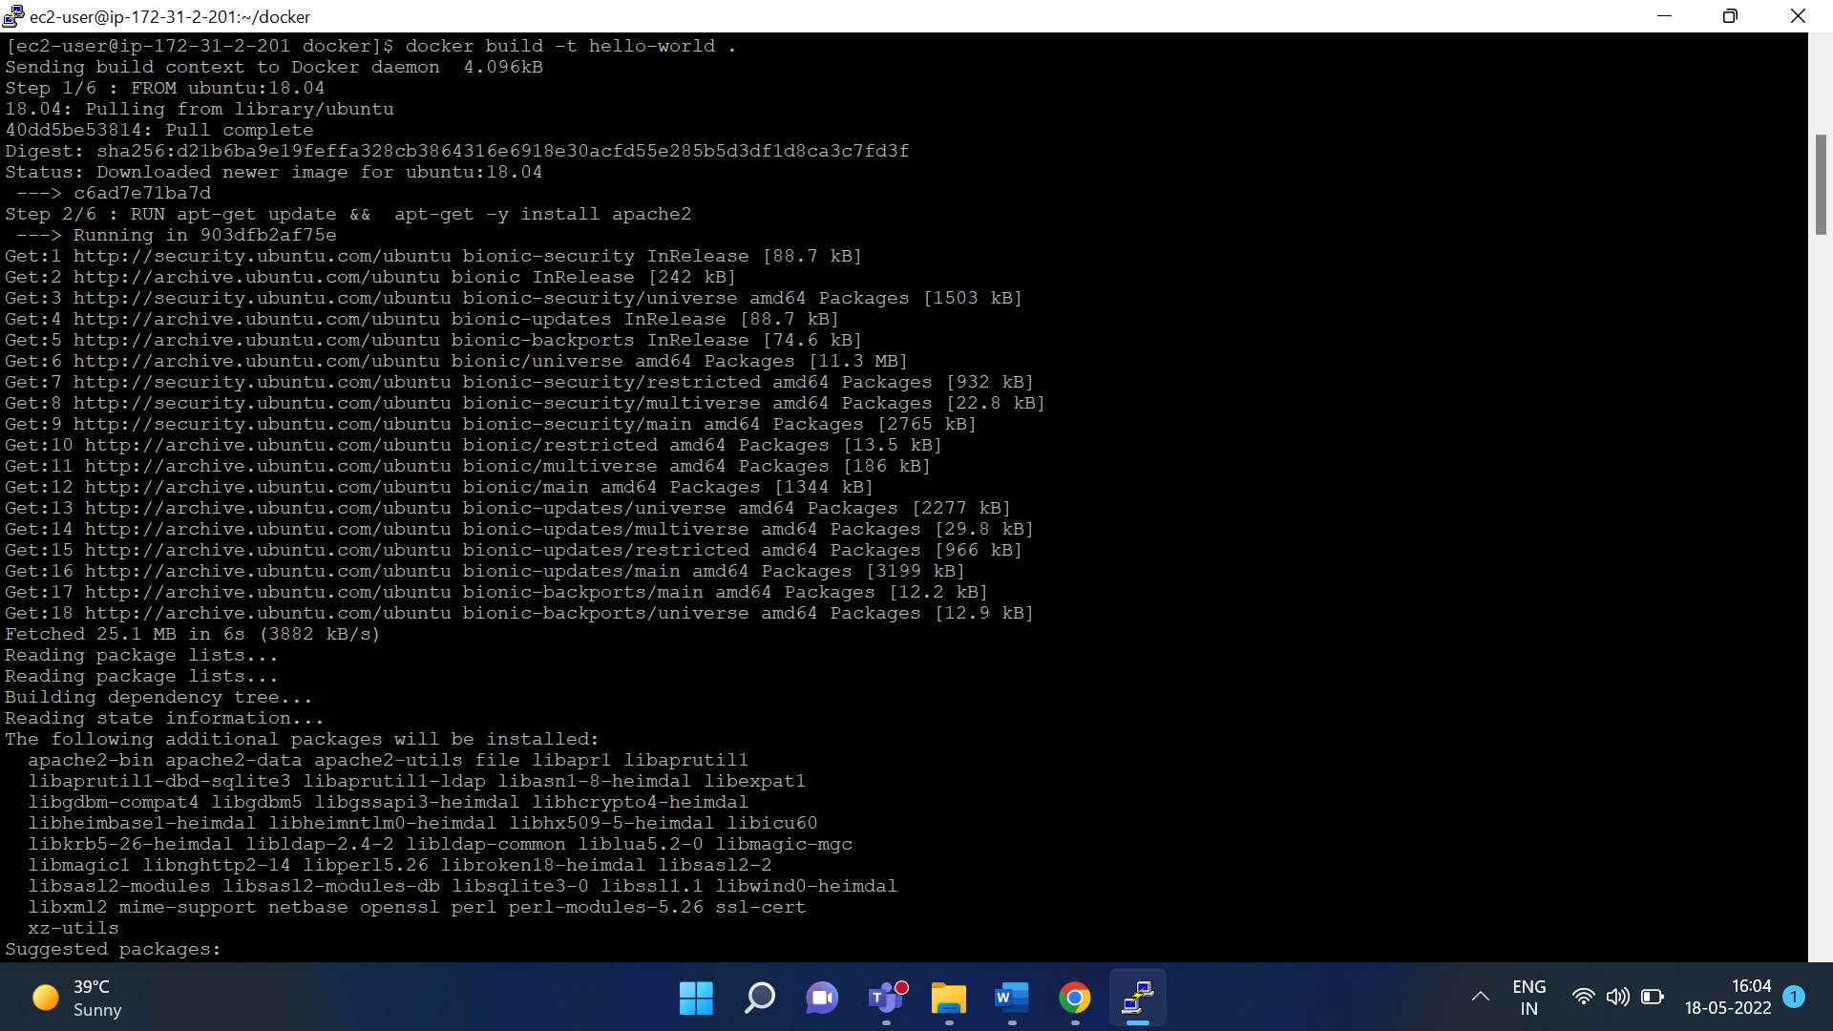

Check the images

docker images

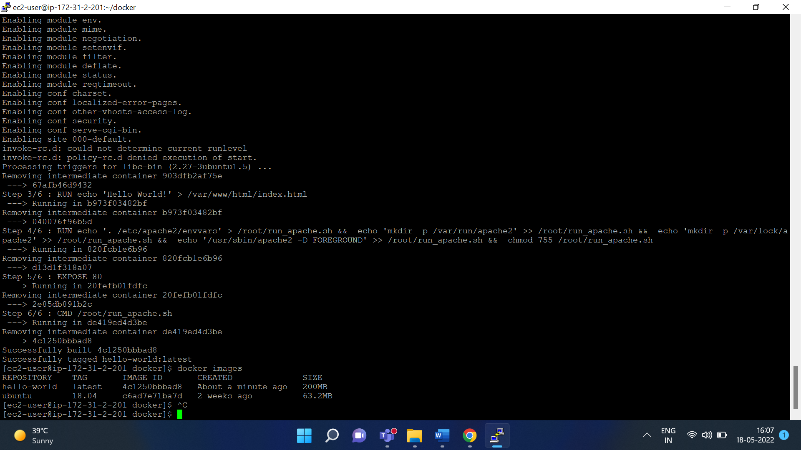

search image created in the above step

docker images --filter reference=hello-world

now verify image working properly or not

docker run -t -id -p 80:80 hello-world

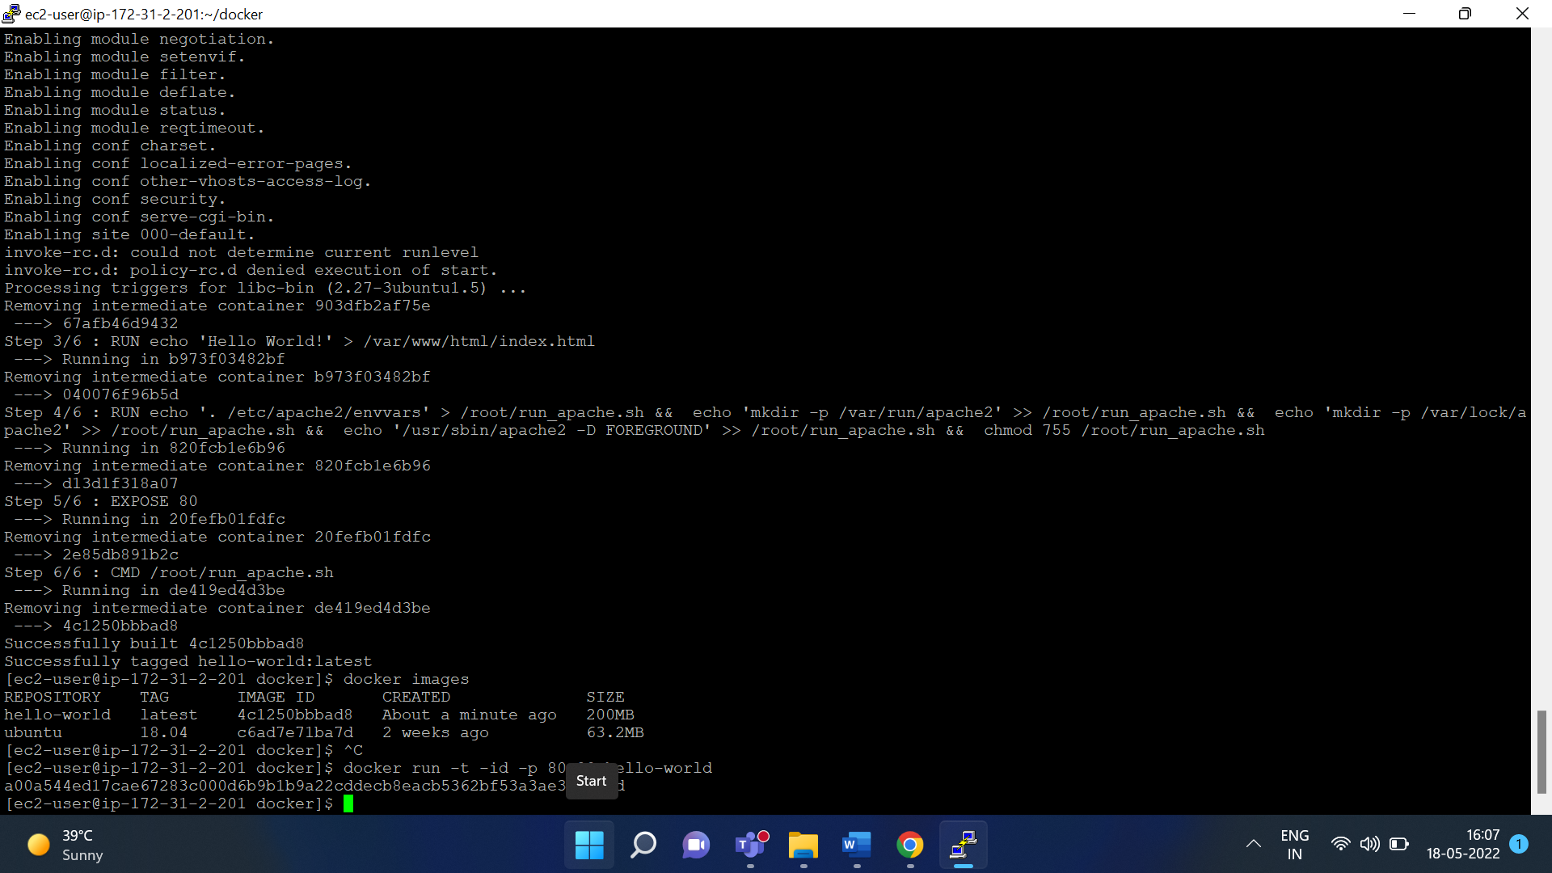

Now go to your instance.

Copy Public IPv4 address and paste it on browser

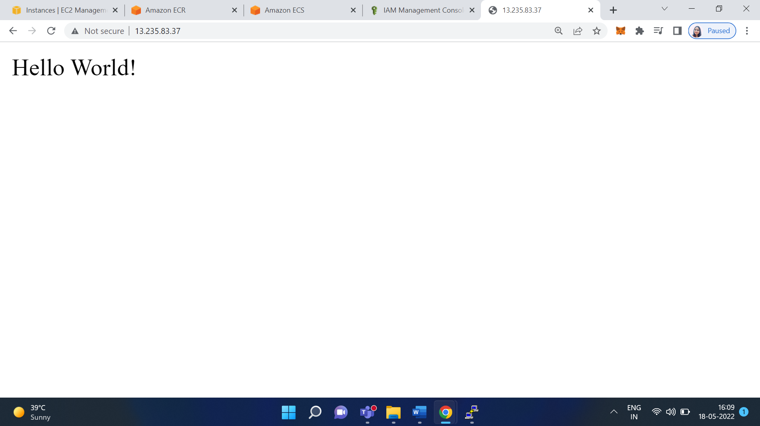

Go to the IAM (Identity and Access Management) Dashboard

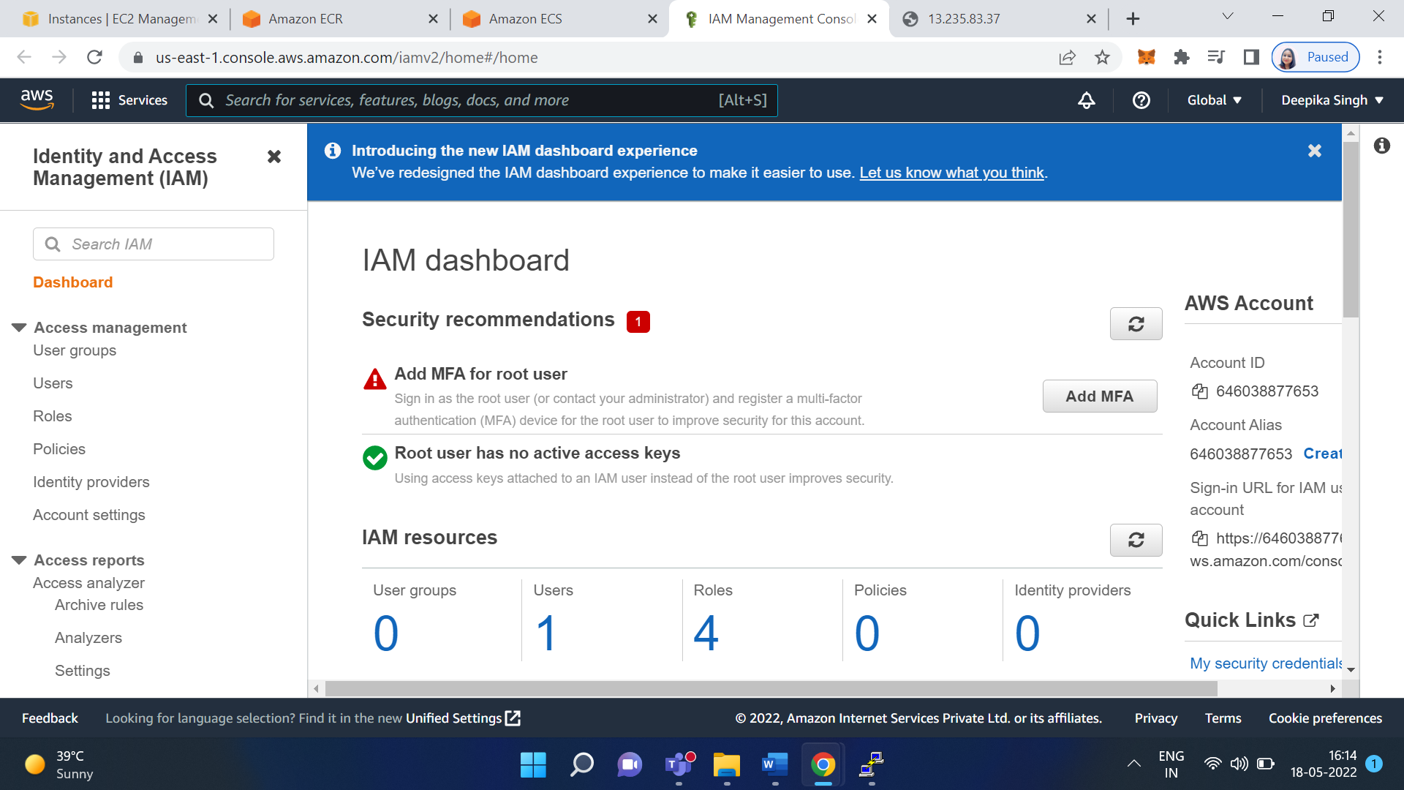

Click on Users

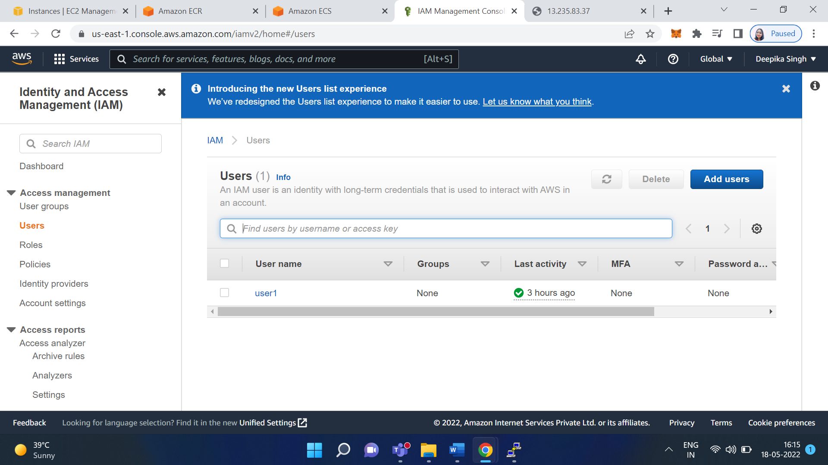

Click on Add user

Give the name as user1

Select AWS credential type: Access key - Programmatic access

Click on Next

Click on attach existing policies directly

Select Administrator access

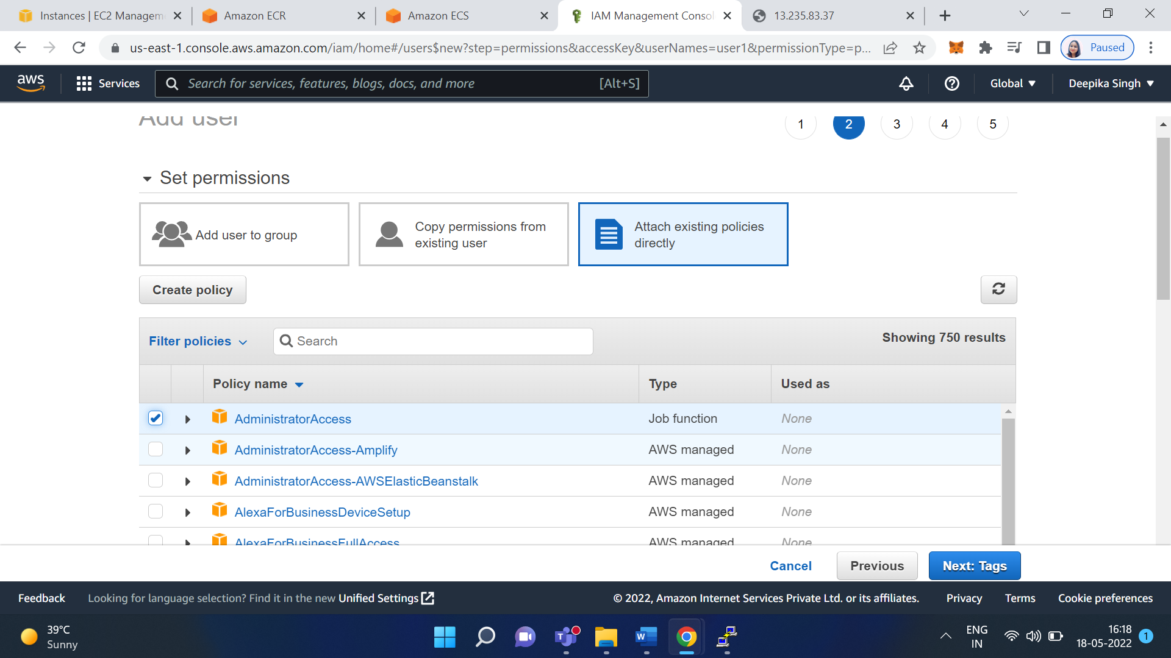

Click on Next

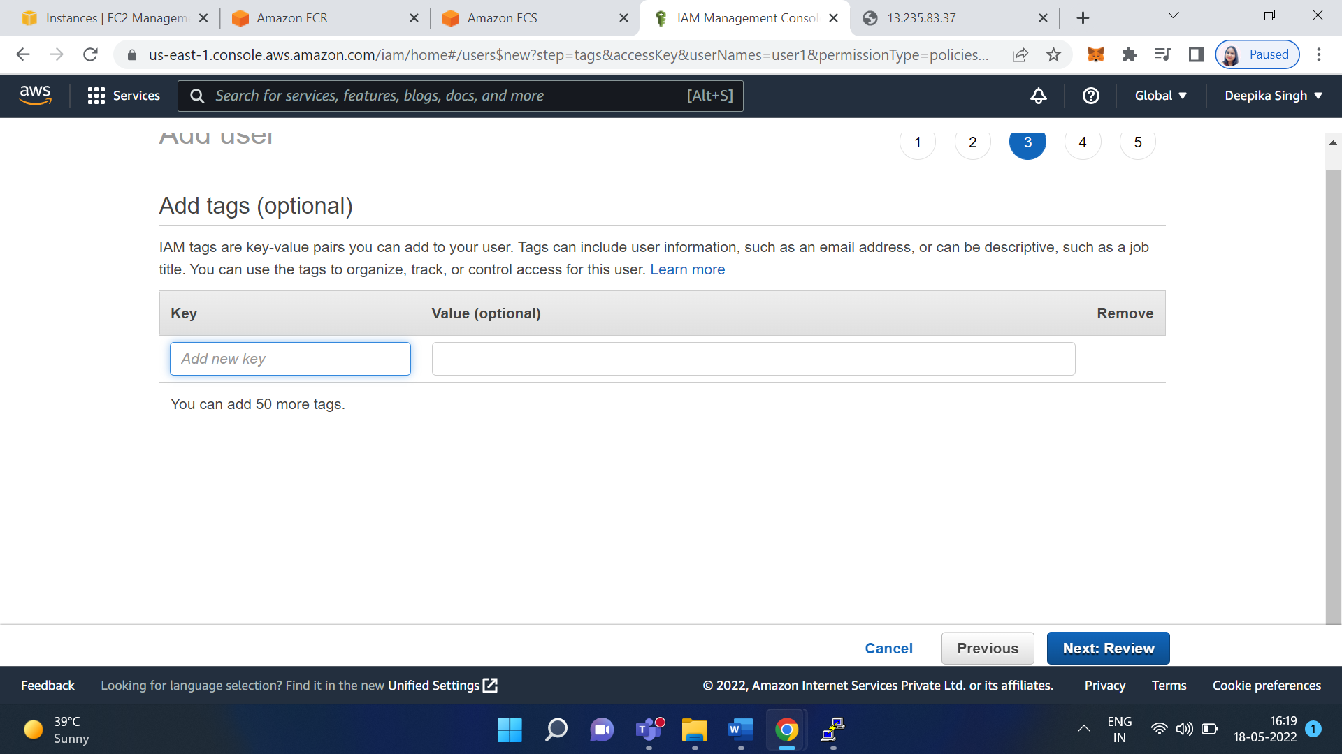

Click on Next

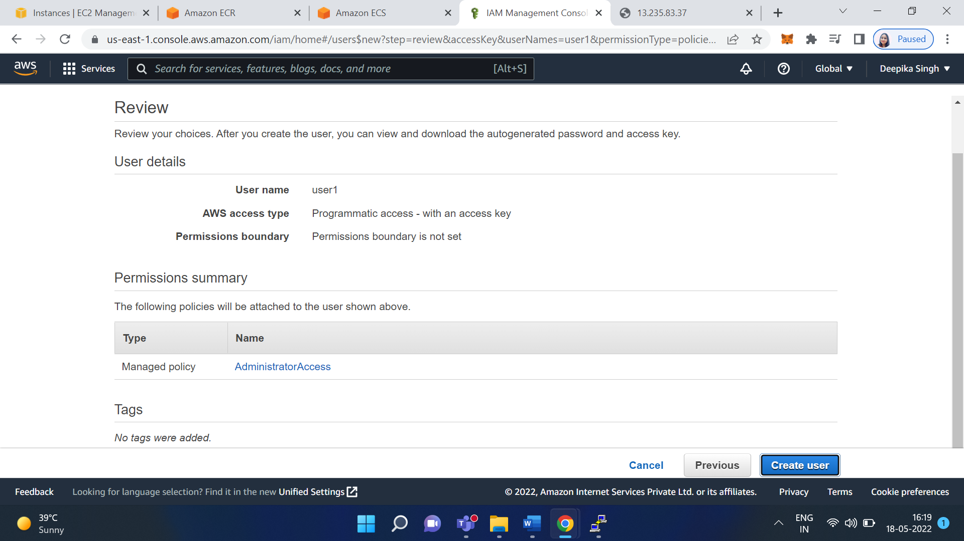

Click on create user

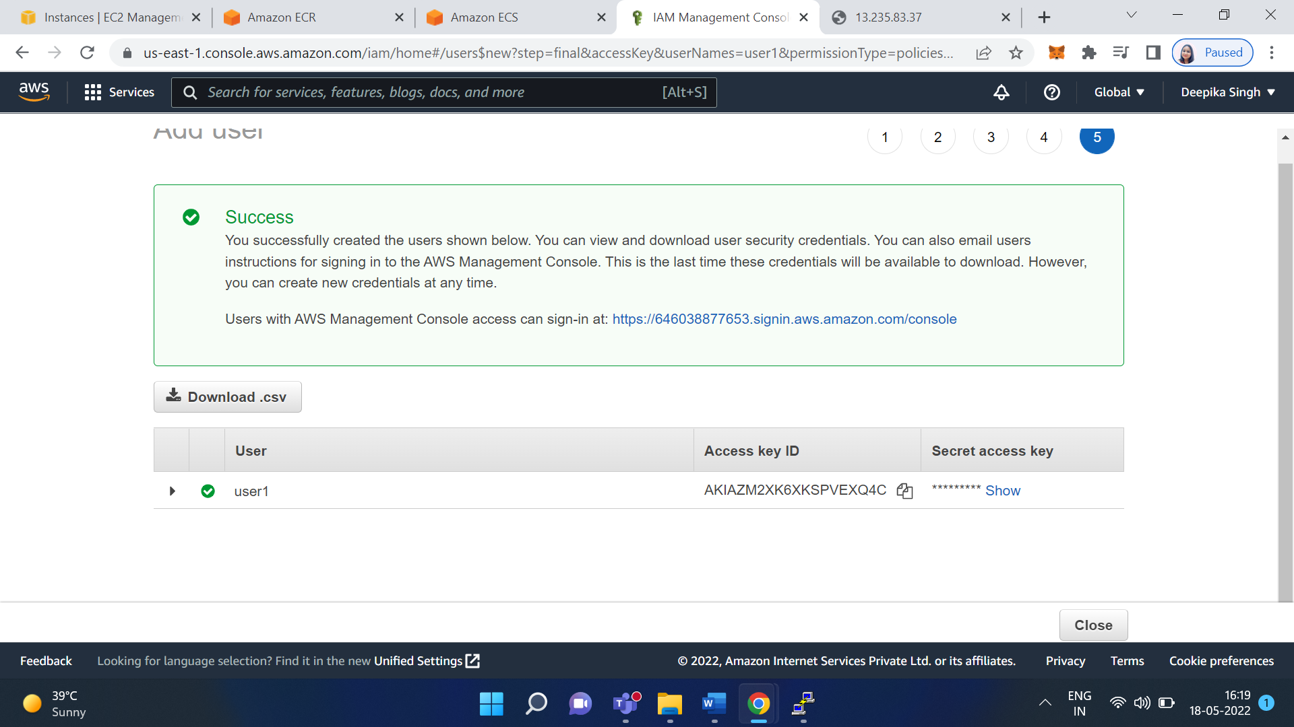

Now download -> download.csv

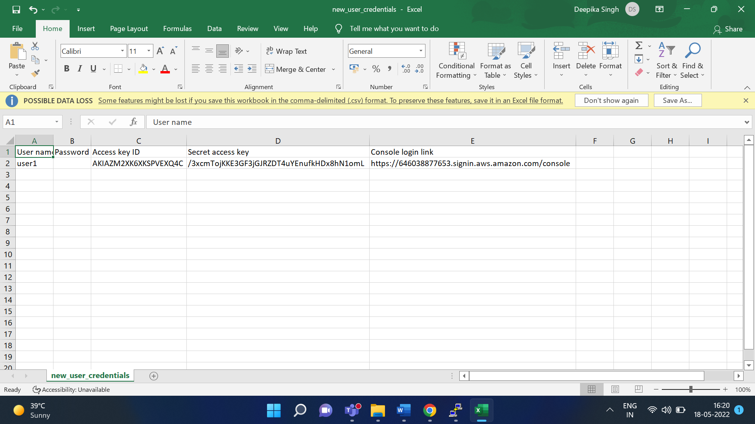

Now goto your Linux machine

Type aws configure

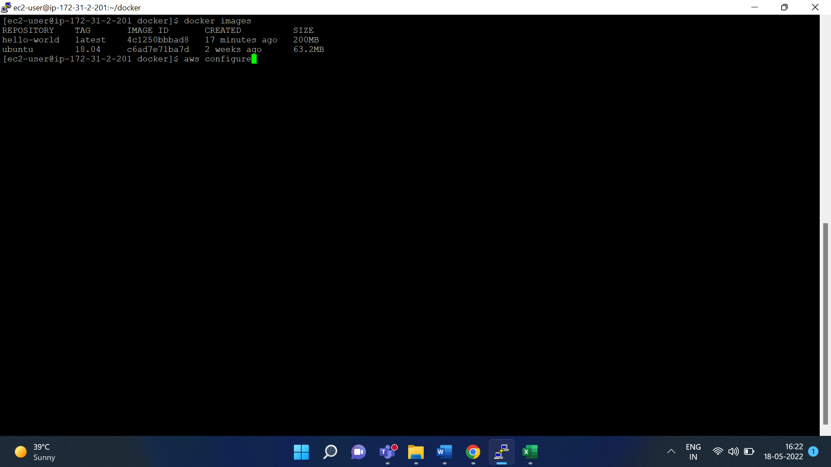

Give AWS access key from the csv file

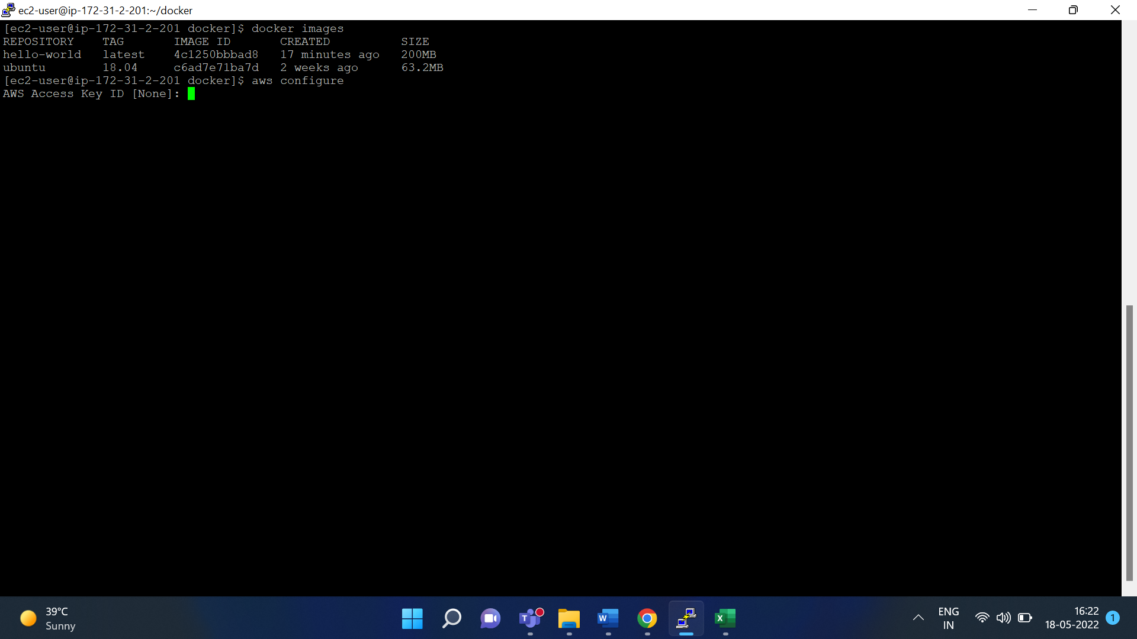

Now paste AWS secret access key from the csv file

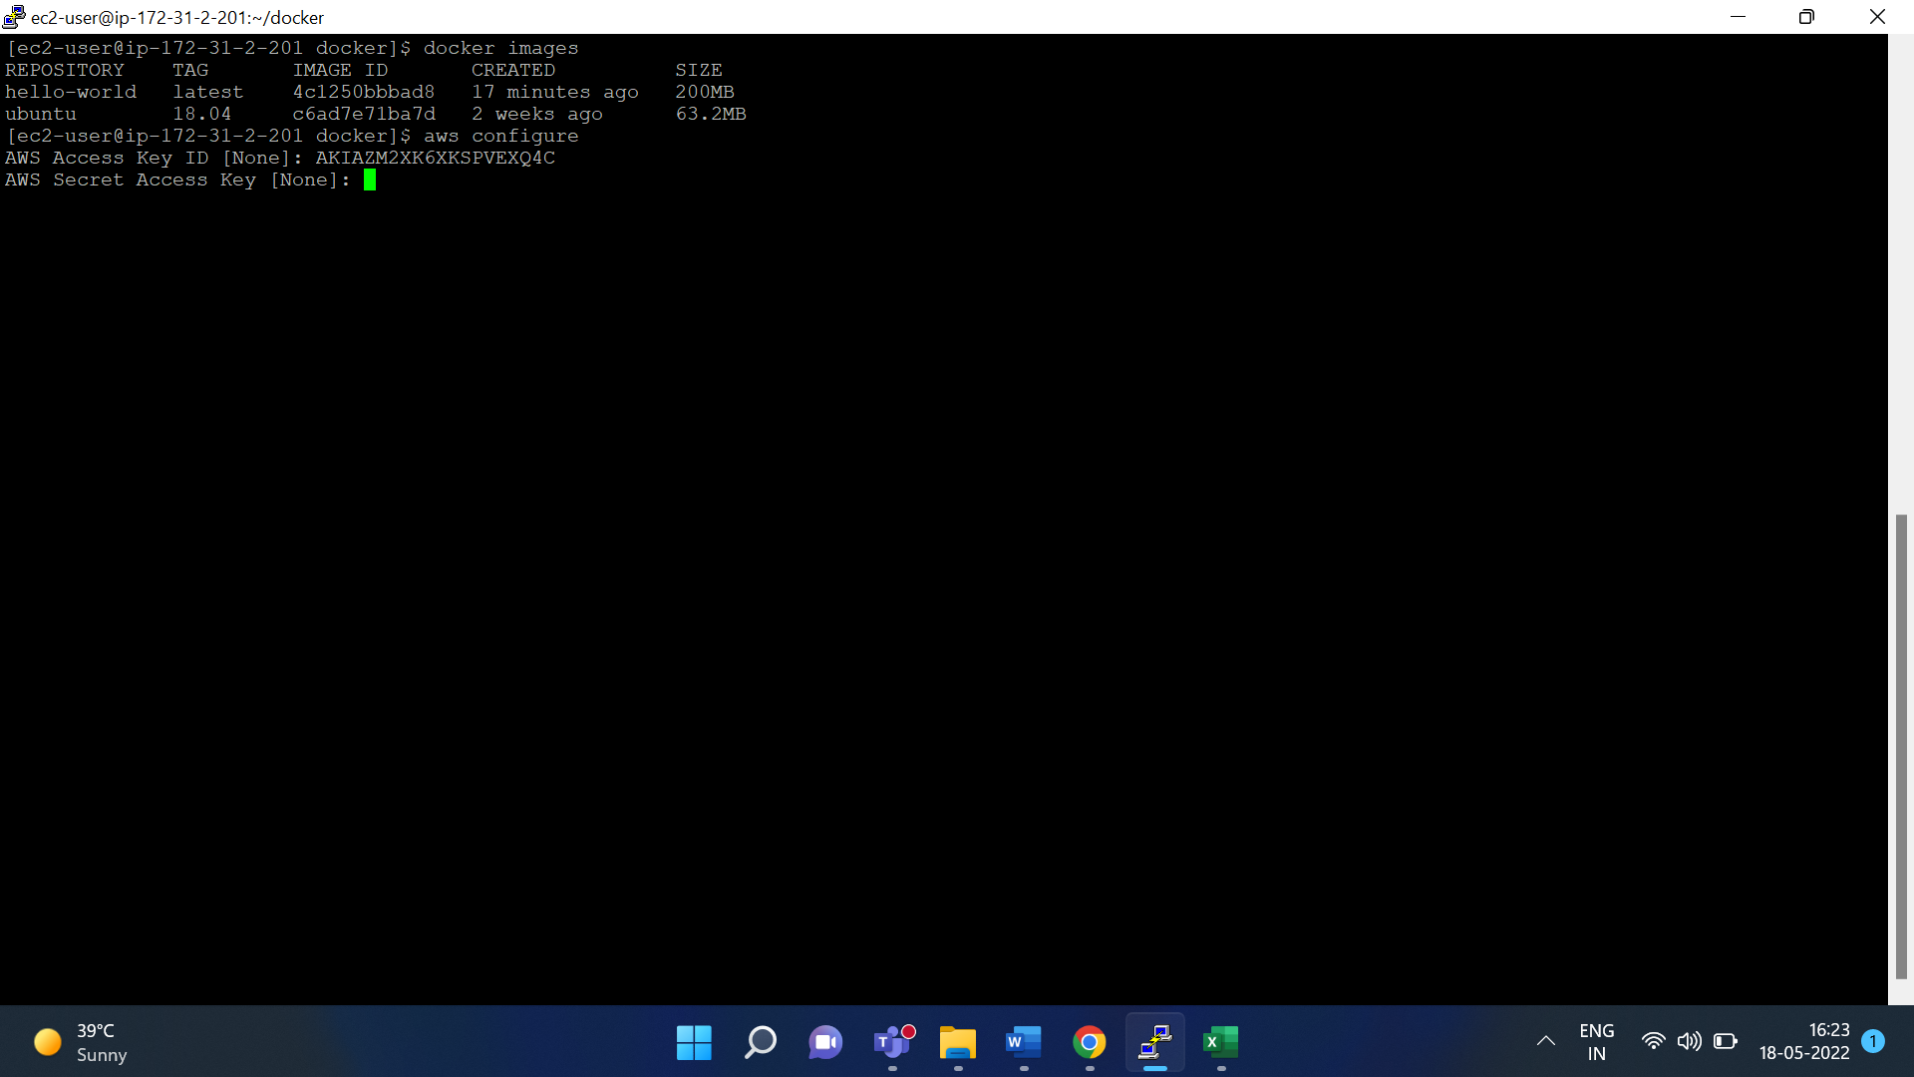

Give the default region name: ap-south-1

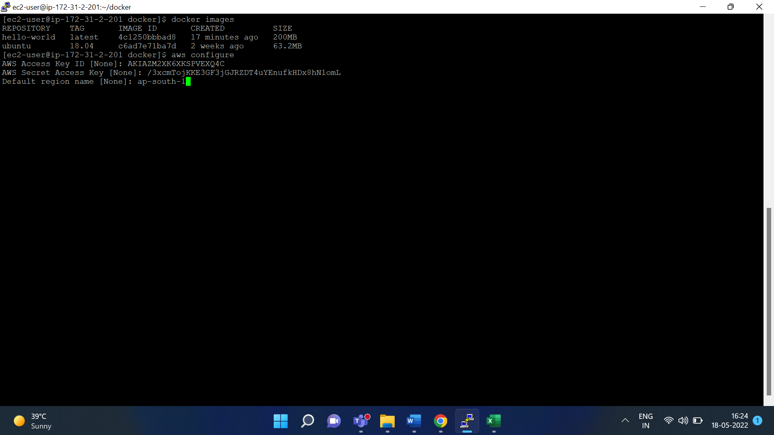

For default output format hit enter

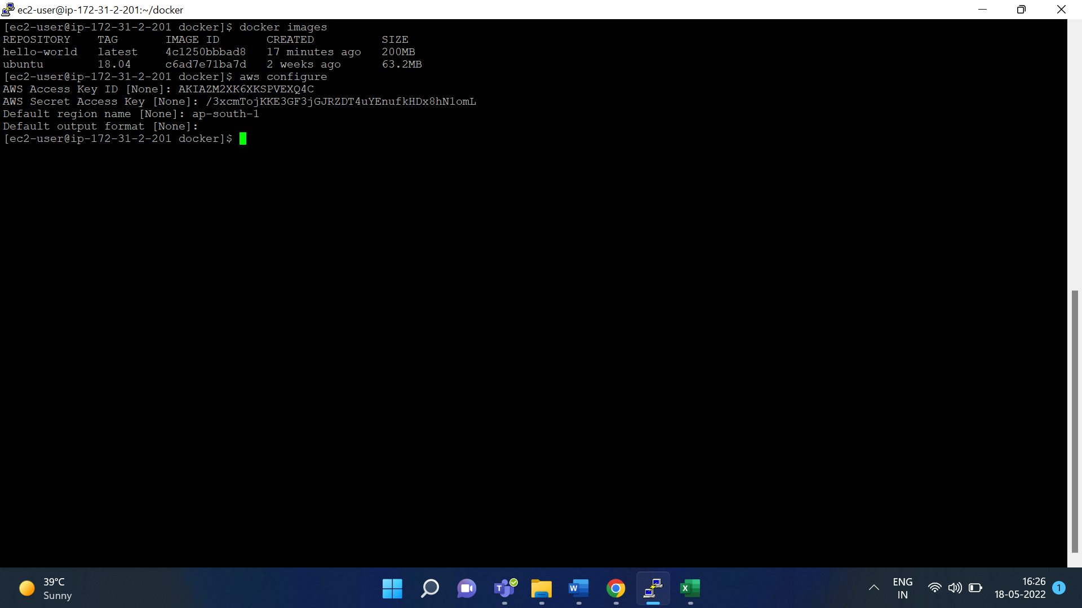

**create ecr repository and push docker image**

aws ecr create-repository --repository-name hello-repository --region ap-south-1

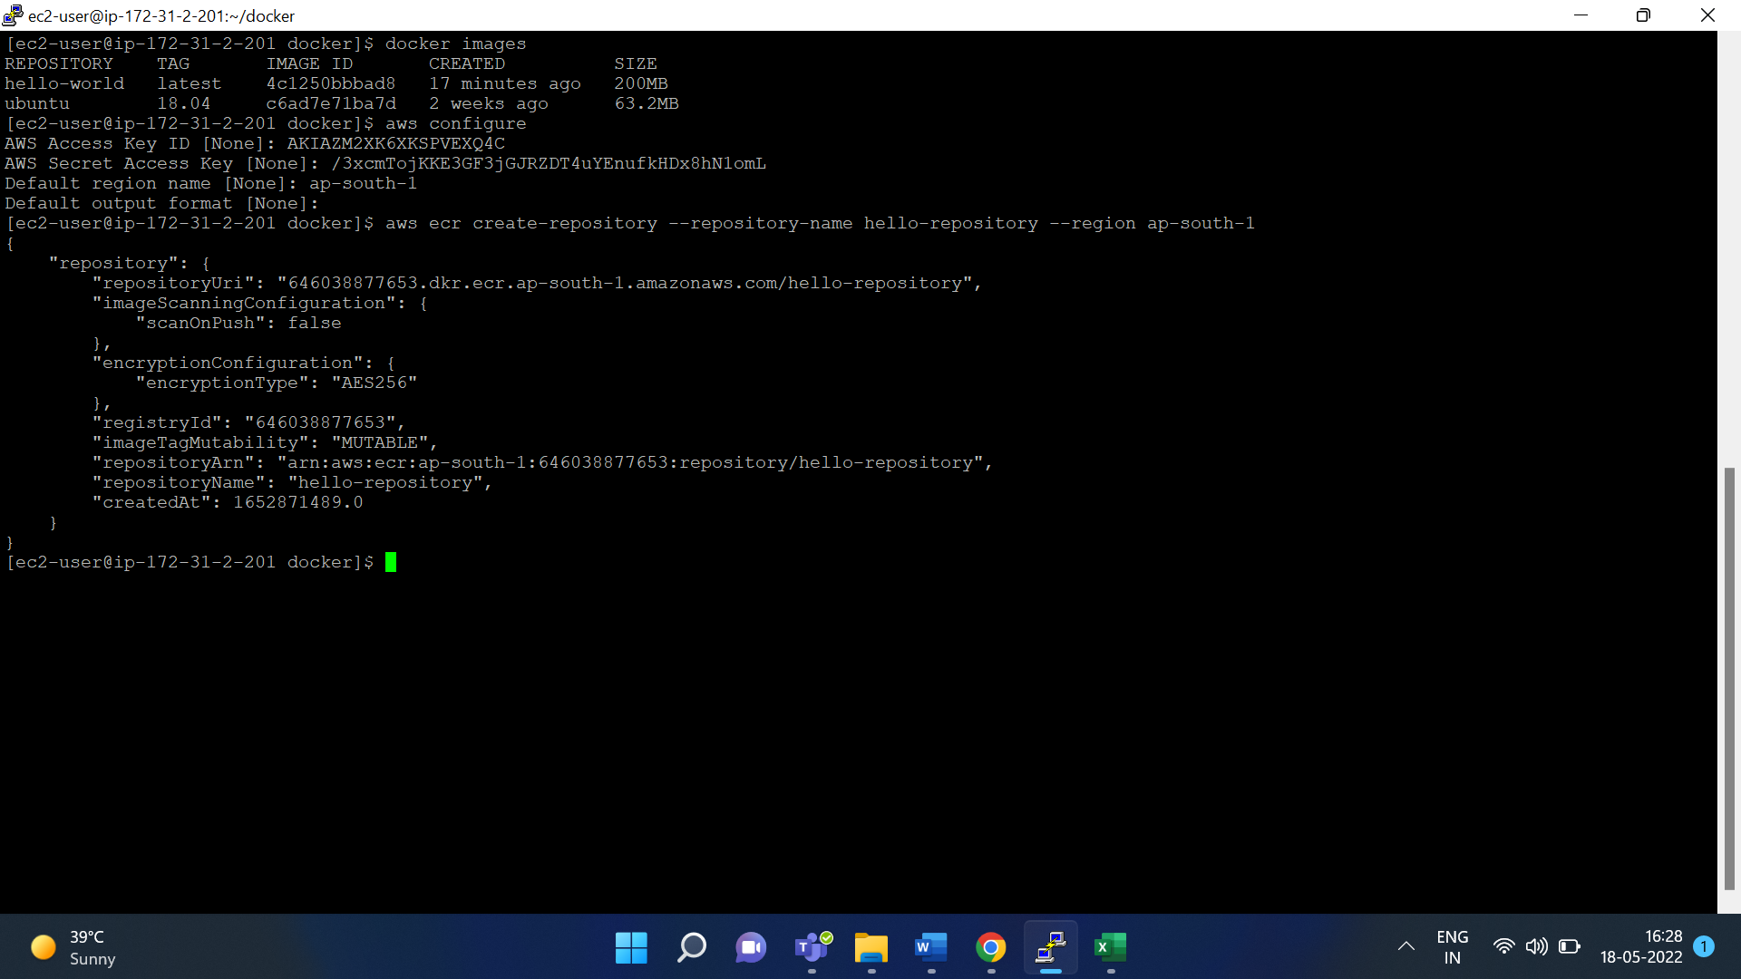

So, our repository has been created in Amazon ECR

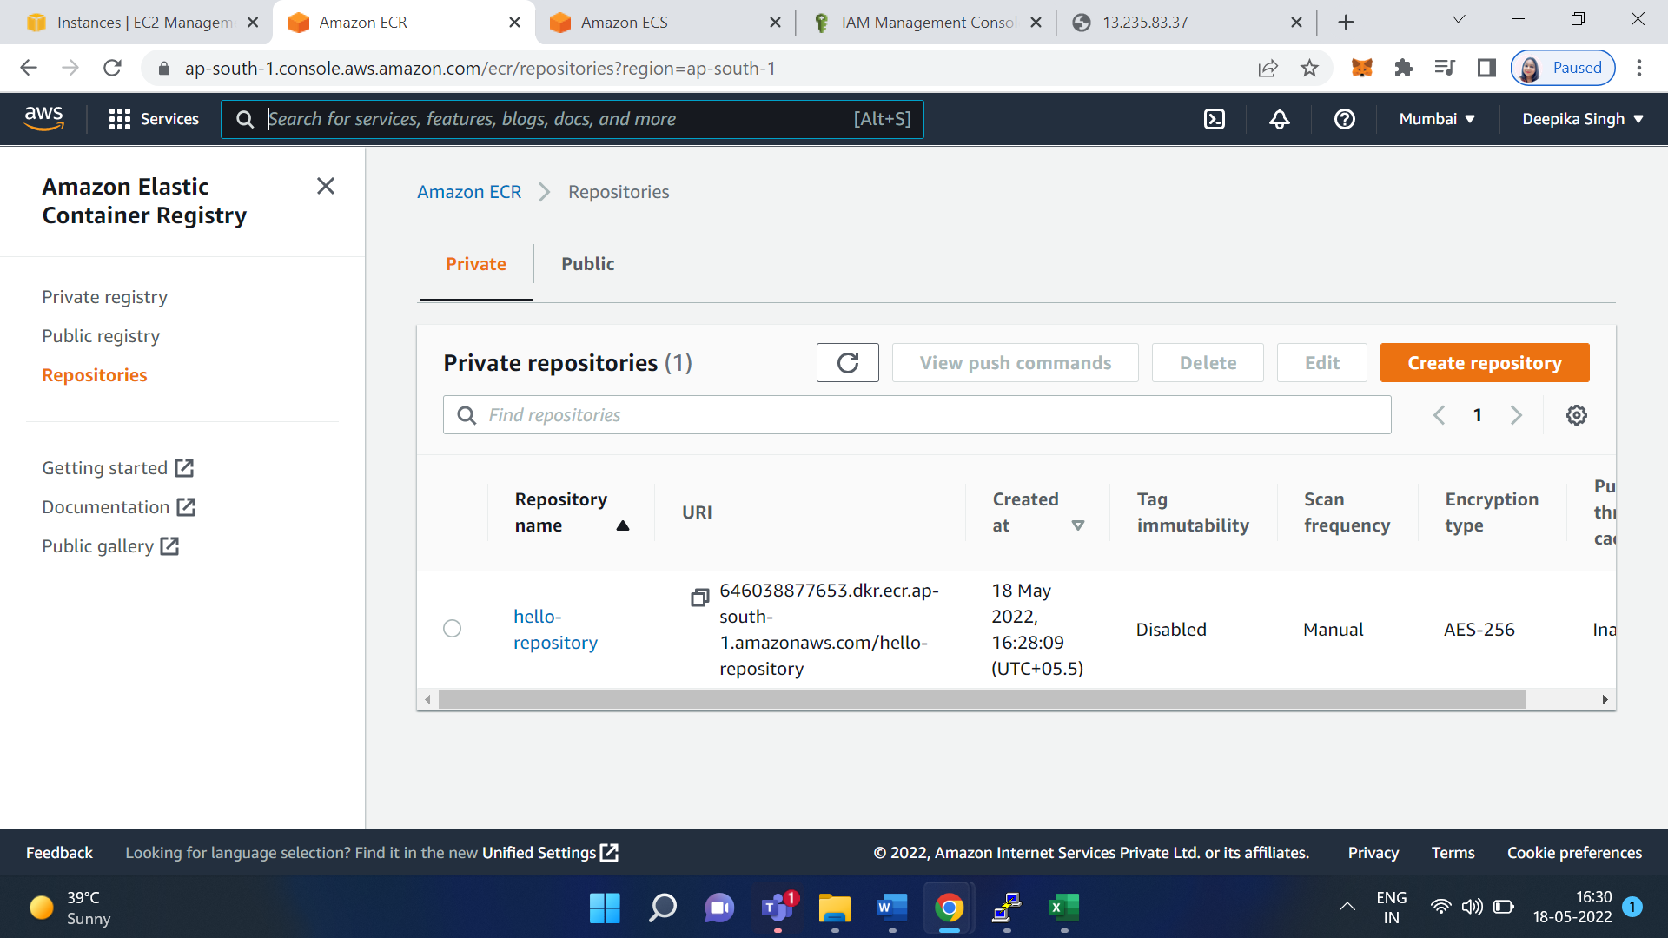

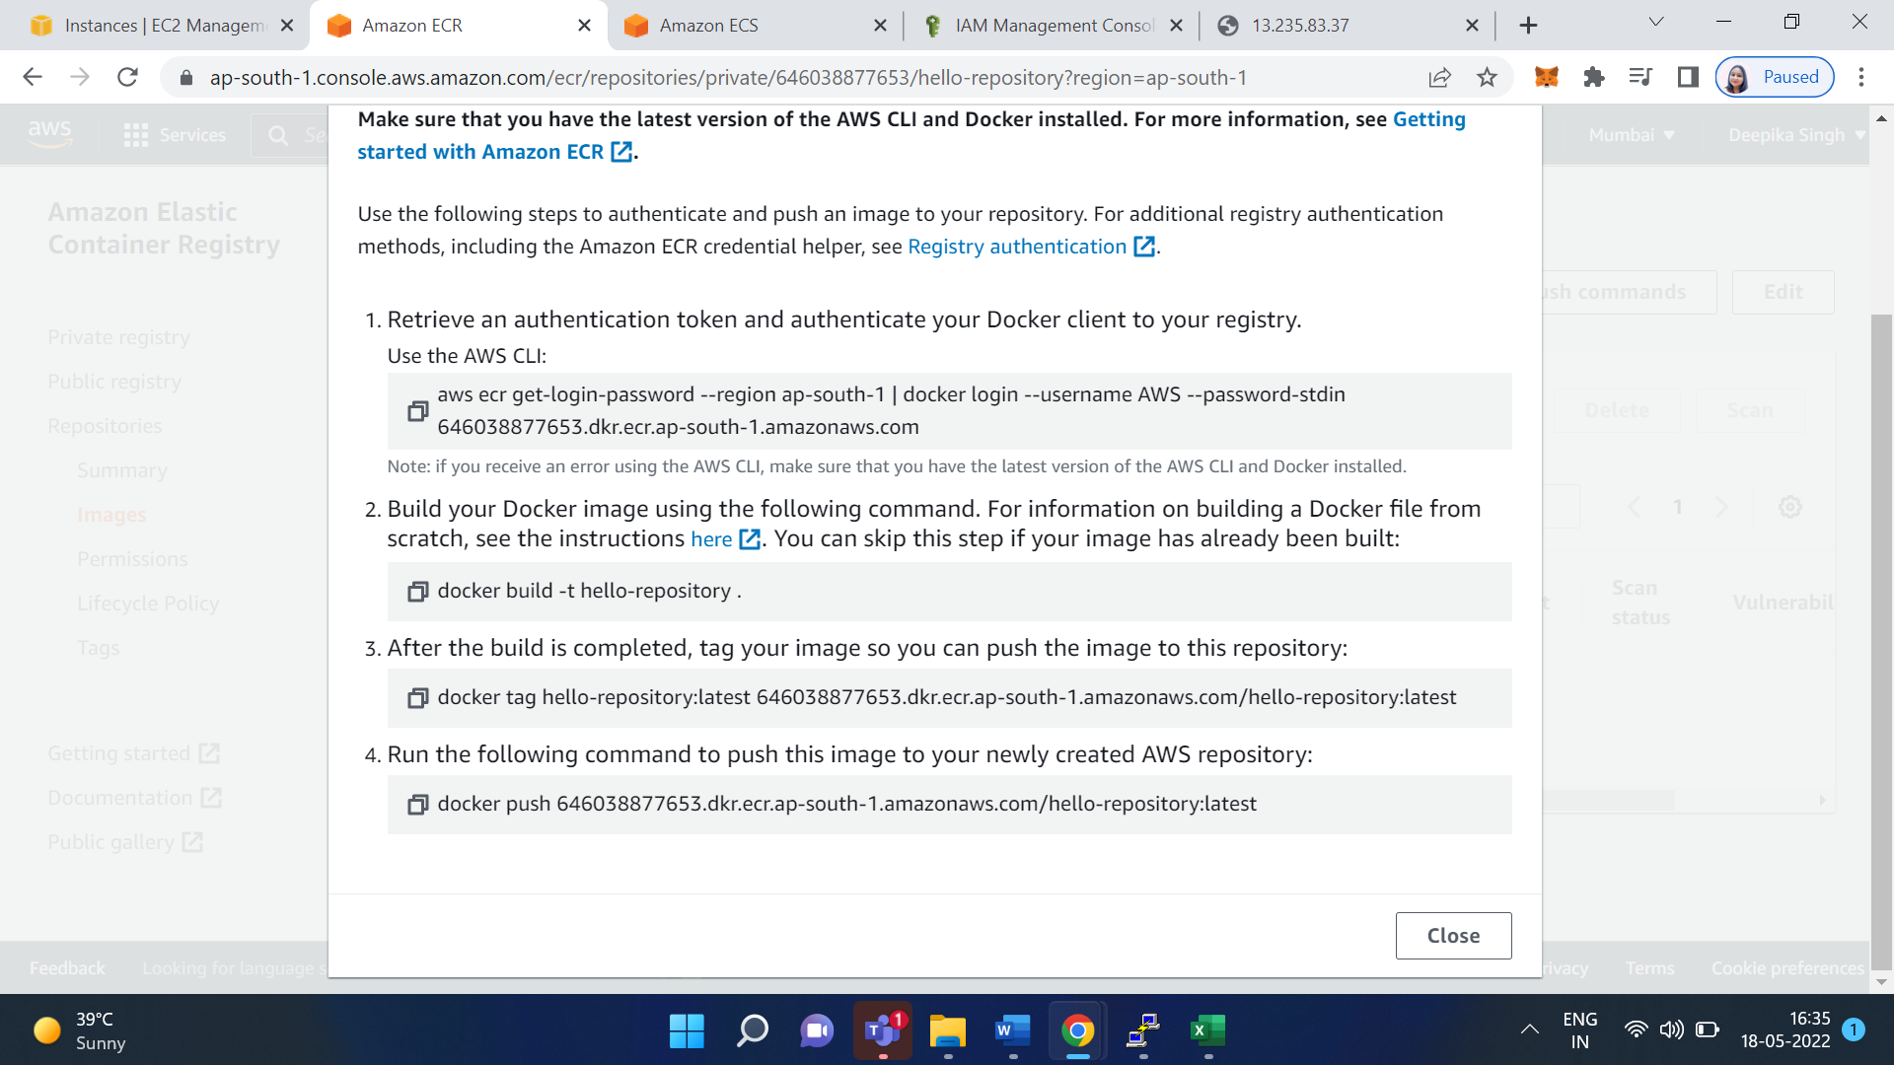

Use the following steps to authenticate and push an image to your repository. For additional registry authentication methods, including the Amazon ECR credential helper.

**Retrieve an authentication token and authenticate your Docker client to your registry.** **Use the AWS CLI:**

aws ecr get-login-password --region ap-south-1 | docker login --username AWS --password-stdin 646038877653.dkr.ecr.ap-south-1.amazonaws.com

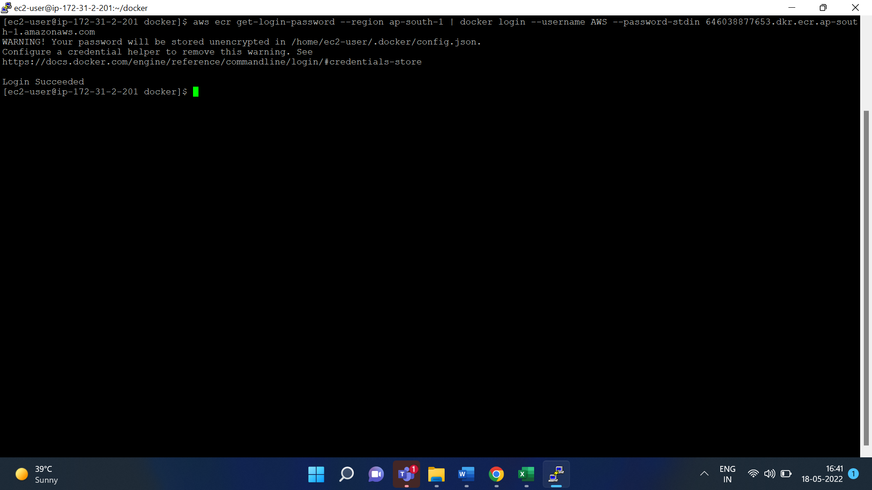

**Build your Docker image using the following command. For information on building a Docker file from scratch, see the instructions here.**

docker build -t hello-repository

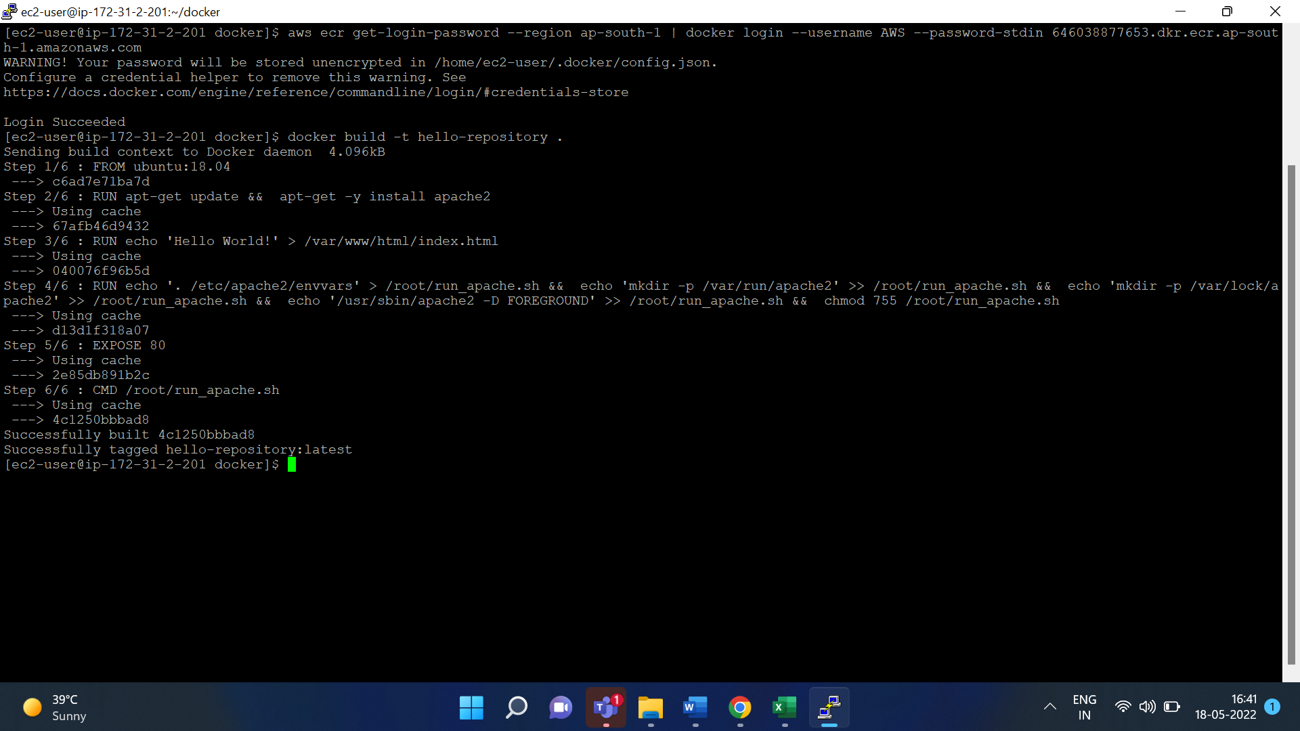 **After the build is completed, tag your image so you can push the image to this repository:**

docker tag hello-repository:latest 646038877653.dkr.ecr.ap-south-1.amazonaws.com/hello-repository:latest

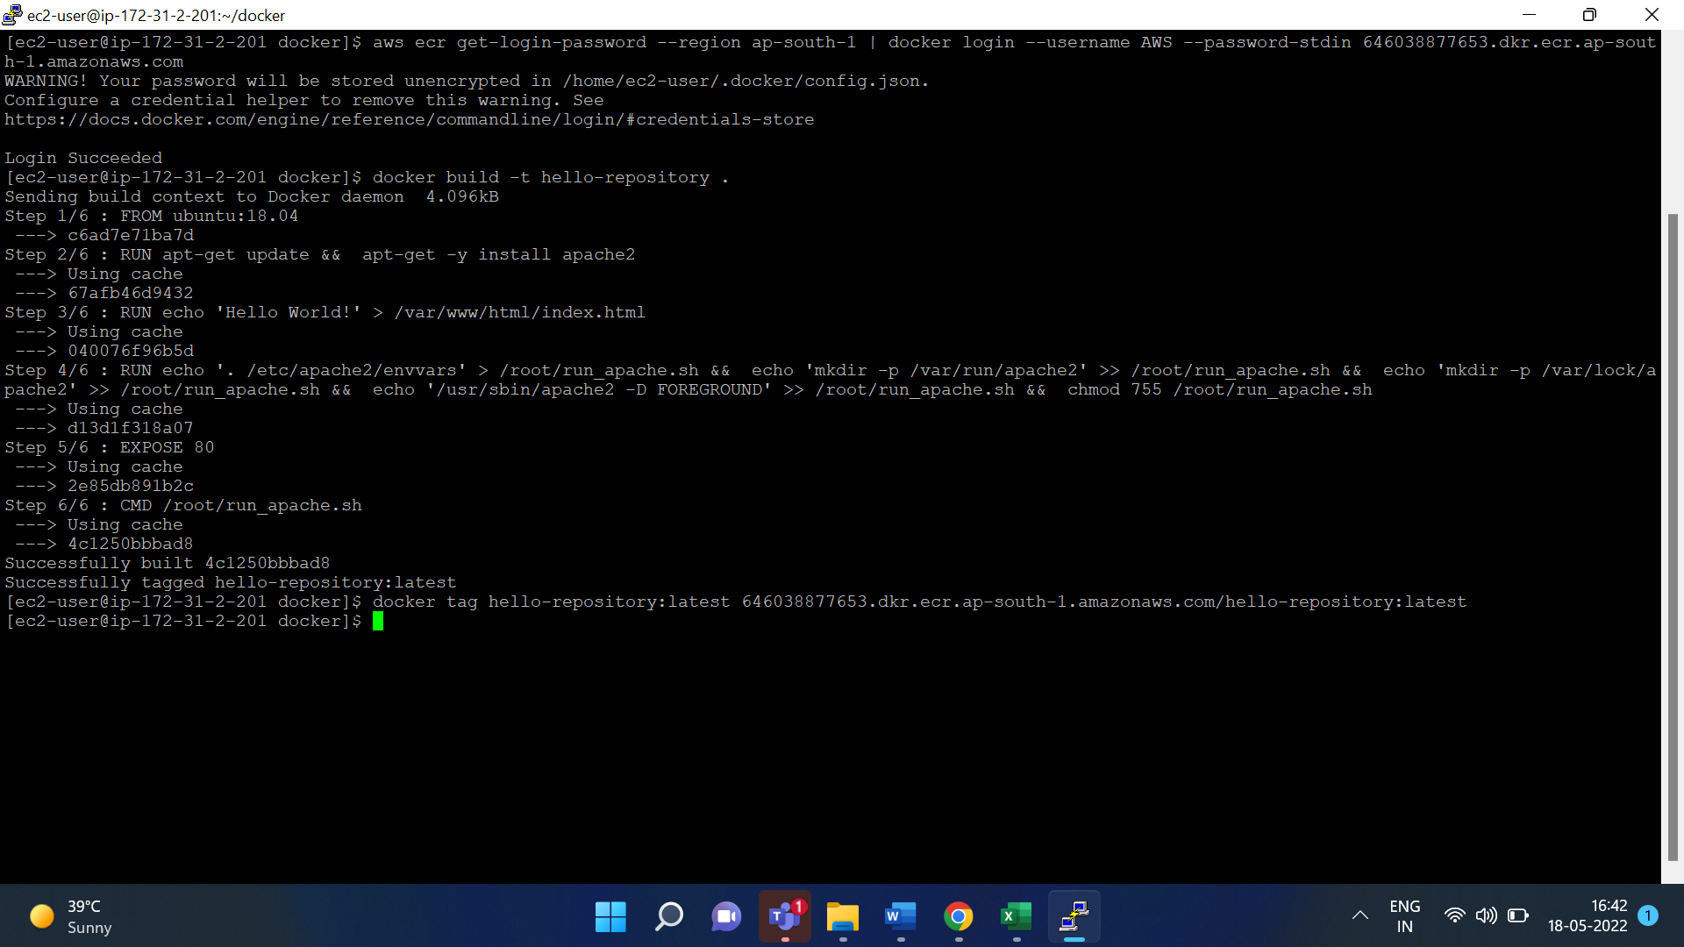

**Run the following command to push this image to your newly created AWS repository:**

docker push 646038877653.dkr.ecr.ap-south-1.amazonaws.com/hello-repository:latest

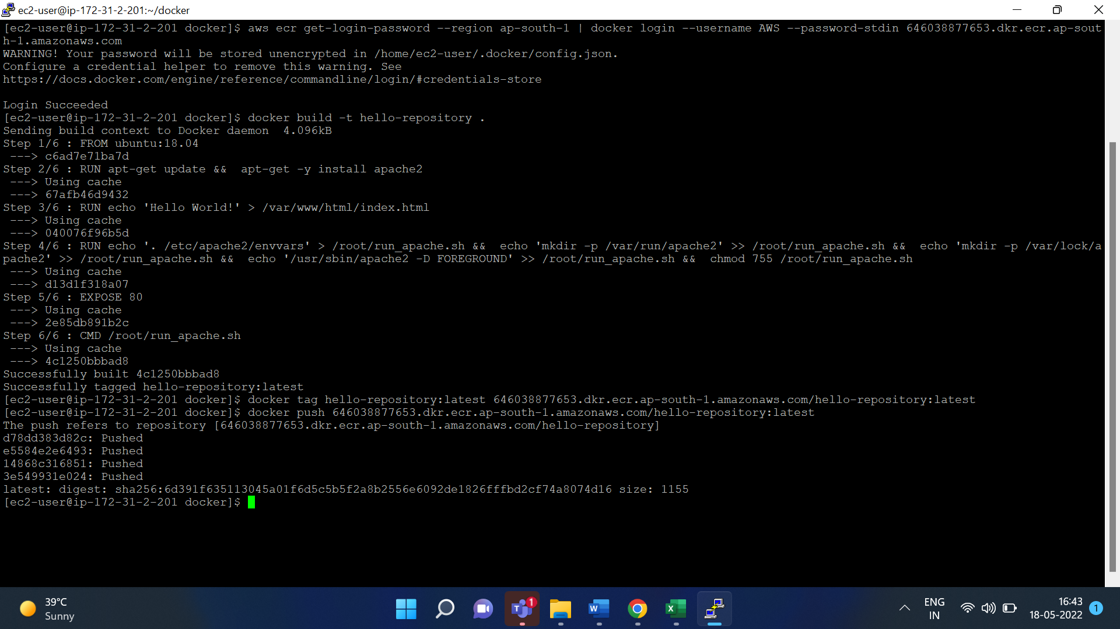

**create task definition**

go to aws console - service - search for ecs

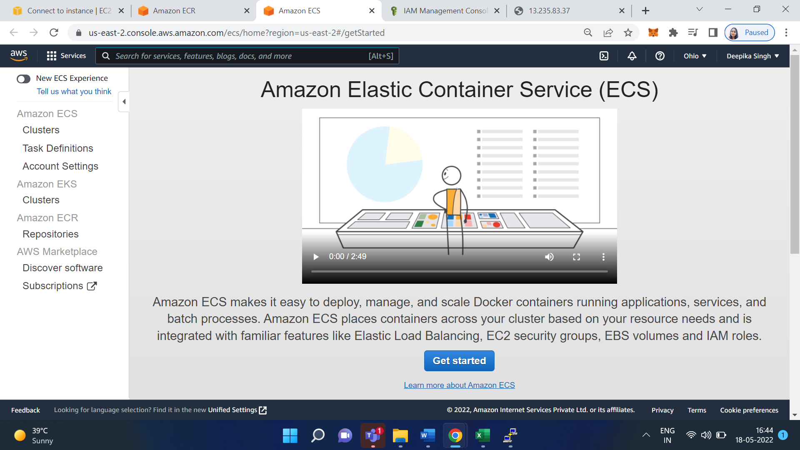

click task definition - and create a new task definition

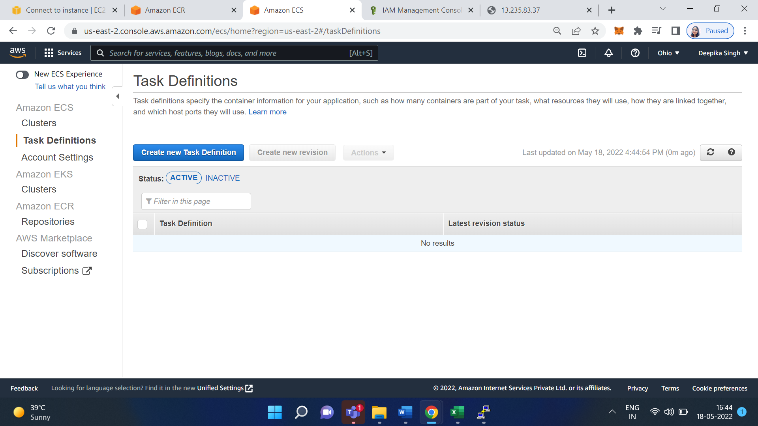

Select launch type compatibility: fargate

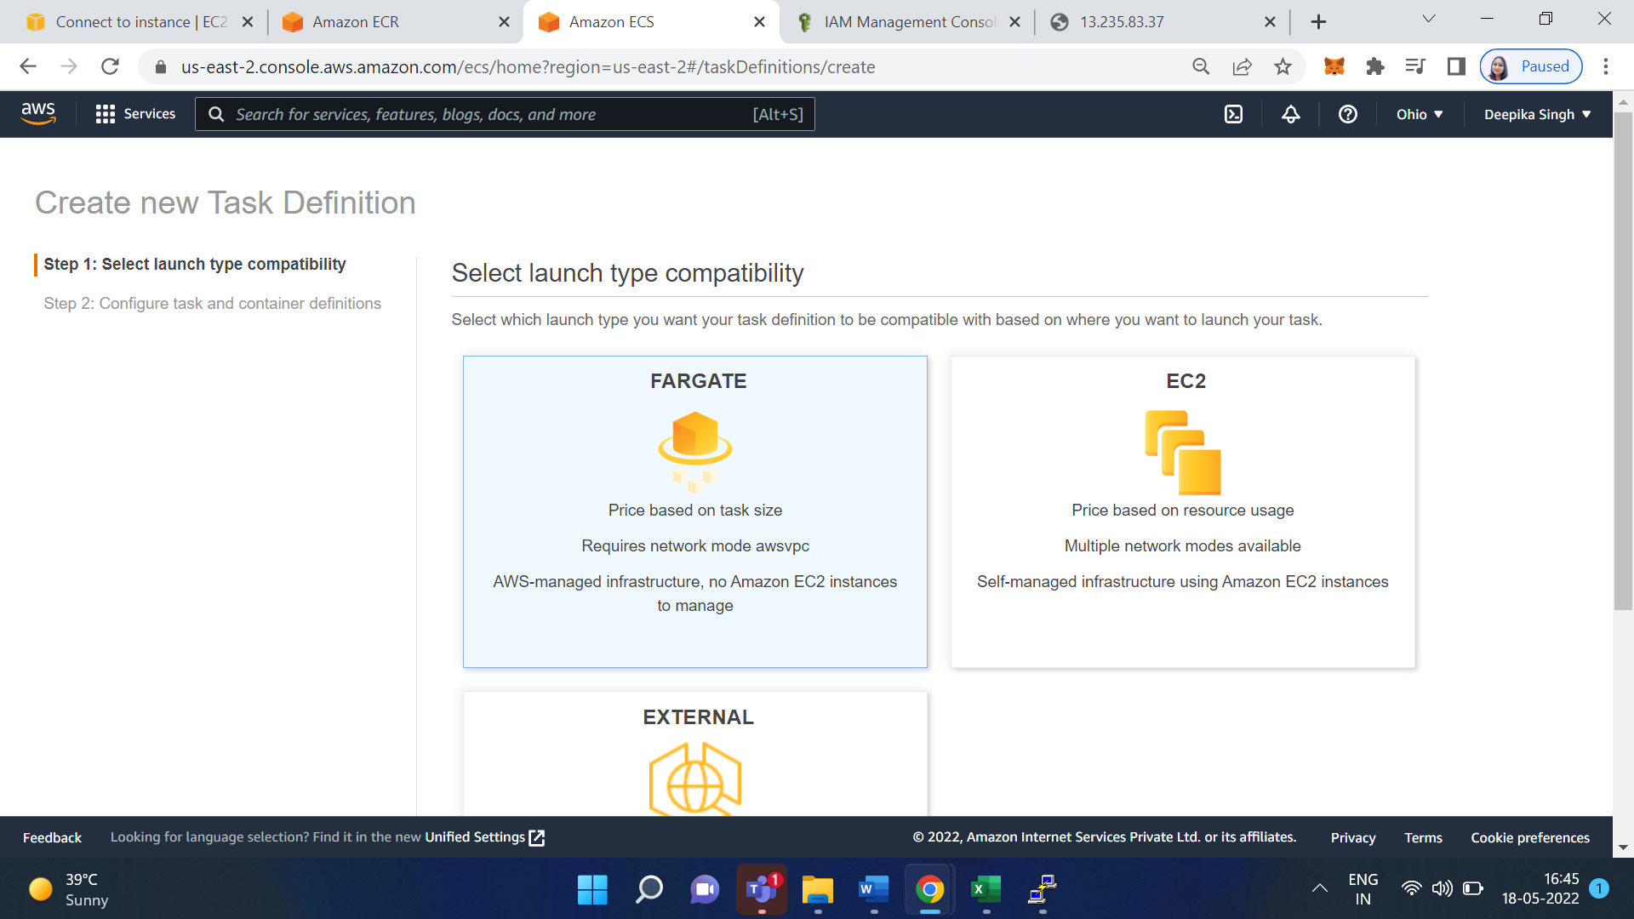

Click on Next

Give the Task definition name: hello-task-demo

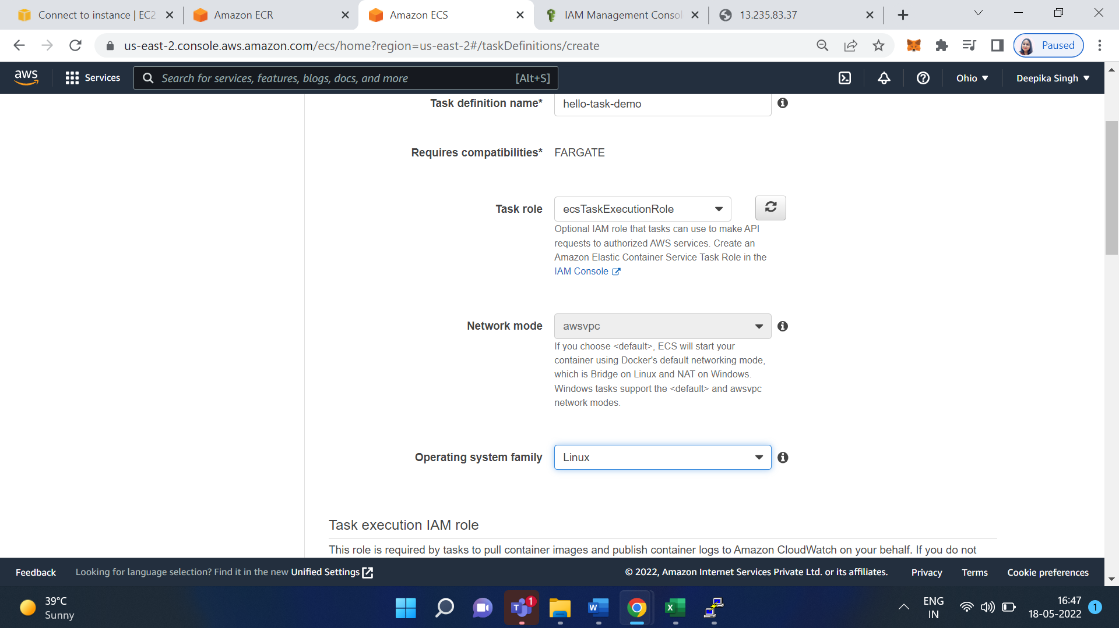

Select Task memory and Task CPU

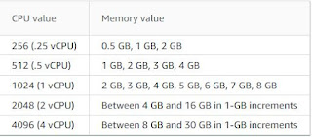

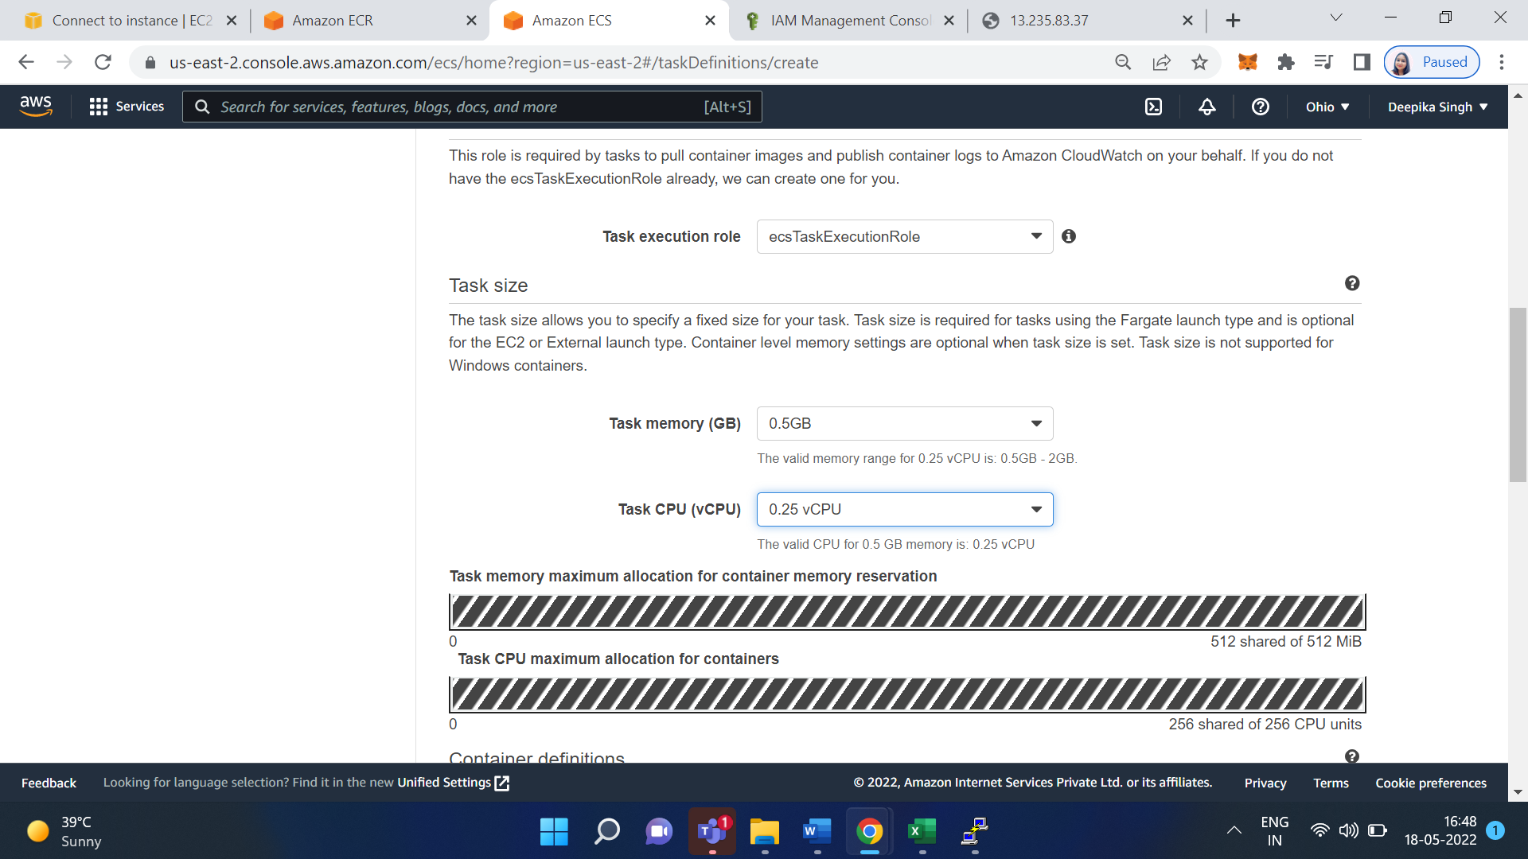

Click on Add Container

Five the container name as hello-world-demo-container

Give image url from Amazon ECR

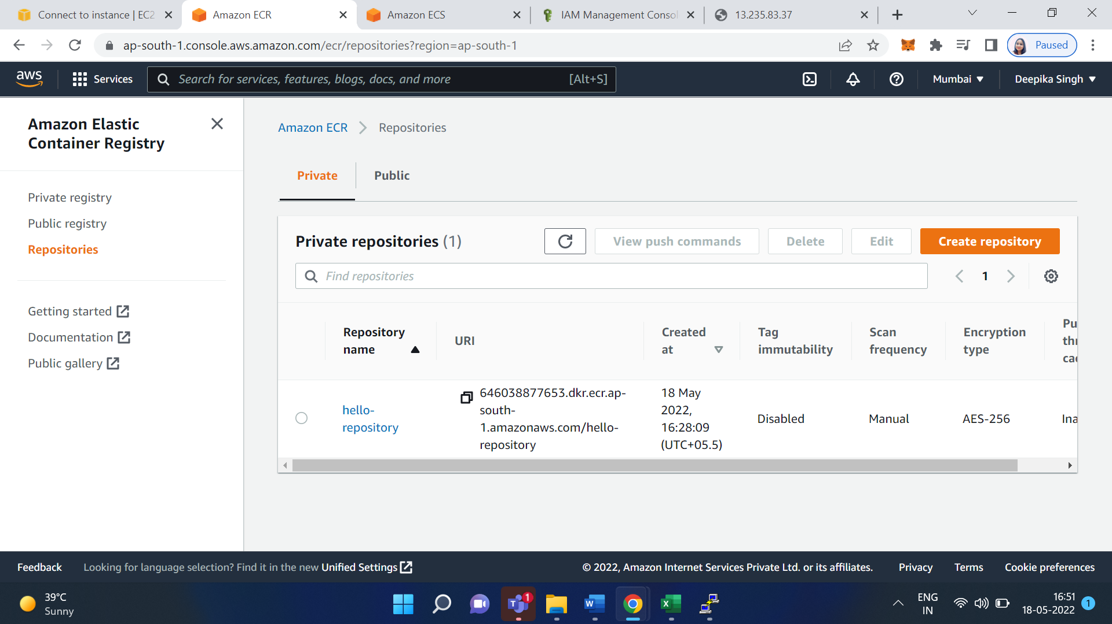

Copy this URL and paste on the container URL

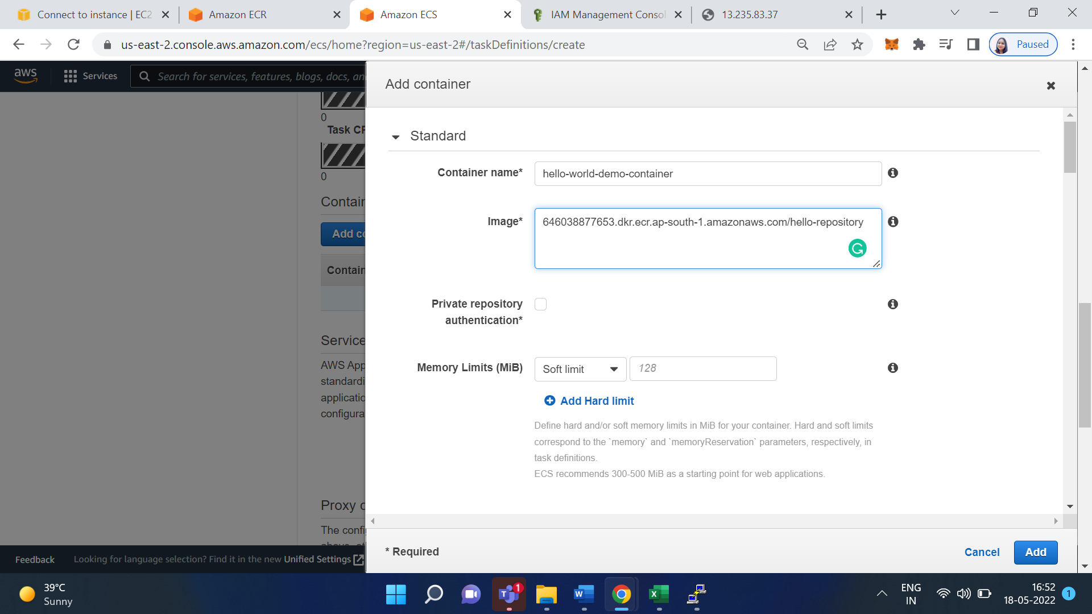

Now click on add url

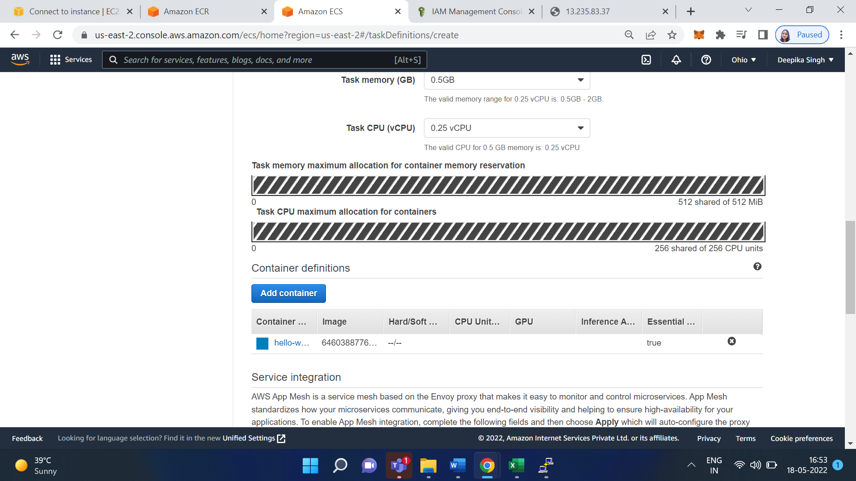

Go down and click on create

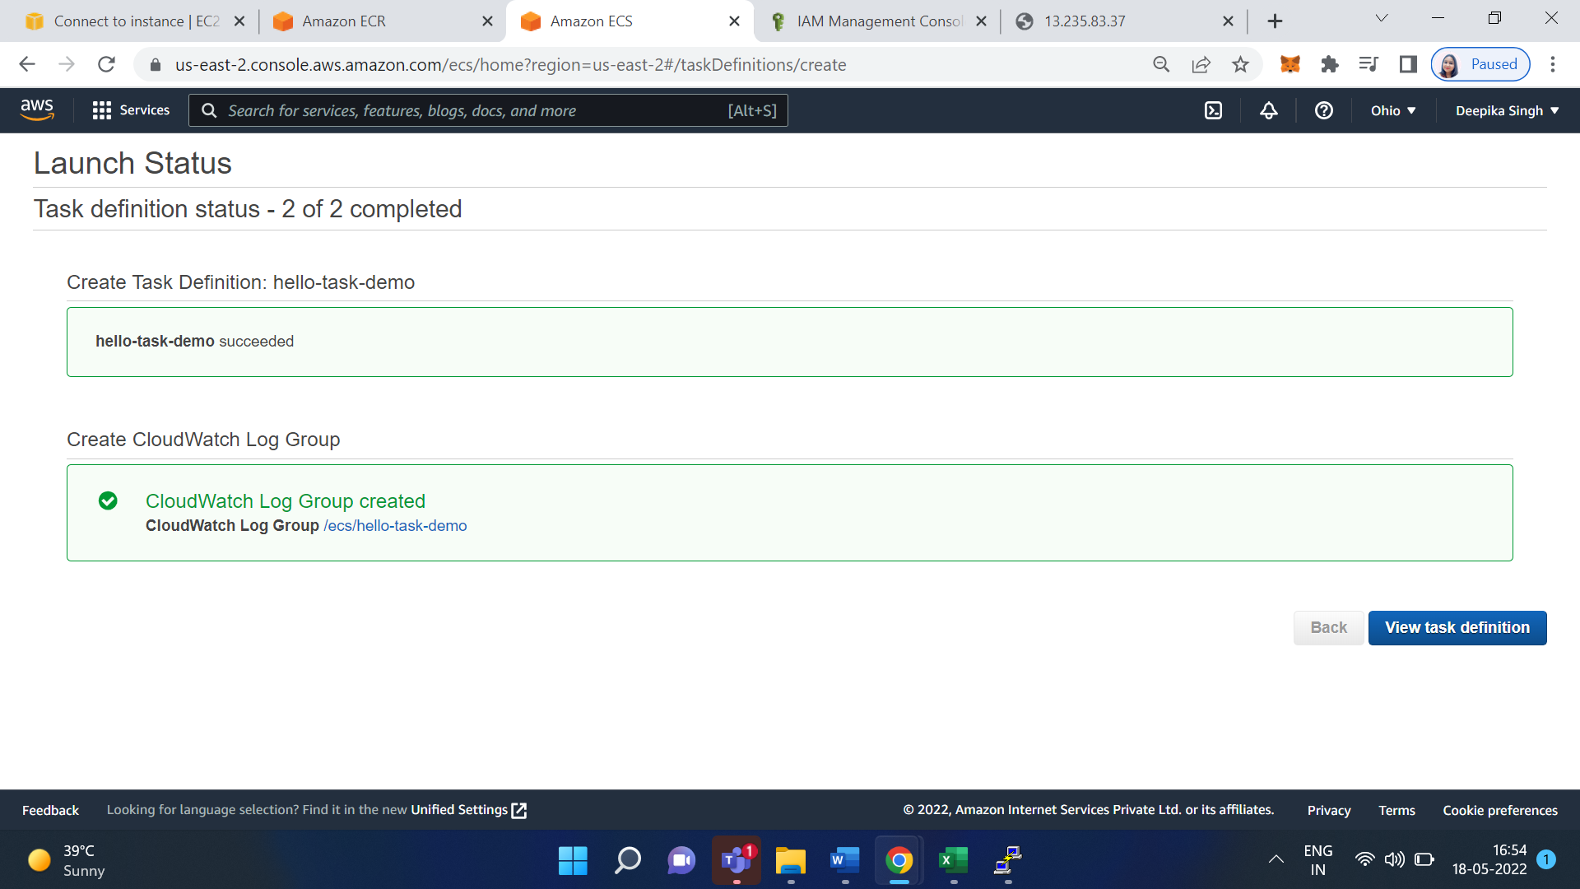

Click on View task definition

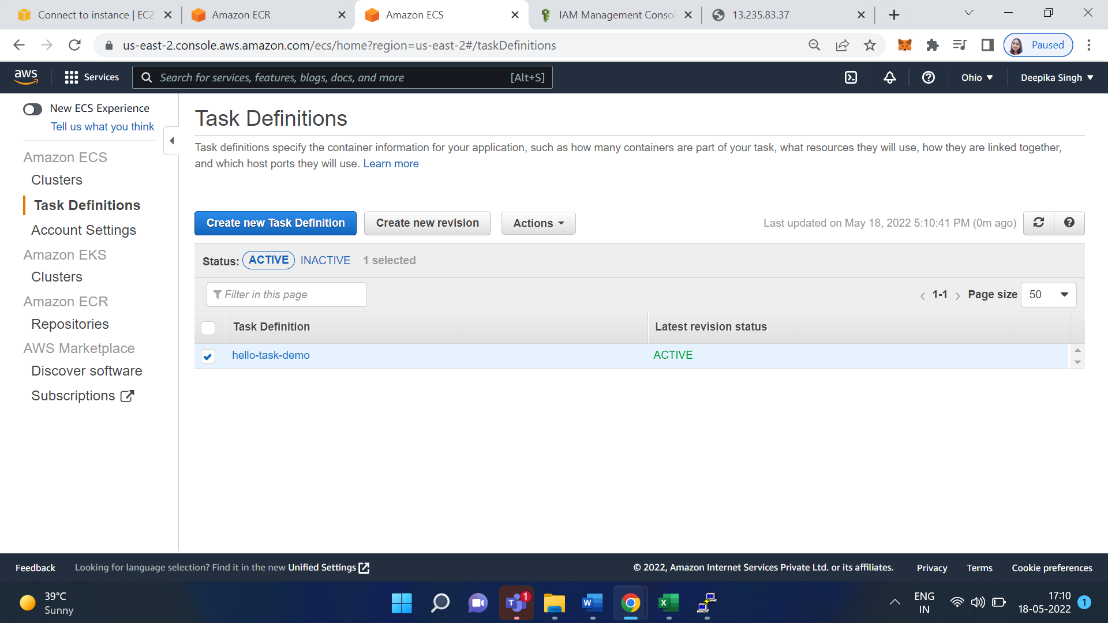

Now we have to create Cluster

Click on Cluster

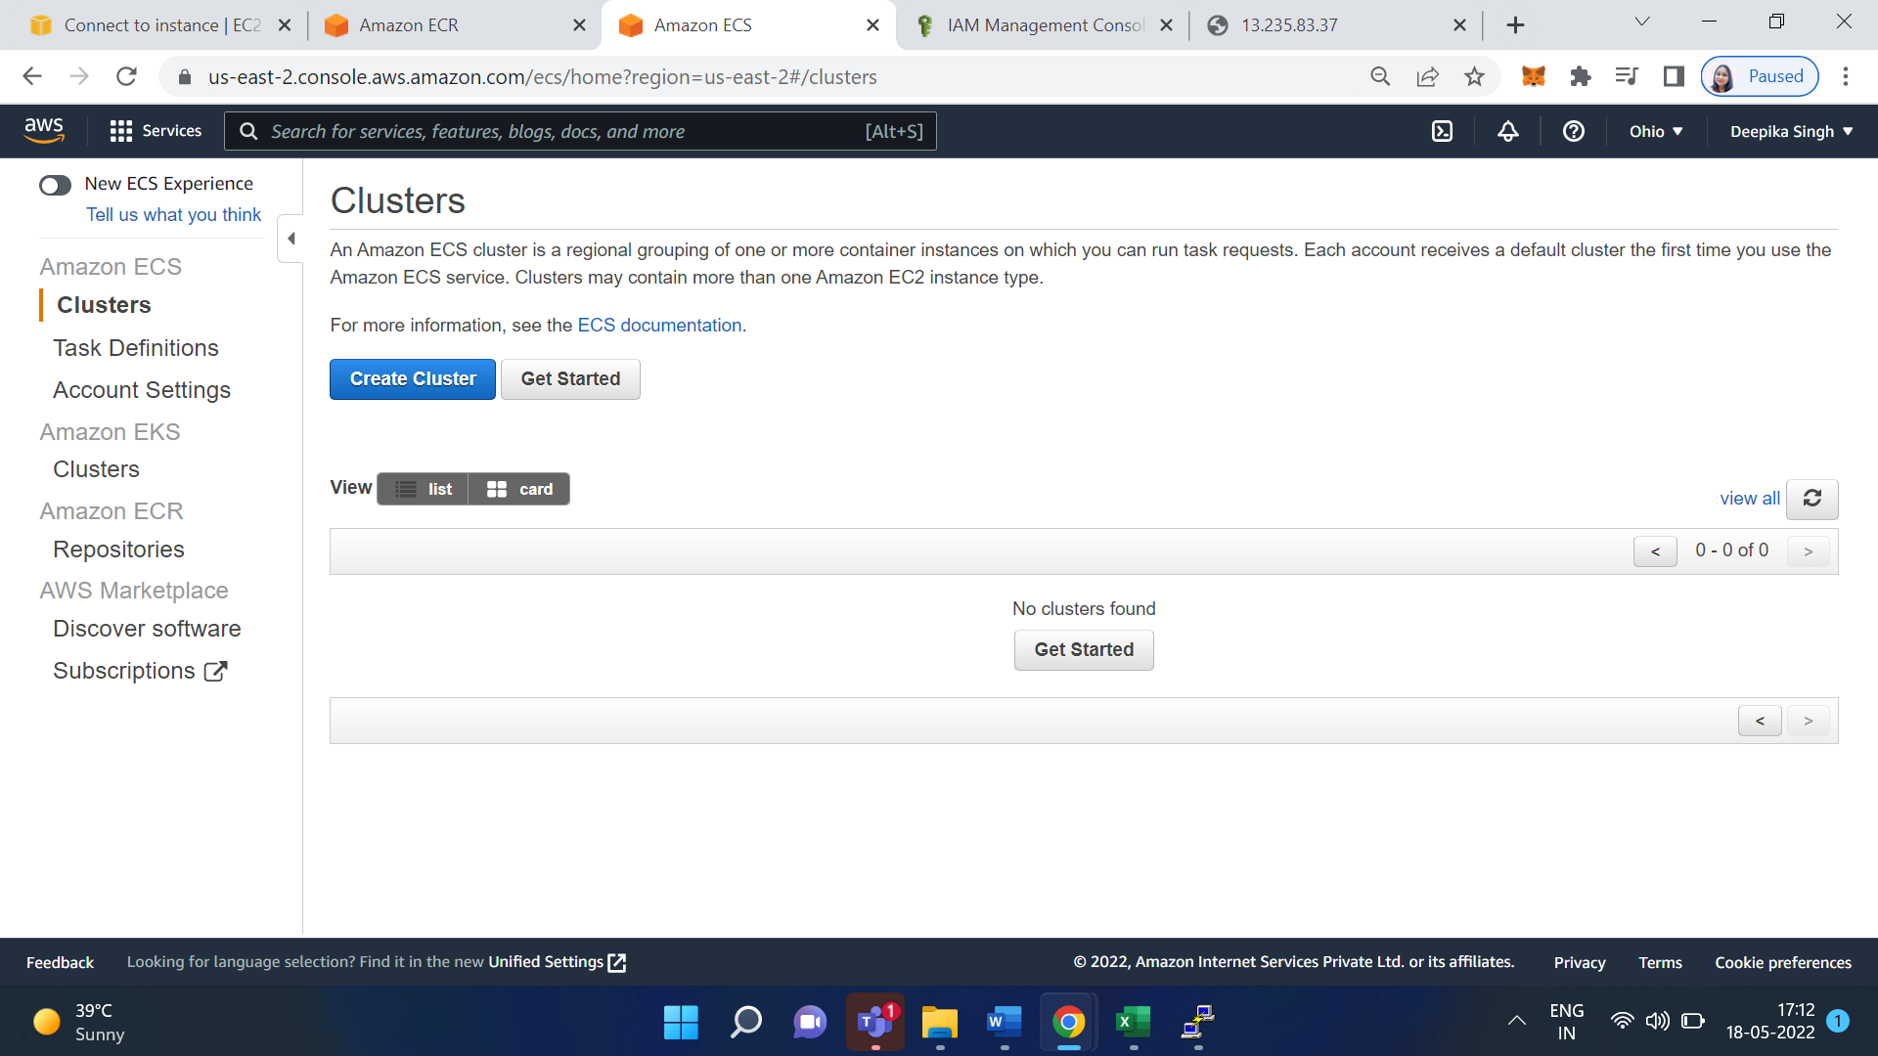

Click on Create Cluster

Select Networking only

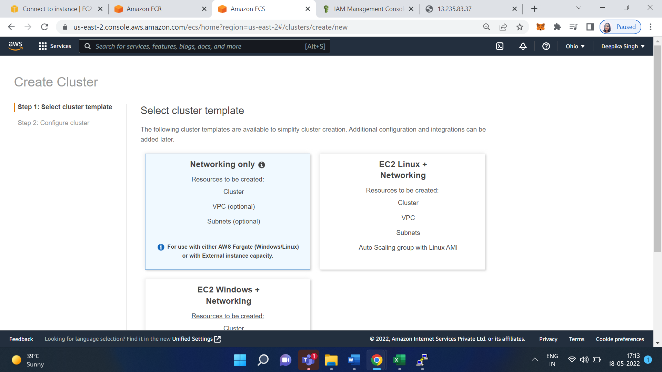

Click on Next

Give the name of the Cluster: cluster-demo

leave the other options as default

Then Click on Create

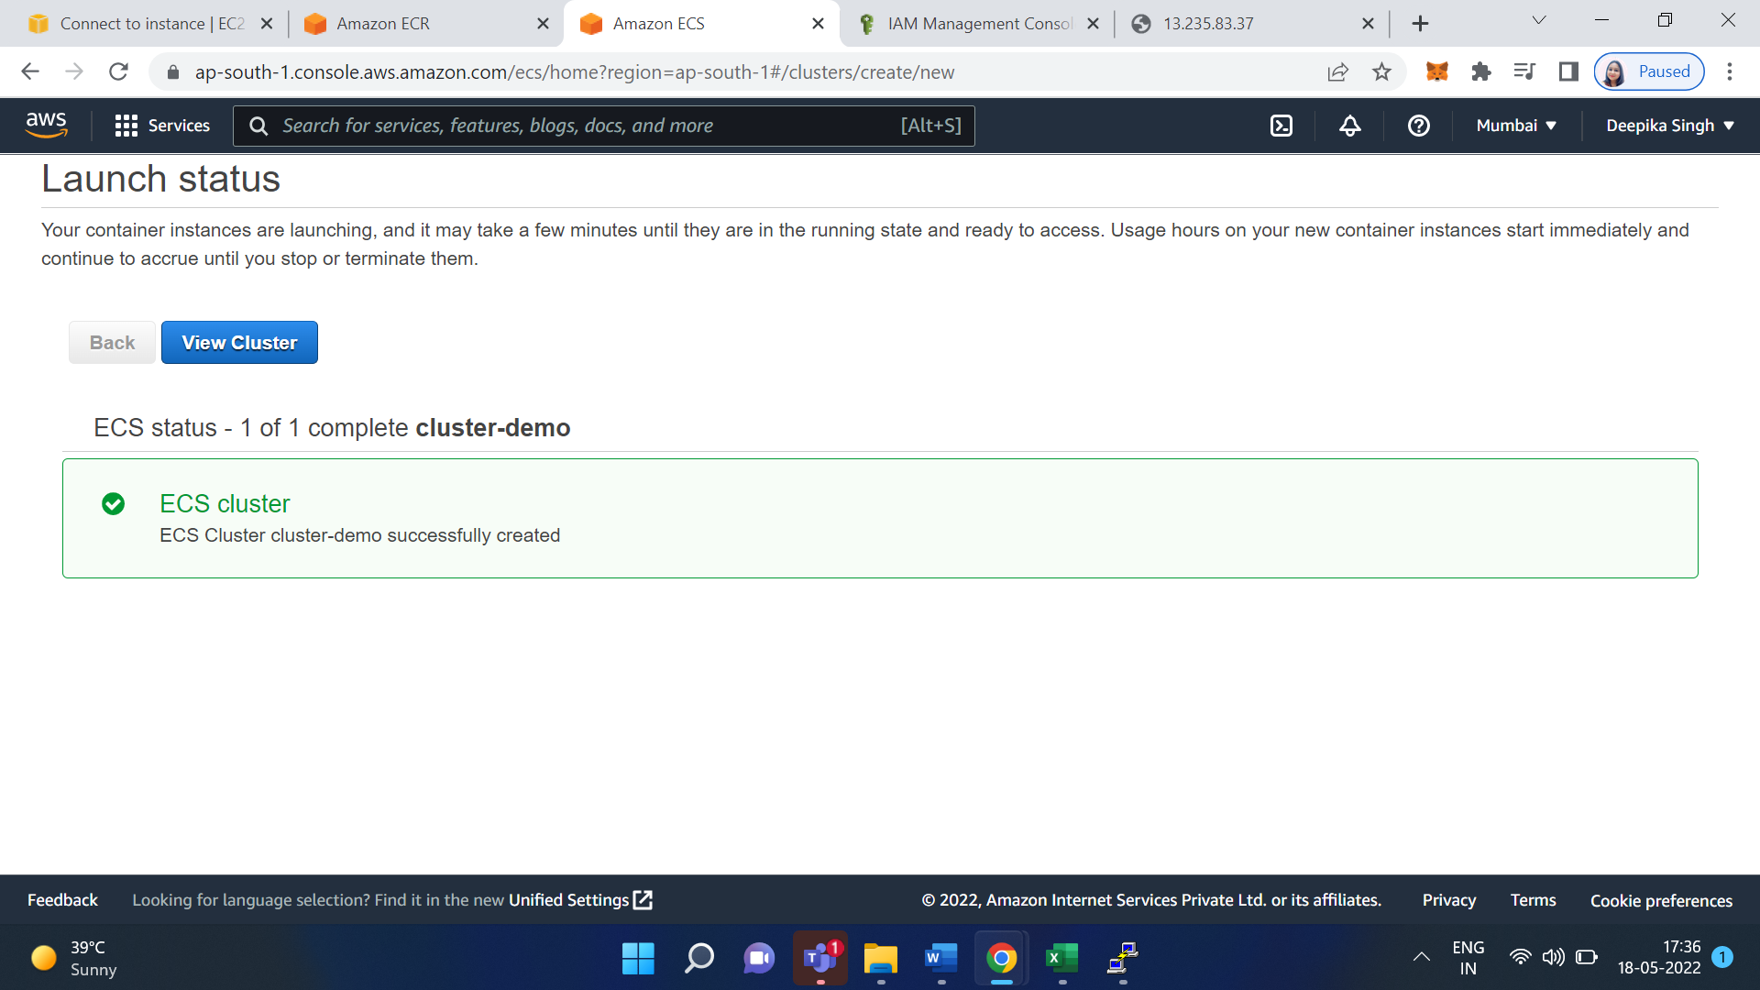

Click on View Cluster

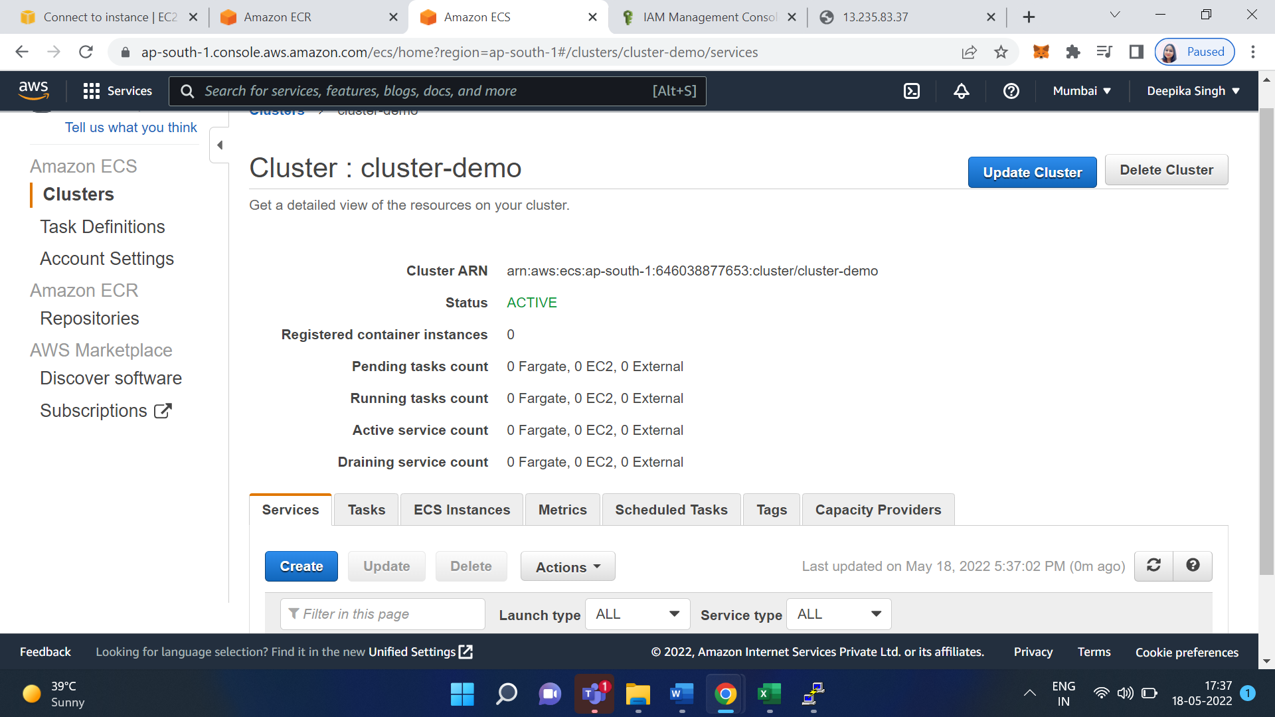

**create service**

select the cluster created in the above step

Now we have to update task

Click on the Run task under the task tab

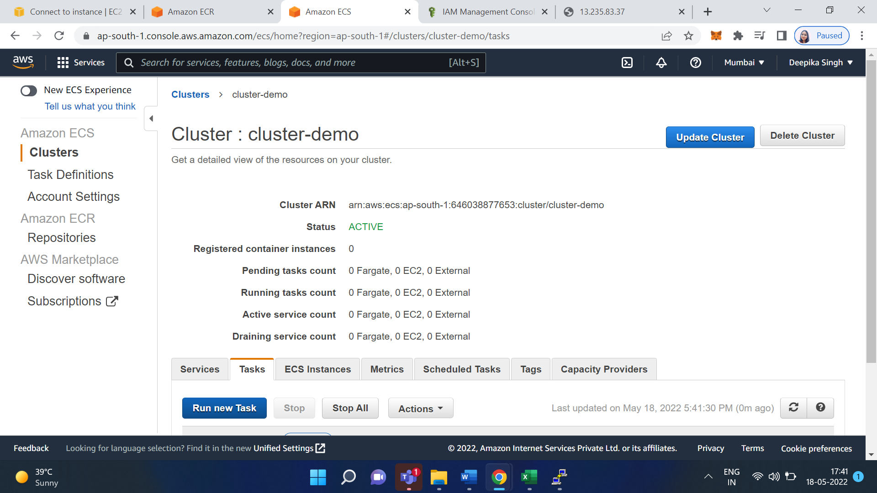

Select launch type as fargete

Select Operating system family: Linux

Select Task Definition: hello-task-demo

Select cluster VPC as default

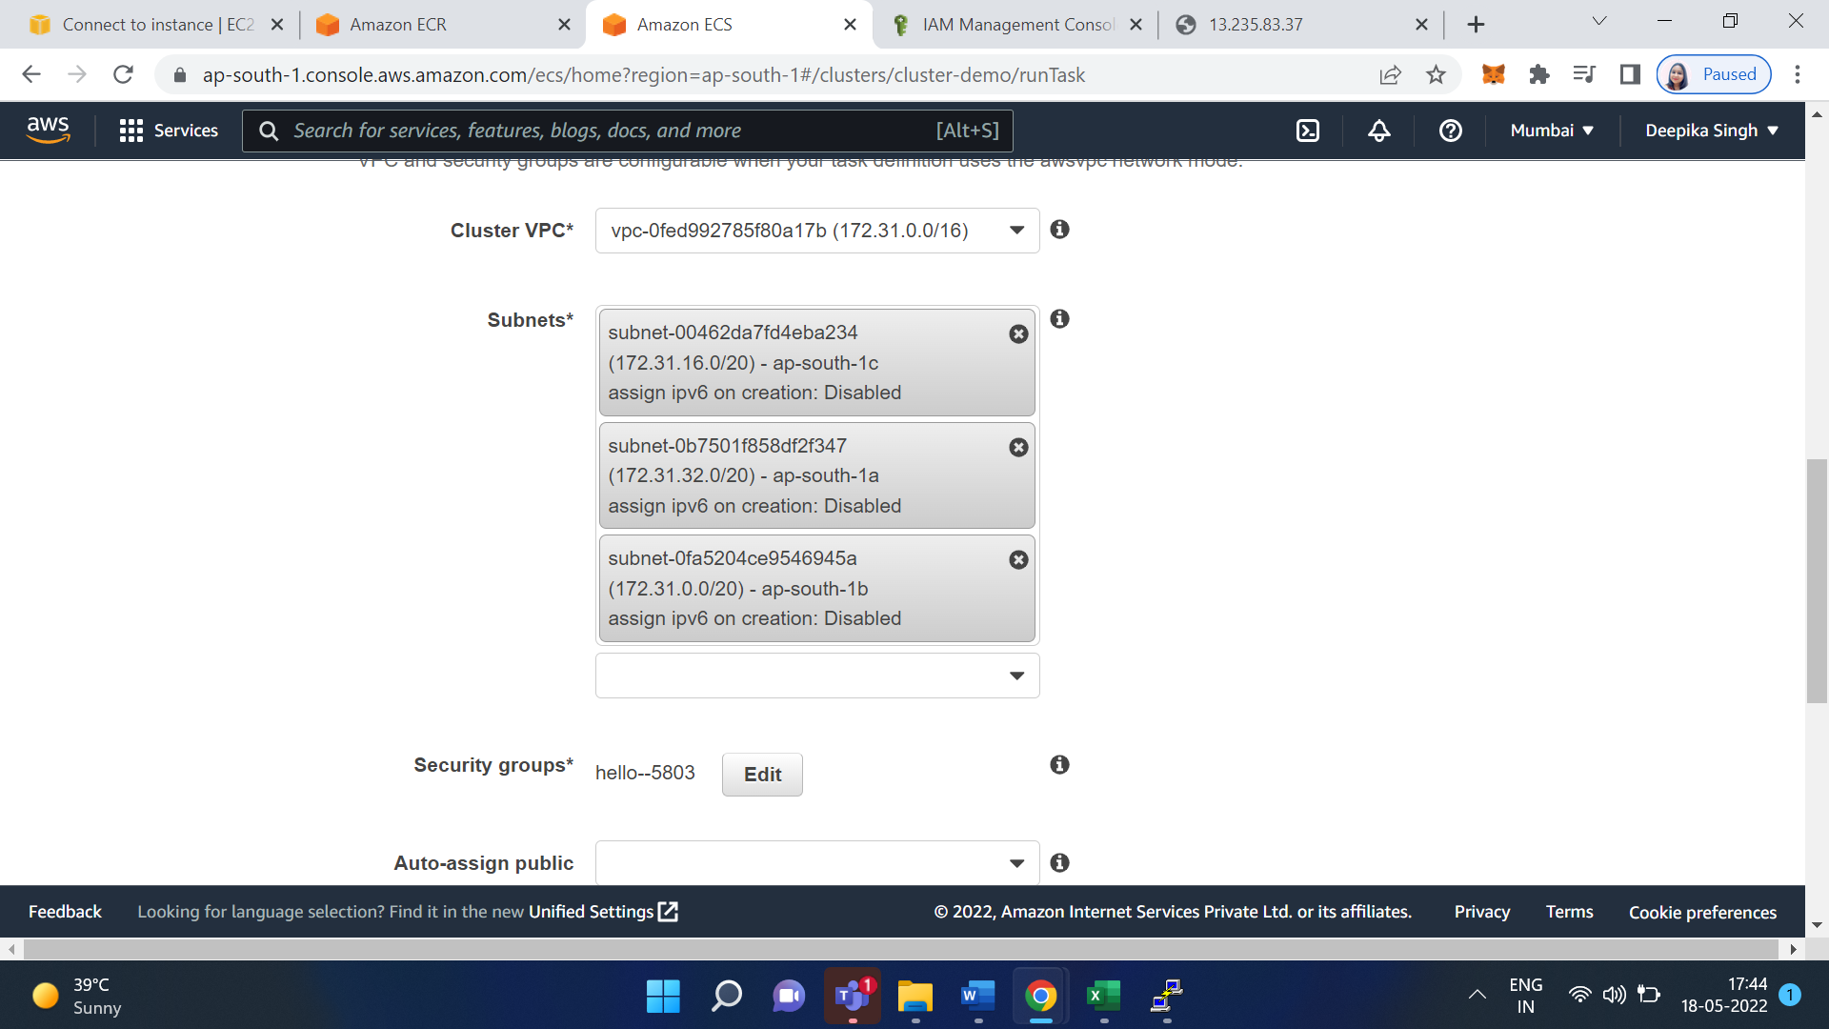

Now click on Run task

Now go to the service and click on create

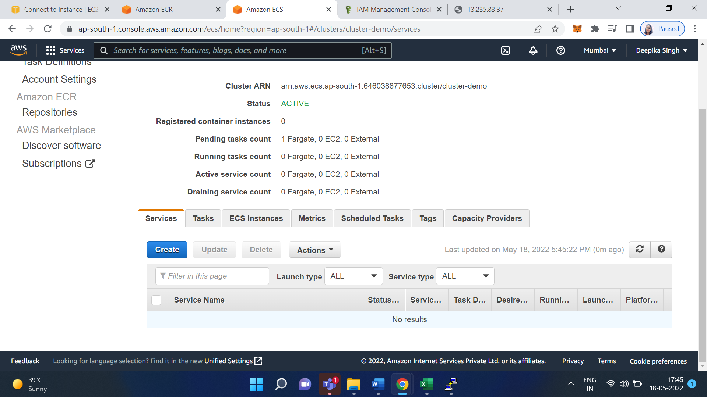

Select Launch type as FARGATE

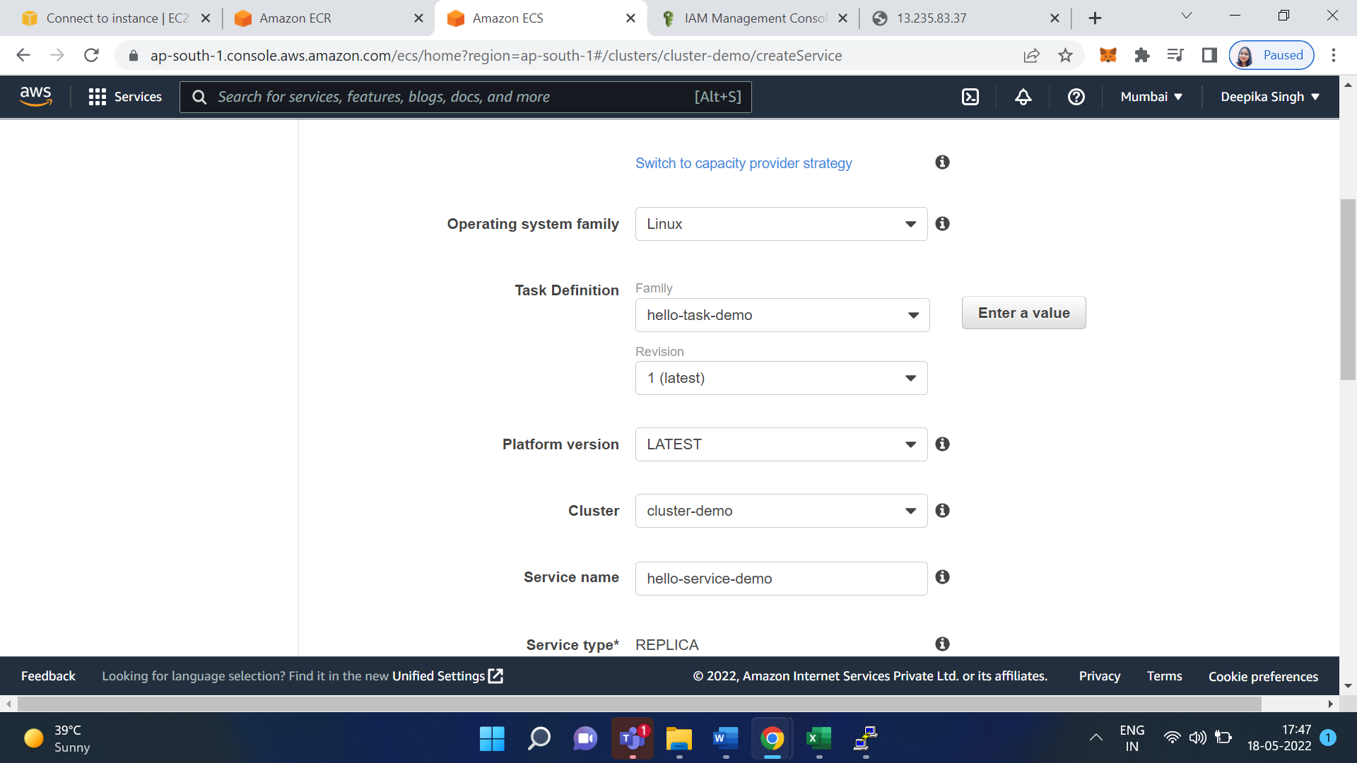

Select number of task: 1

Click on Next

Now configure Network

Select Cluster VPC and Subnets

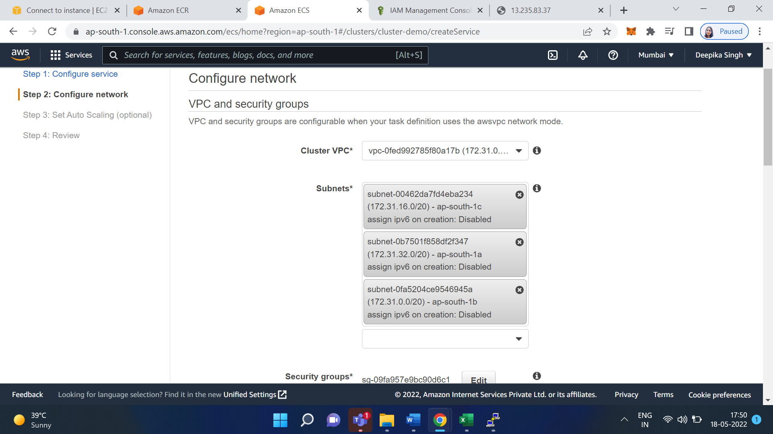

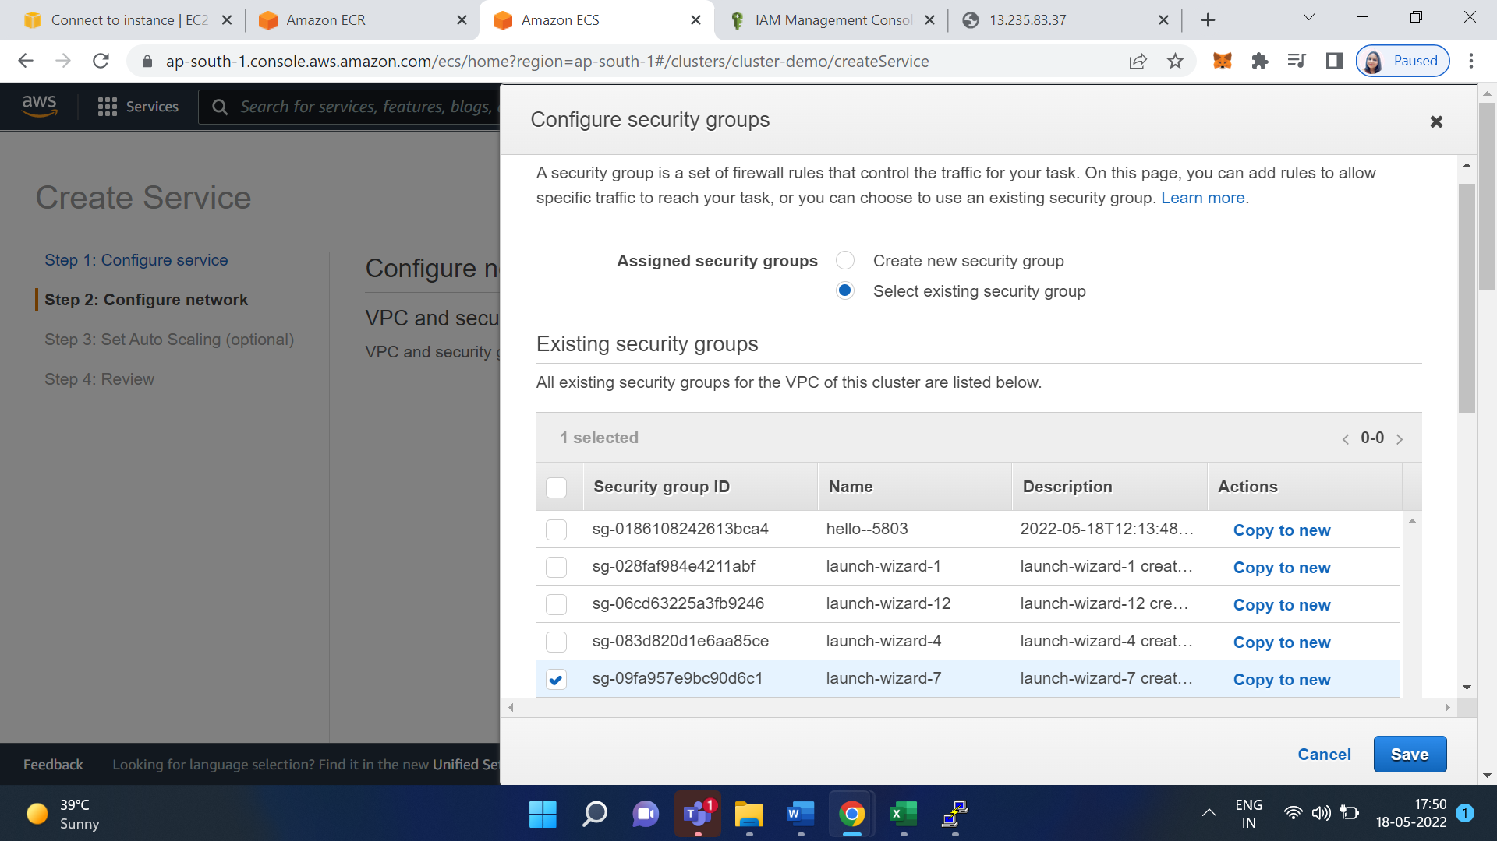

Now click on Next

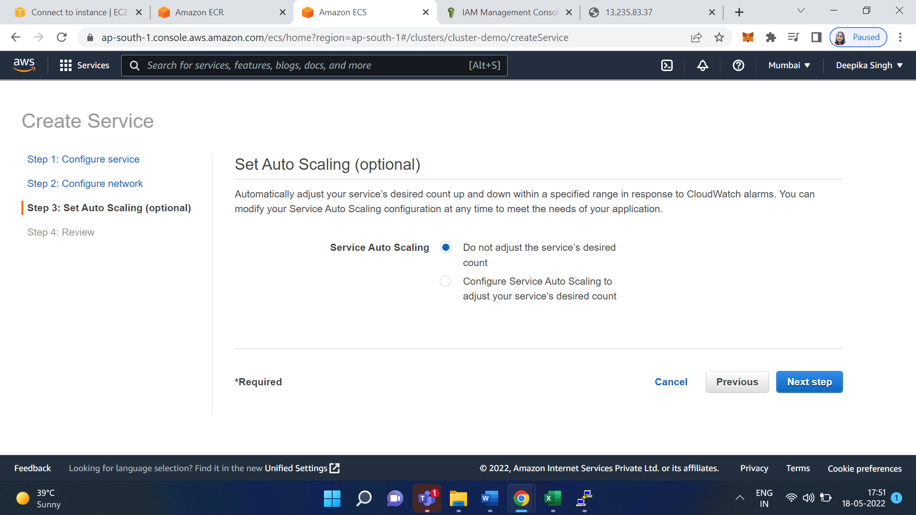

Click on Create Service

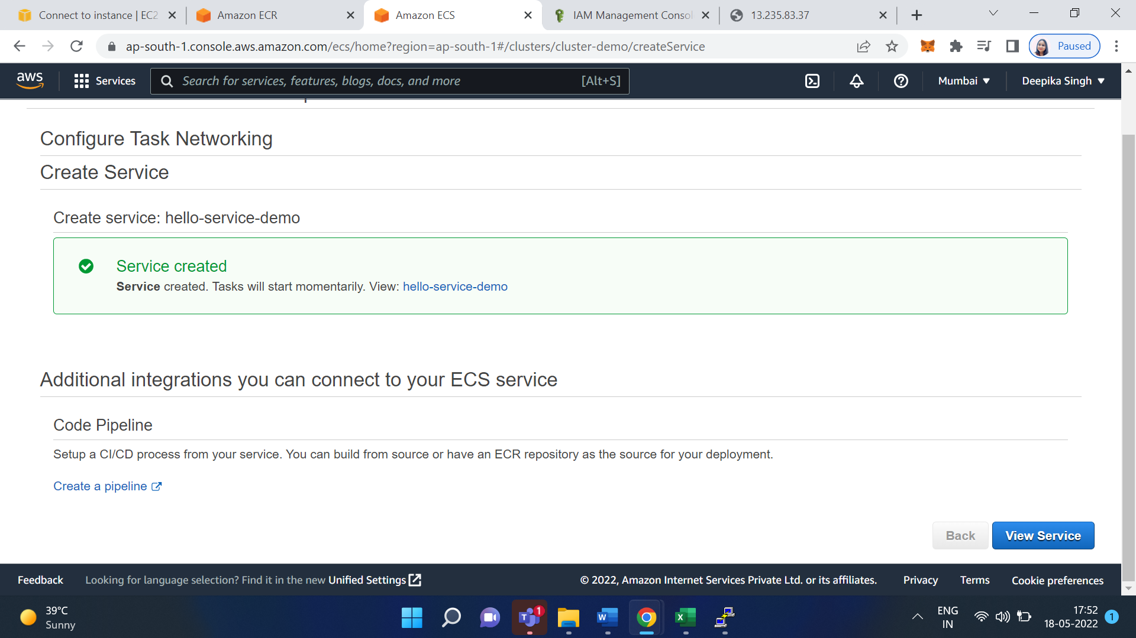

Click on View Service

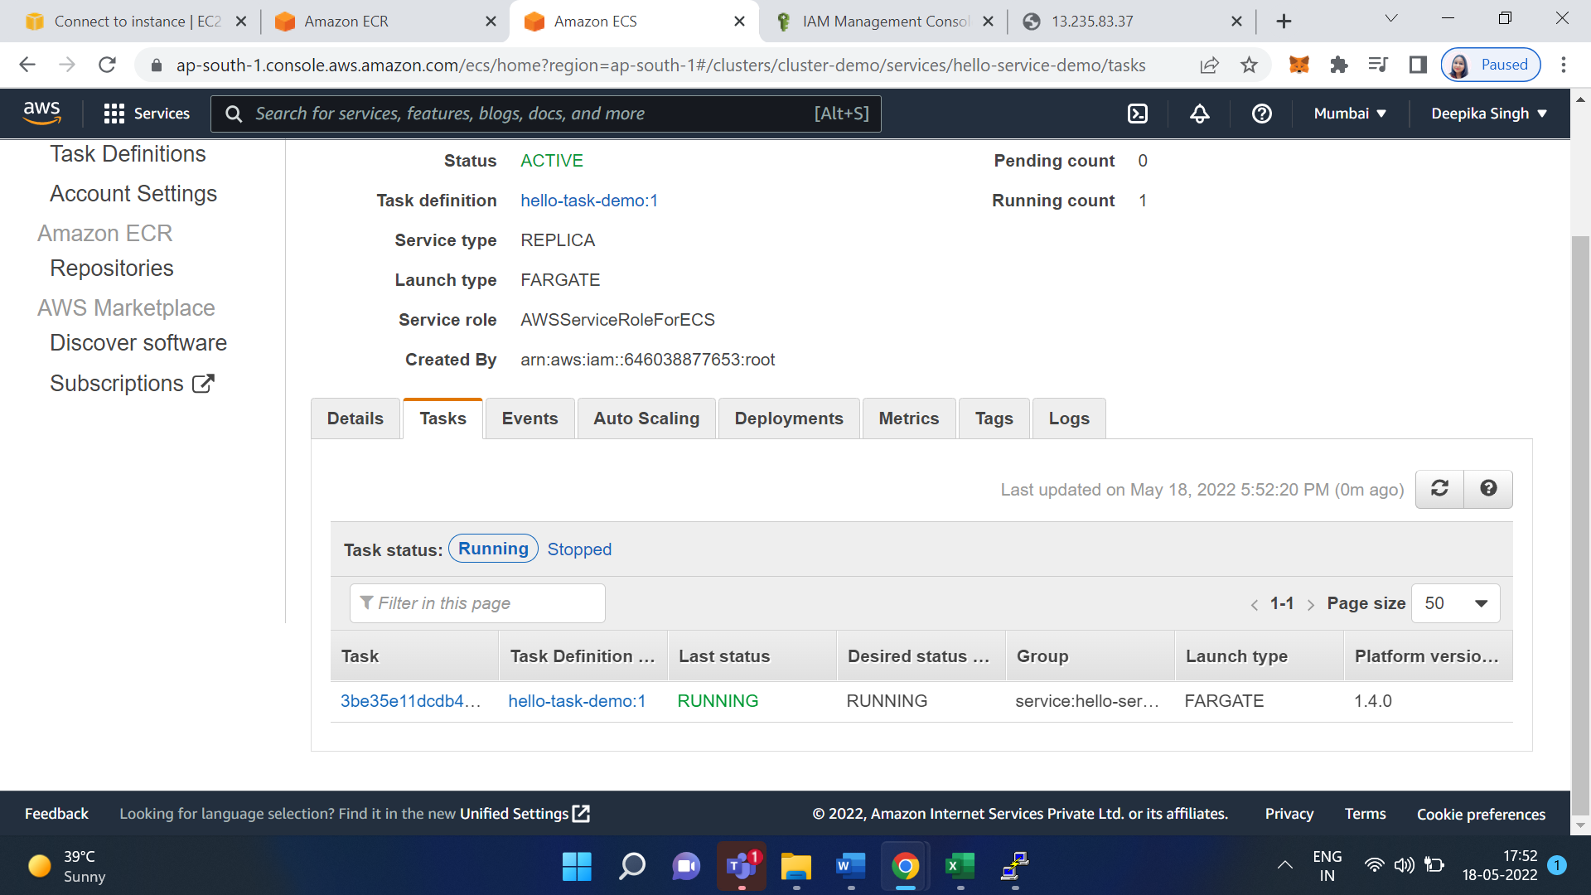

Go to the networking section of your cluster

Copy Public IP address and paste it on Browser

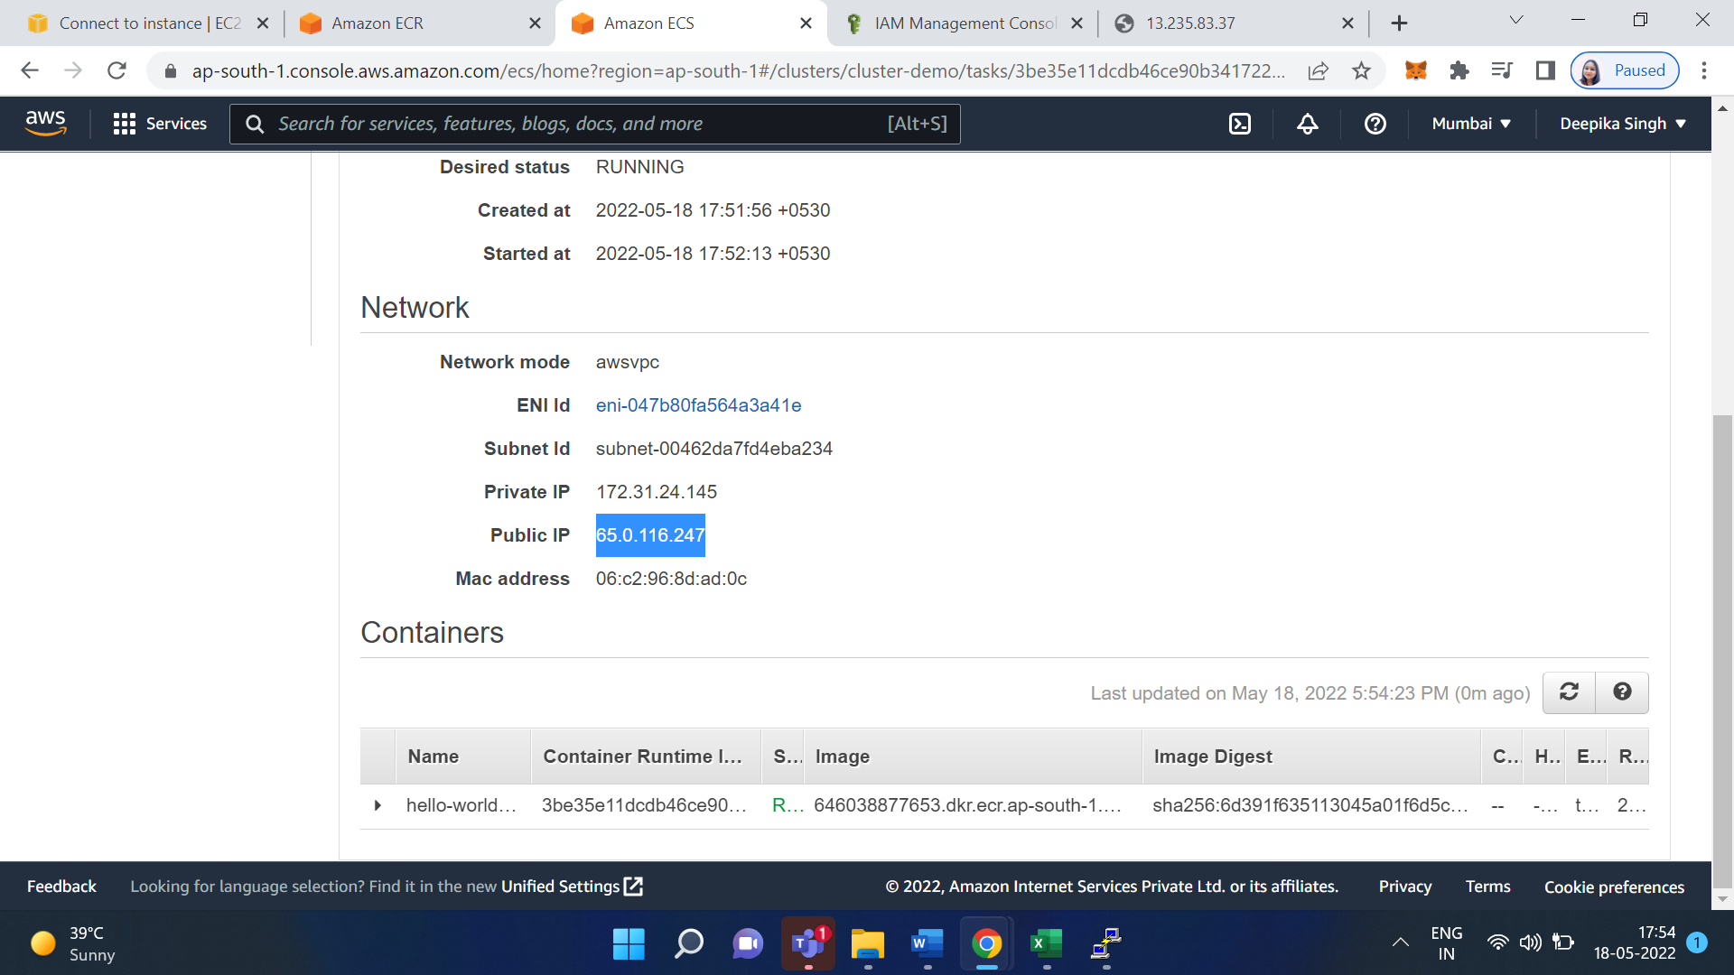

**Output/Results snippet:**

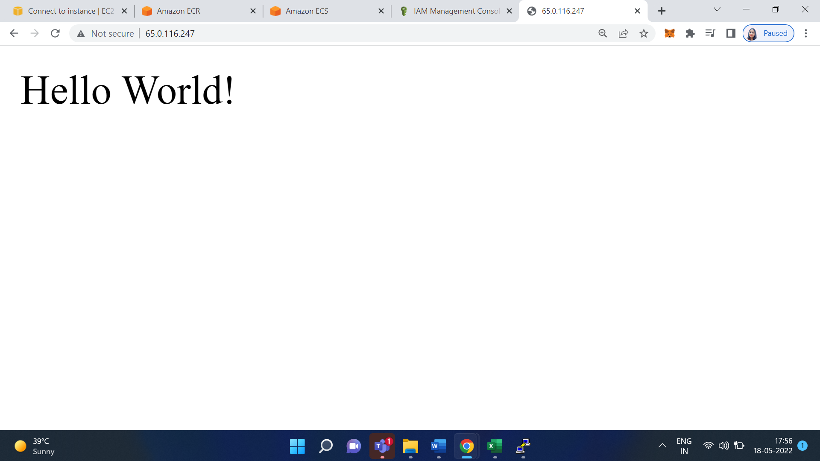

**References:**

* <https://docs.aws.amazon.com/AmazonECS/latest/userguide/create-container-image.html>
* <https://aws.amazon.com/blogs/containers/deploy-applications-on-amazon-ecs-using-docker-compose/>
* <https://aws.amazon.com/blogs/containers/deploy-applications-on-amazon-ecs-using-docker-compose/>

# 

# Activity 2

## Aim: Scale container application using Kubernetes AWS EKS service.

**Learning outcome:** Able to Build a web application on modern cloud-based architectures and services.

**Duration:** 5 hour

**List of Hardware/Software requirements:**

1. User account on AWS Cloud
2. Laptop/Computer with Windows OS/Ubuntu
3. AWS CLI for Windows/Linux
4. Kubectl for Windows/Linux

**Code/Program/Procedure (with comments):**

Amazon Elastic Container Service for Kubernetes (EKS) is a cloud-based container management service that natively integrates with Kubernetes to deploy applications.

Login to your AWS account

Search Elastic Kubernetes Service.

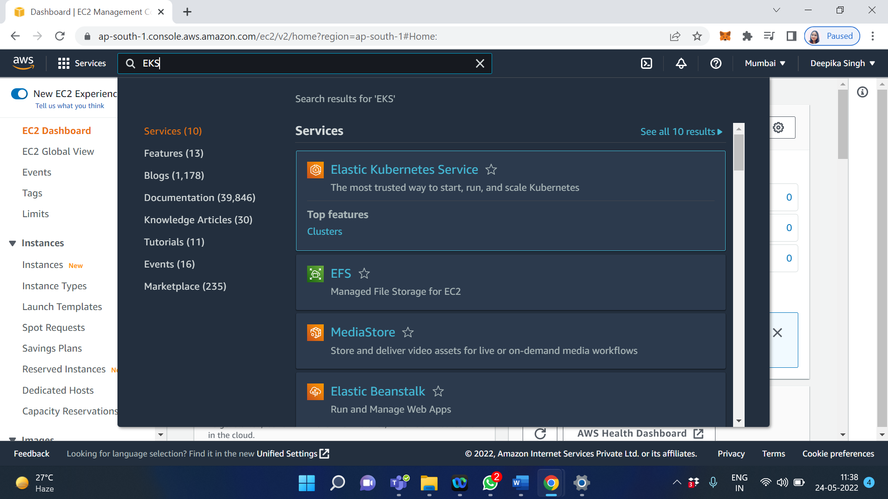

Create a Cluster

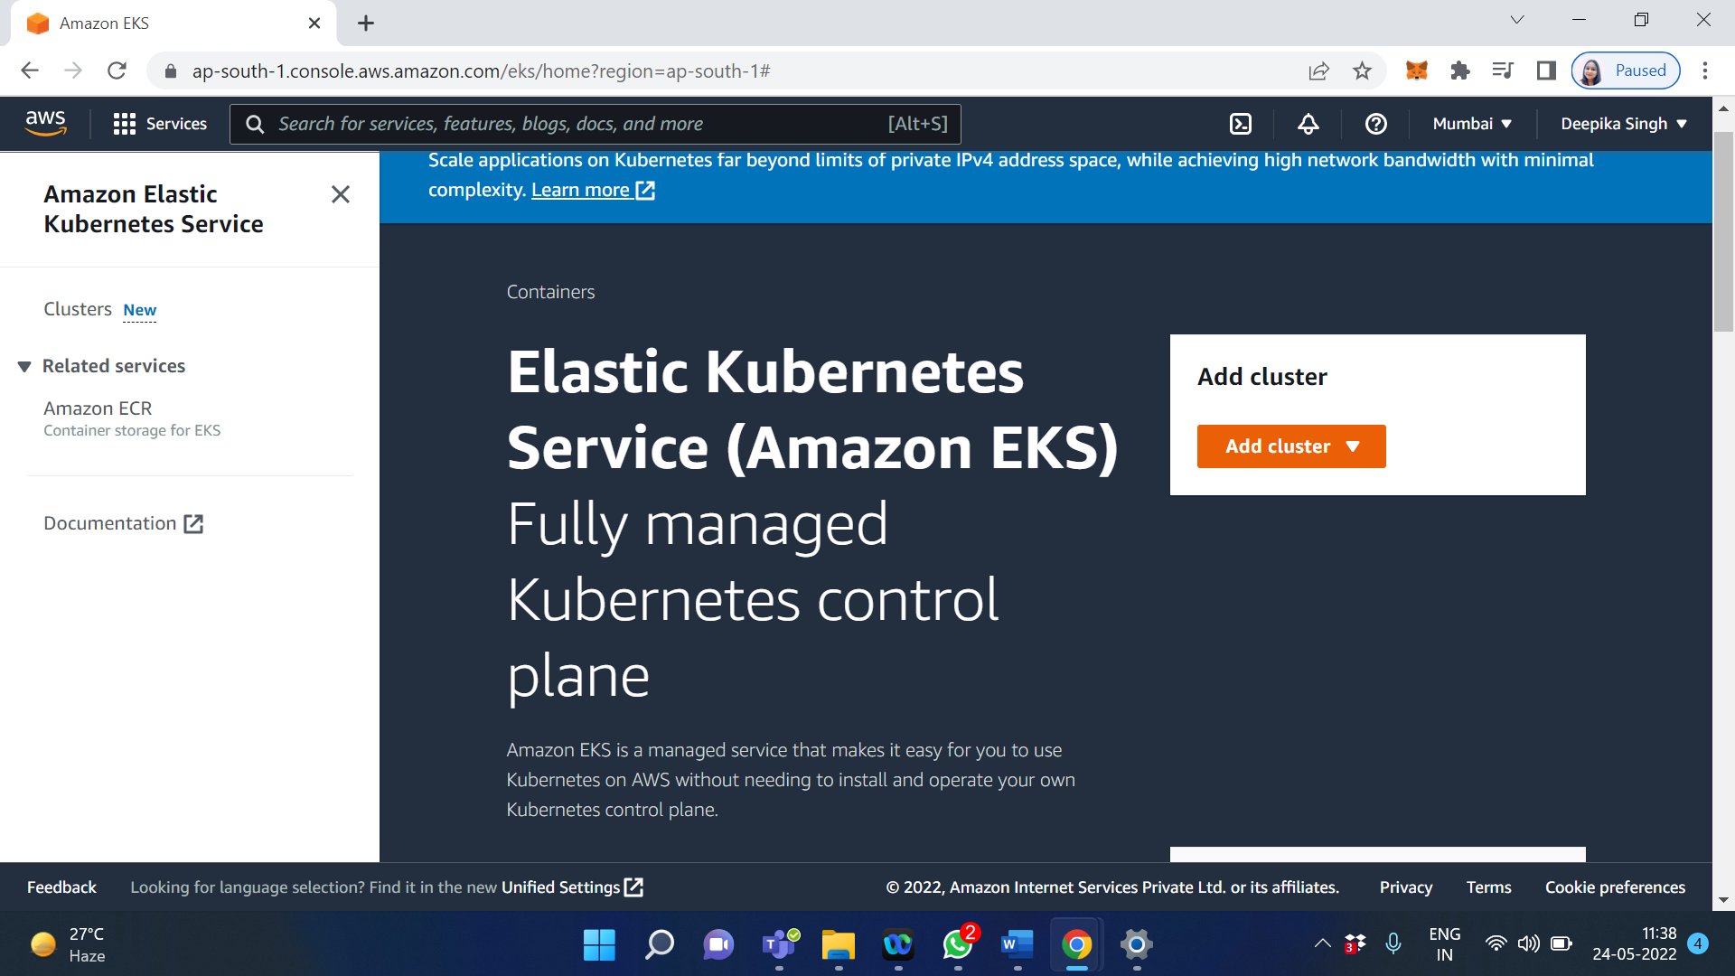

Click on Add cluster

Enter the name of the cluster

Select the default kubernetes version

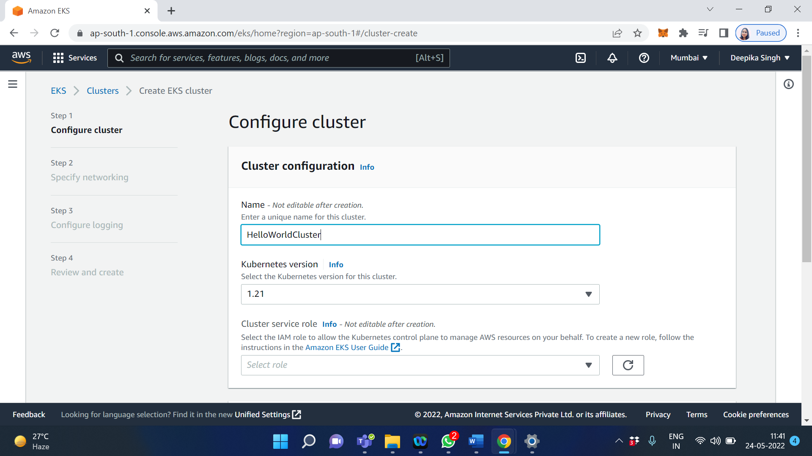

Create a cluster service role – [Click here to create EKS cluster IAM role](https://docs.aws.amazon.com/eks/latest/userguide/service_IAM_role.html%23create-service-role)

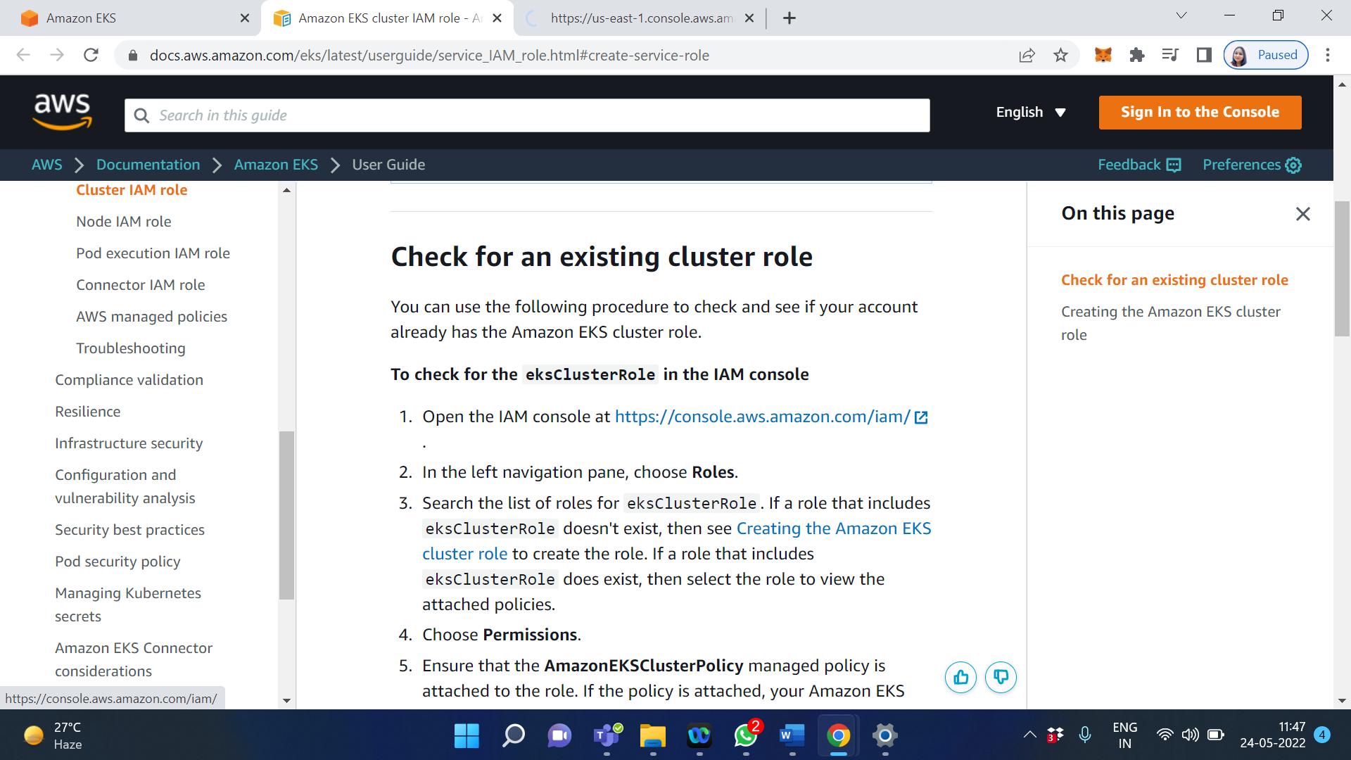

Click on Creating the Amazon EKS cluster role

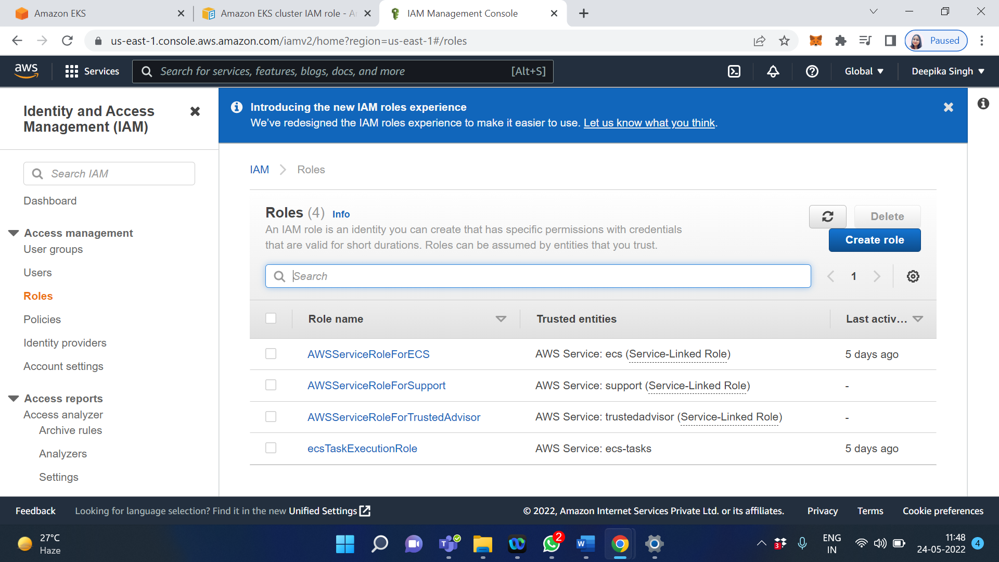

Click on Create role

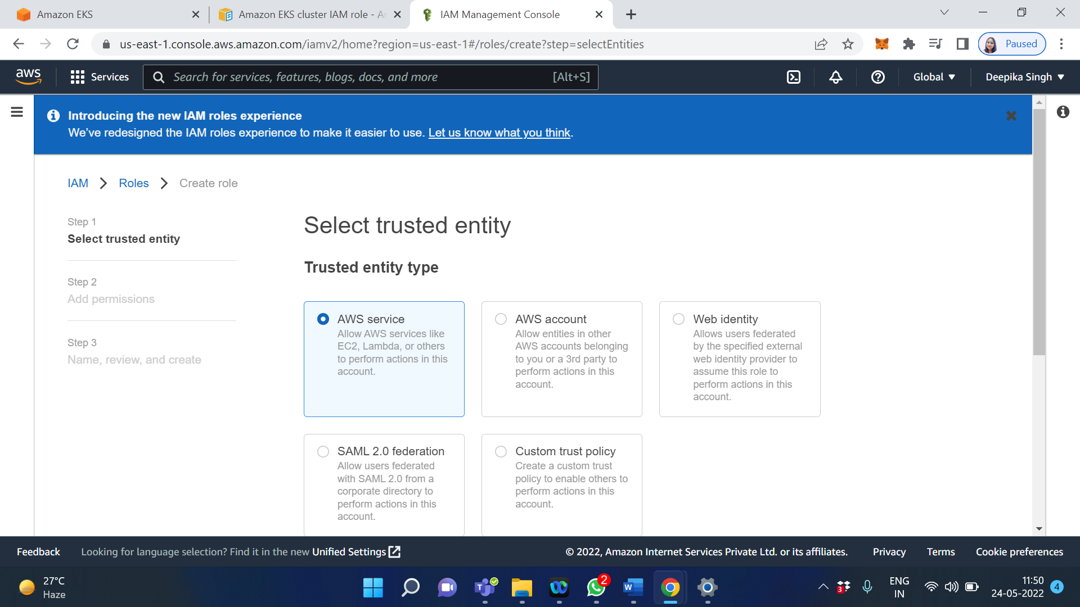

Scroll down and Select EKS from Use cases for other AWS services

Within EKS select EKS cluster

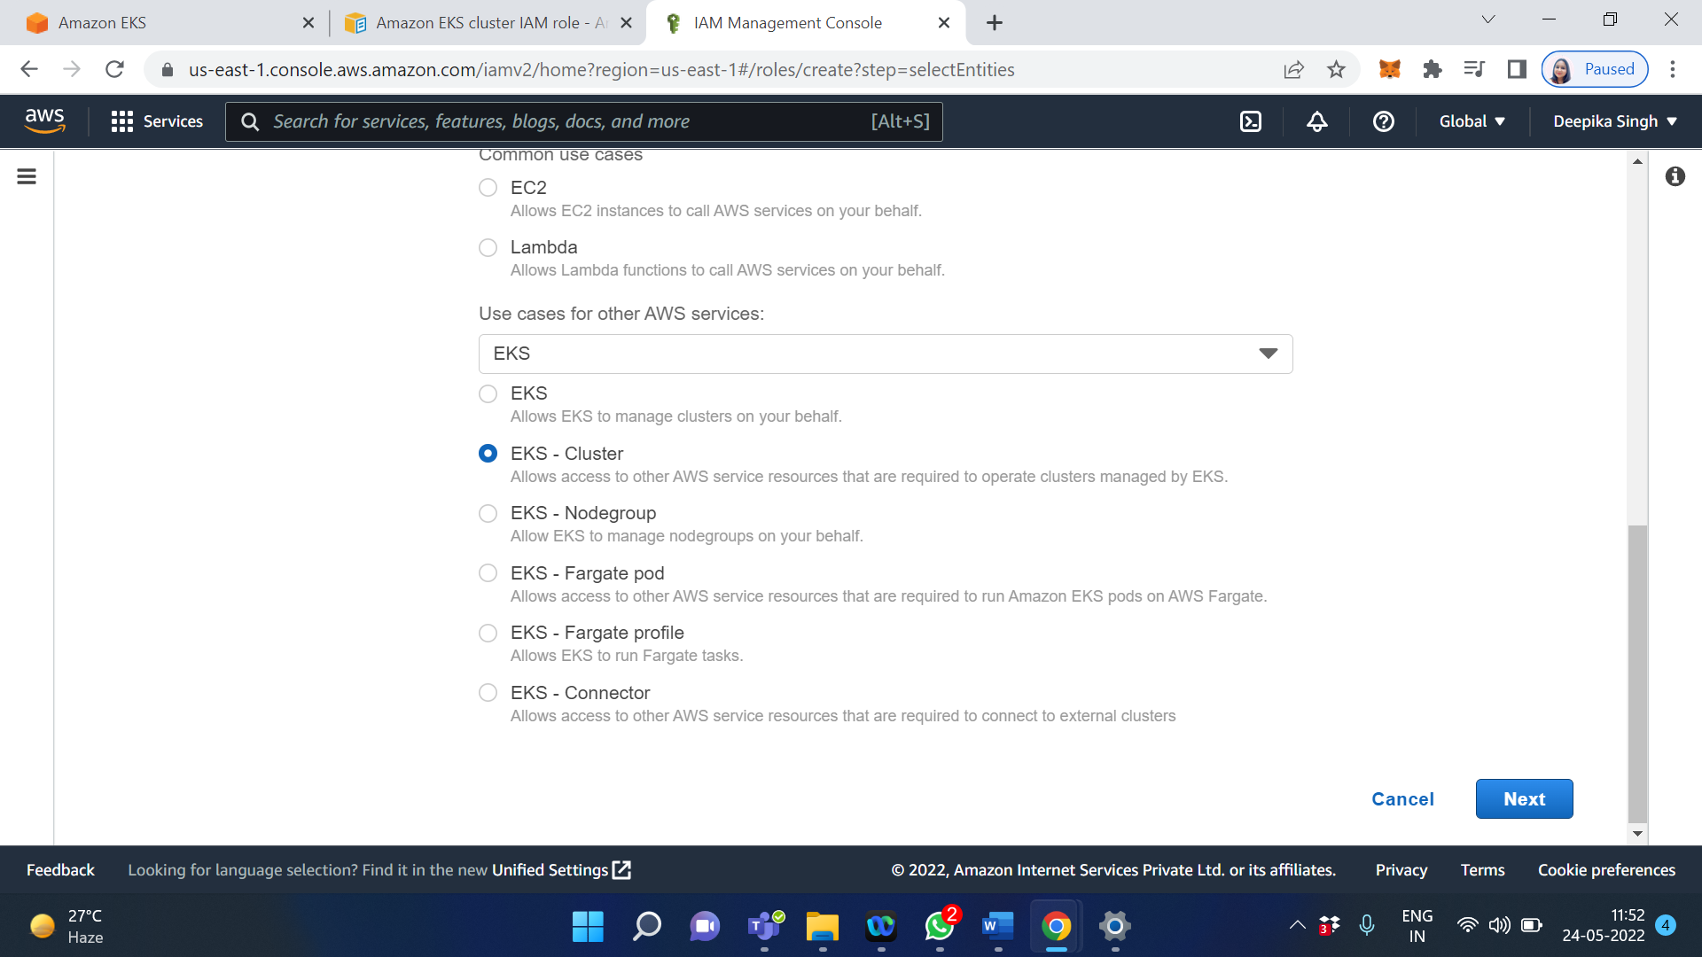

Click on Next

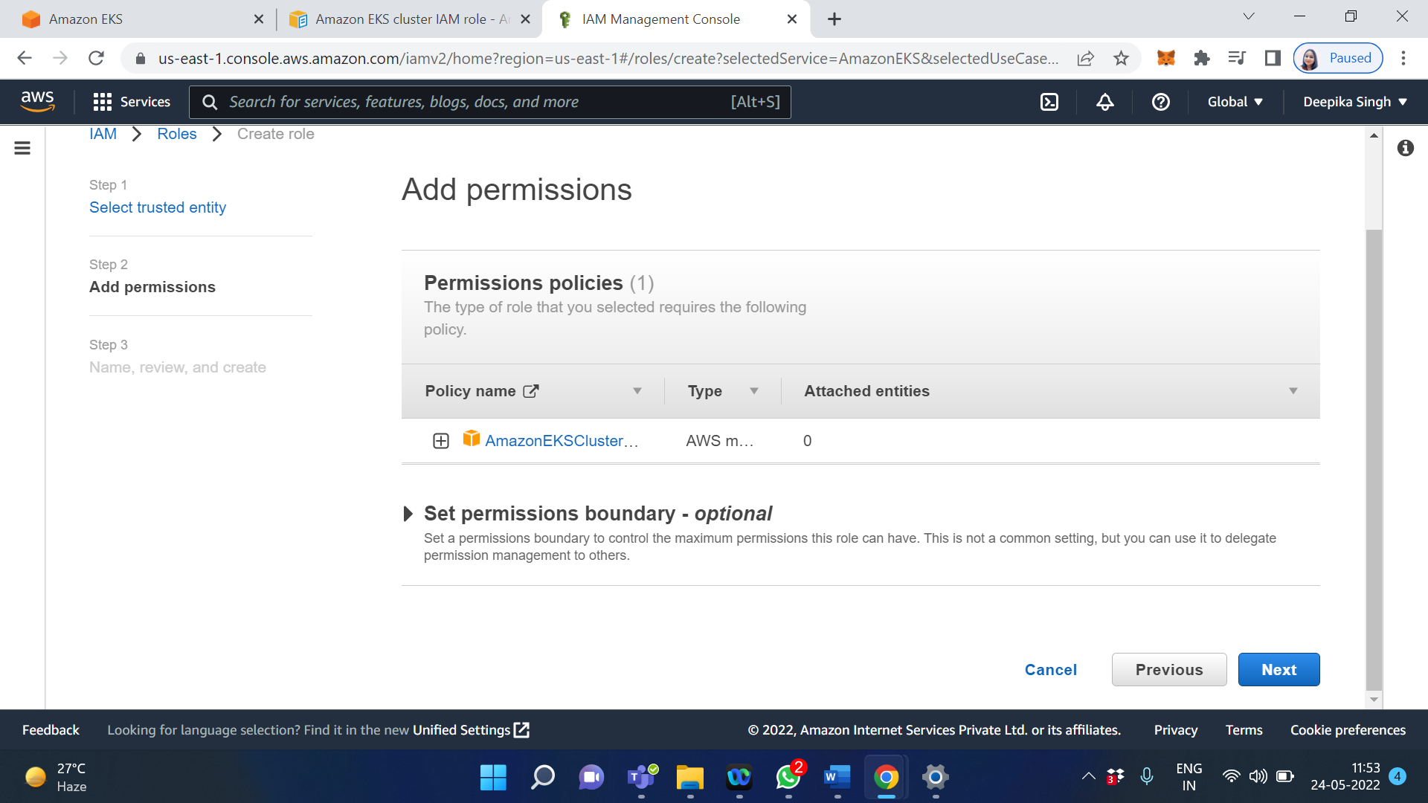

Click on Next

Enter the Role name

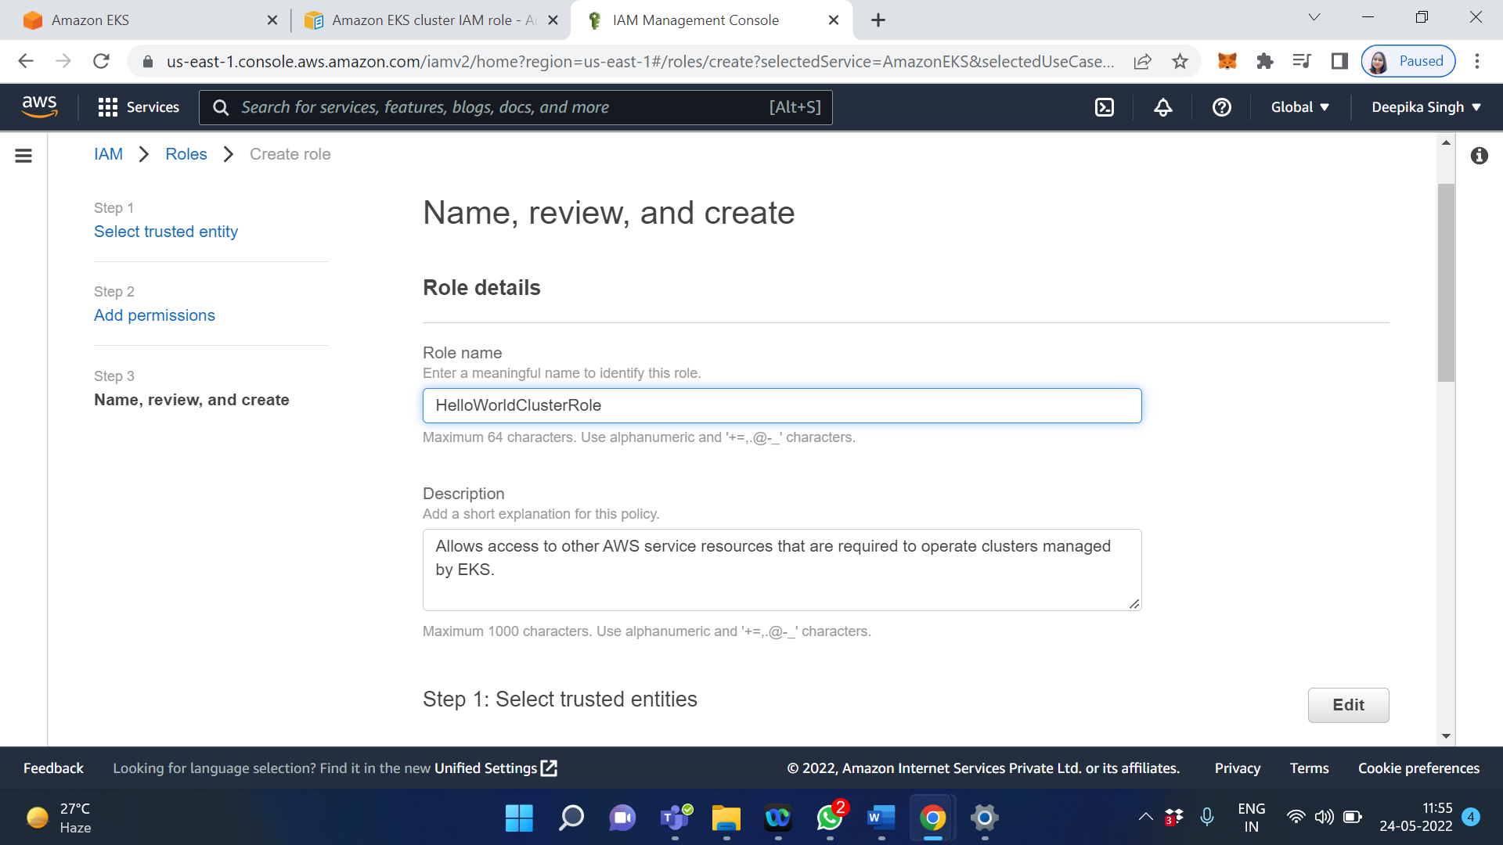

Click on Create Role

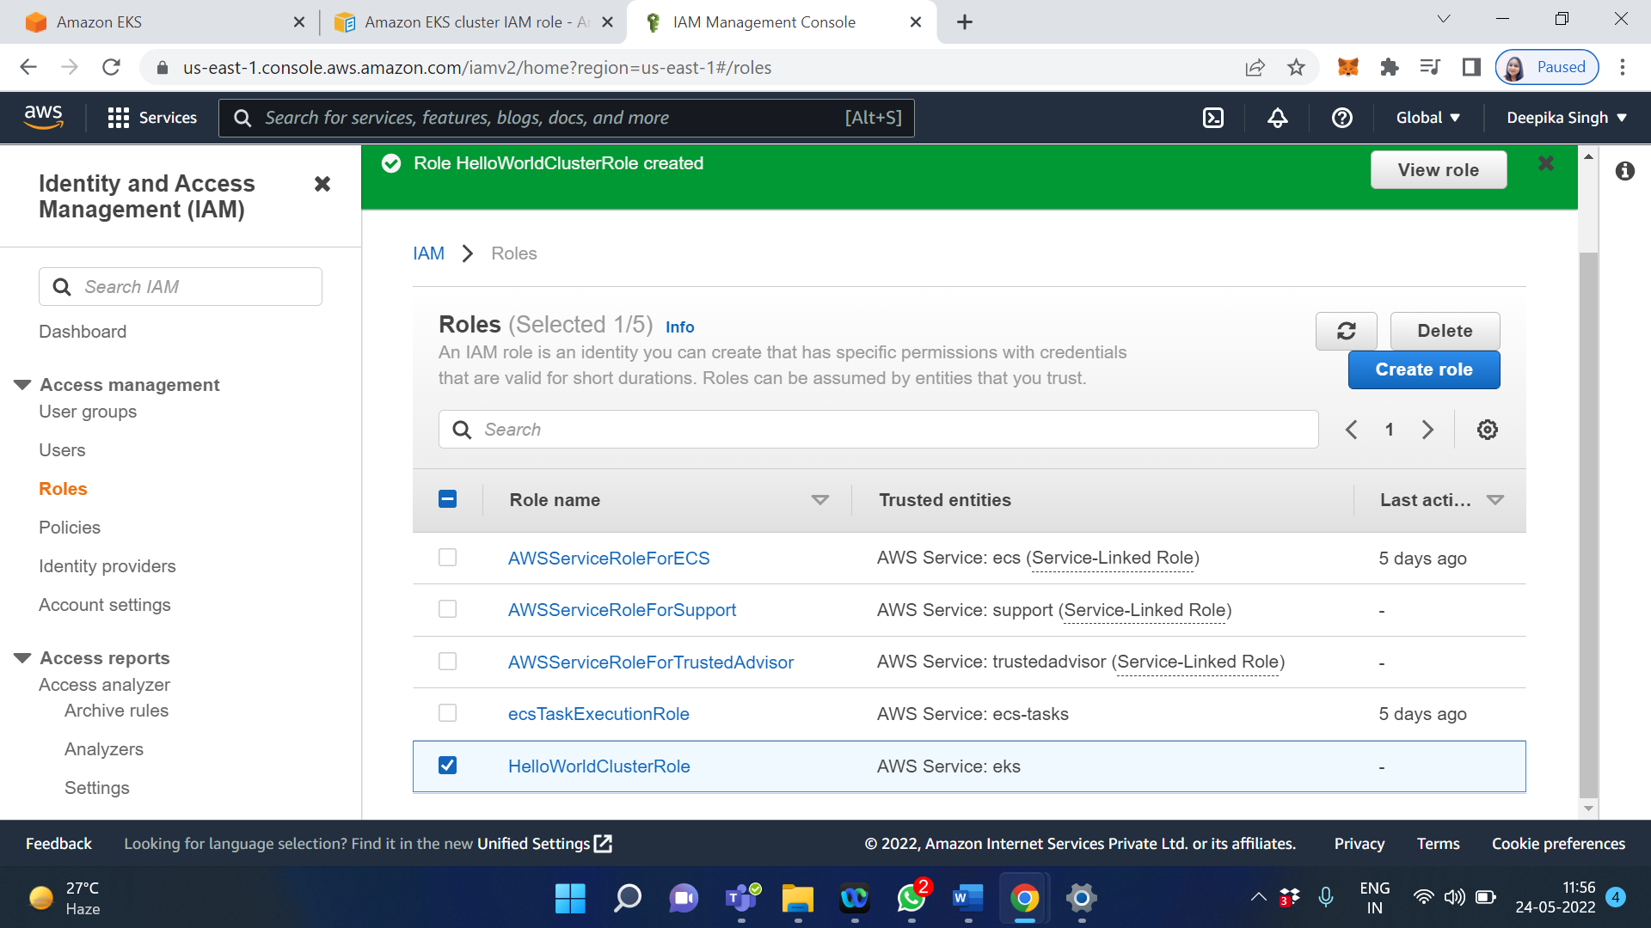

Now goto the Amazon EKS

Refresh the Cluster service role

Select HelloWorldClusterRole

Click on Next

No need to change anything in Specify networking

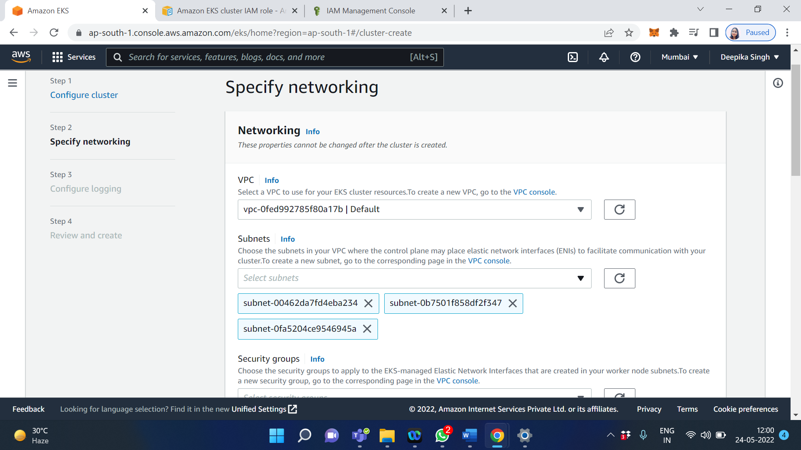

Click on Next

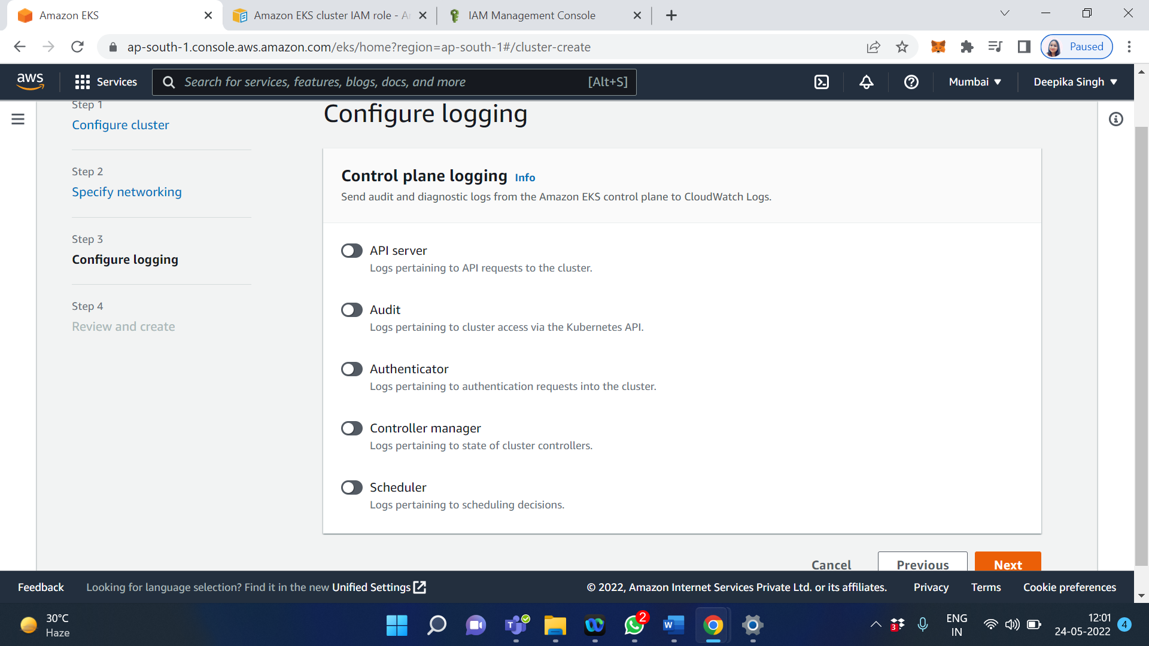

Click on Next

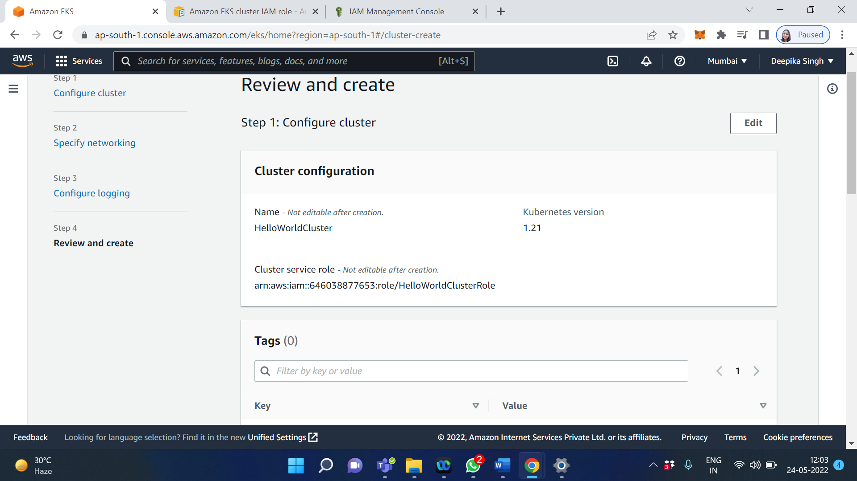

Now review your cluster and click on Create

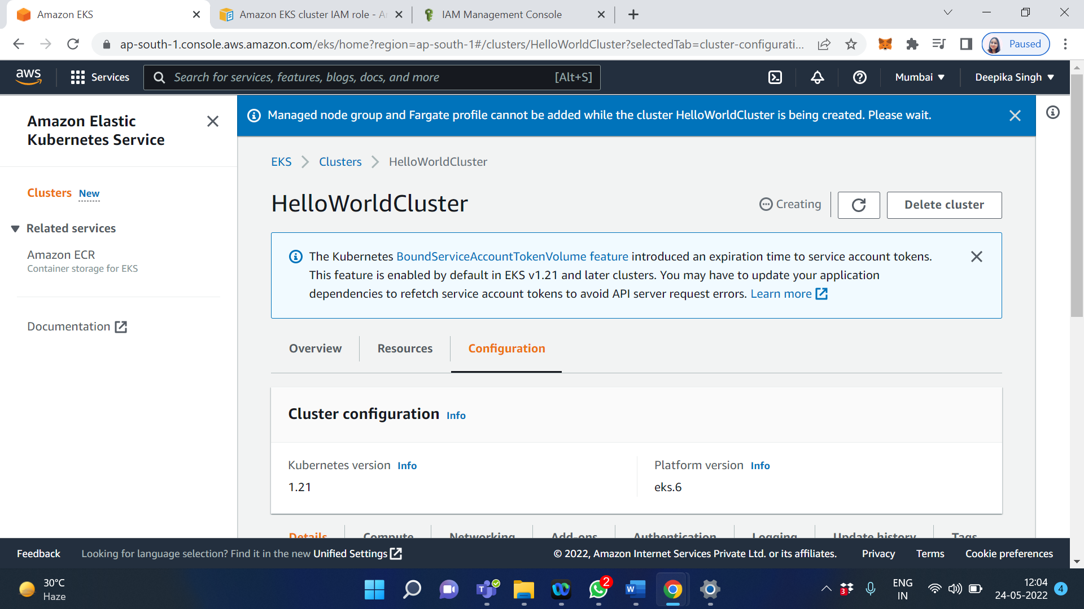

It will take 8-10 min to create a cluster

Now It’s Active

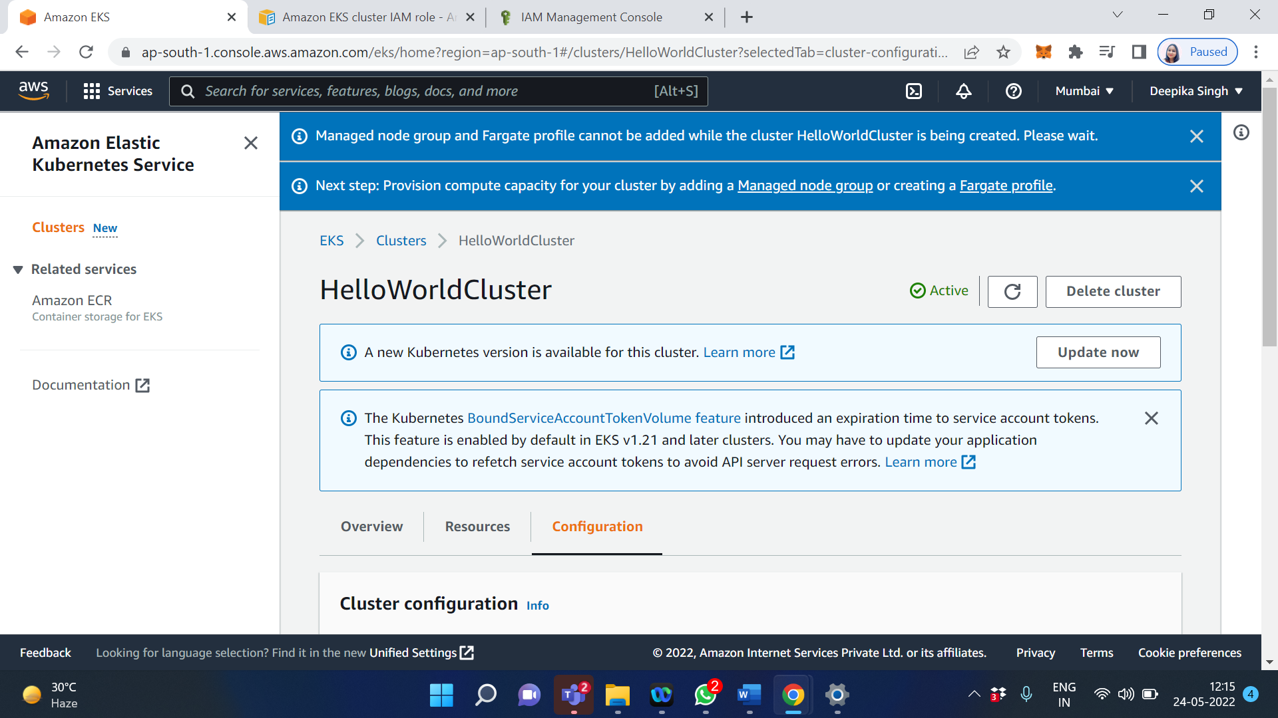

Download AWS command line interface: [Click here to download AWS CLI](https://awscli.amazonaws.com/AWSCLIV2.msi)

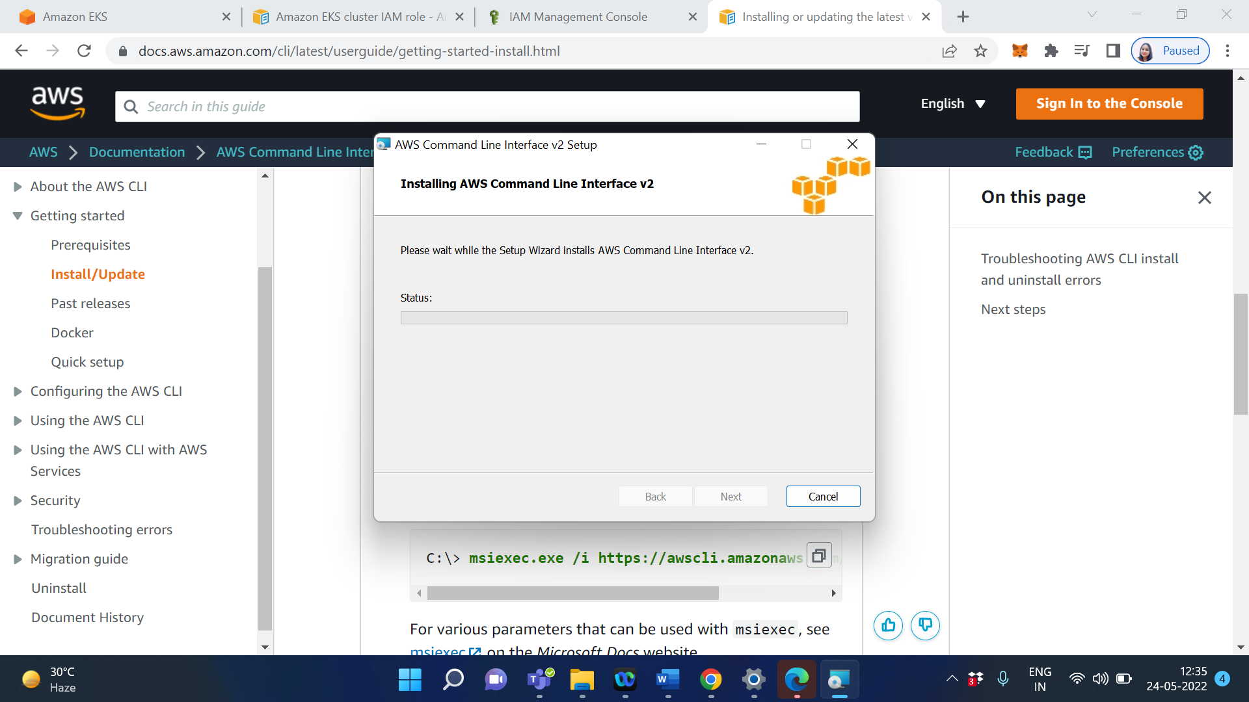

Open cmd

Type aws –version

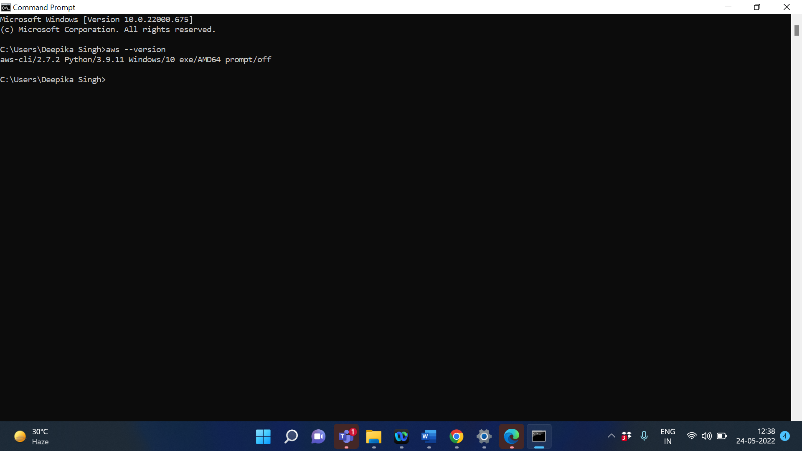

Click on Security credential

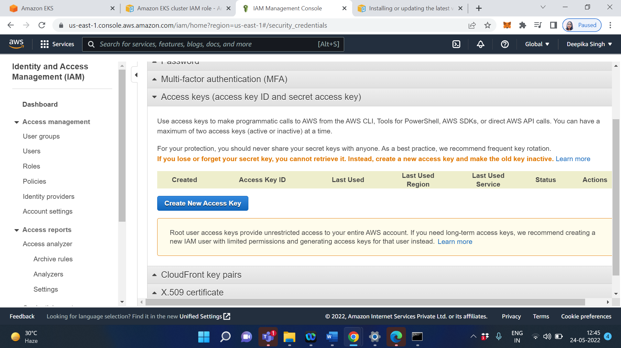

Click on Create New Access Key

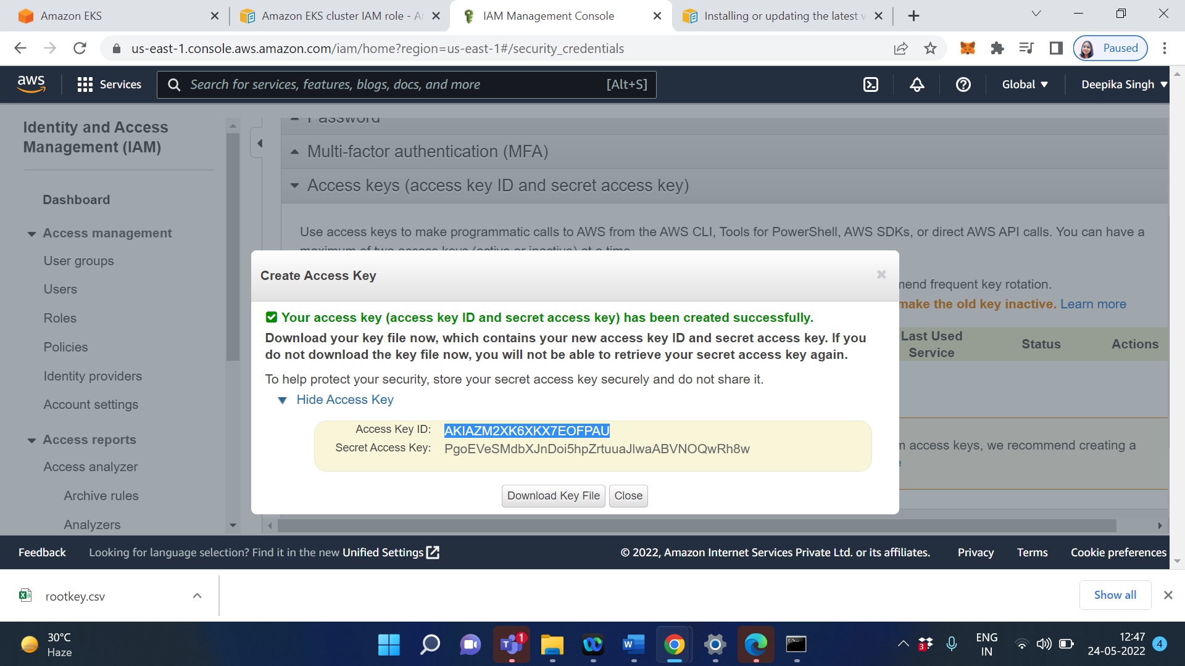

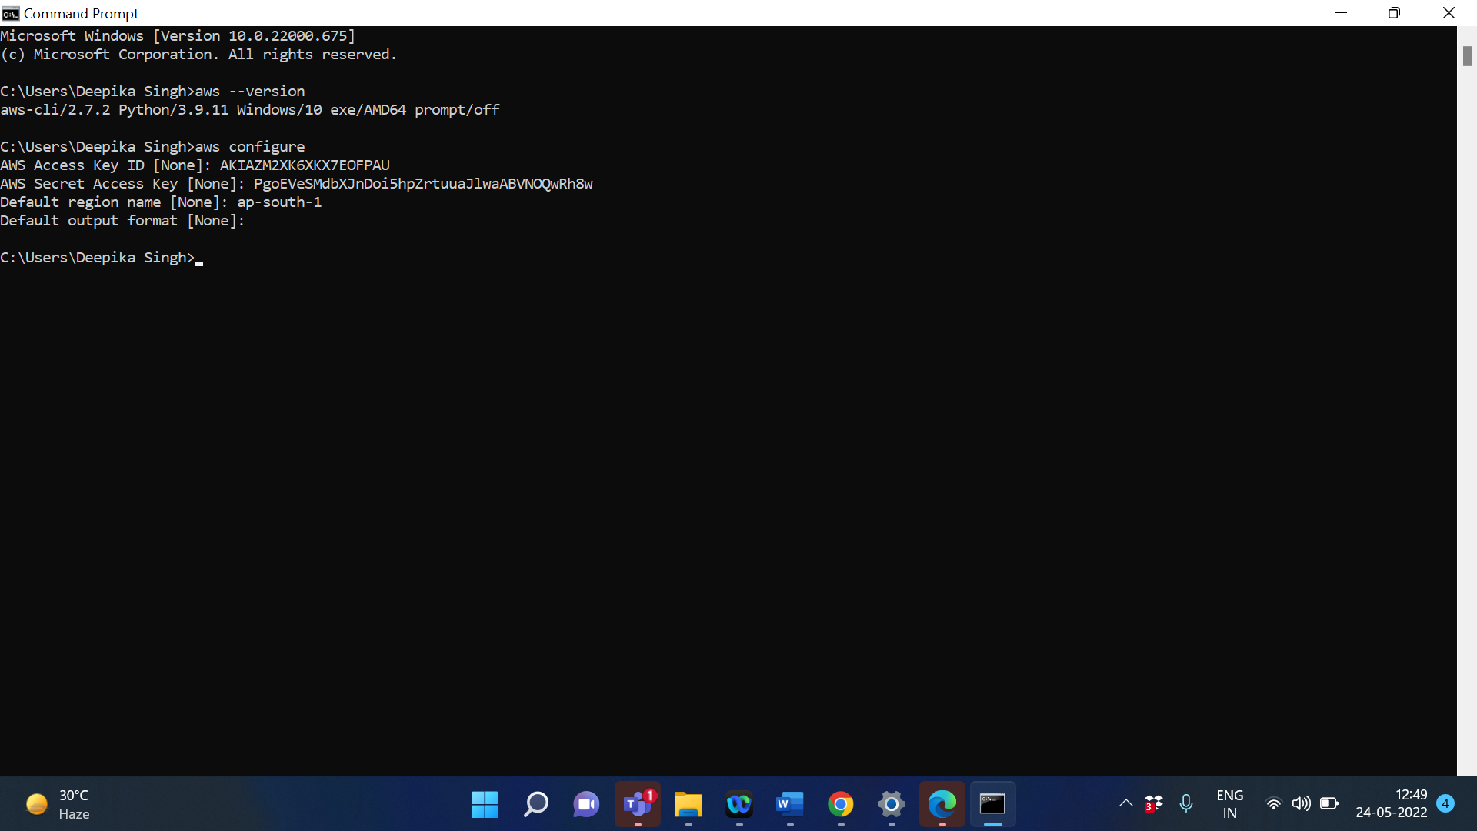

Install Kubectl - [Click here to download kubectl](https://docs.aws.amazon.com/eks/latest/userguide/install-kubectl.html)

Run the following command on AWS CLI

curl -o kubectl.exe https://s3.us-west-2.amazonaws.com/amazon-eks/1.21.2/2021-07-05/bin/windows/amd64/kubectl.exe

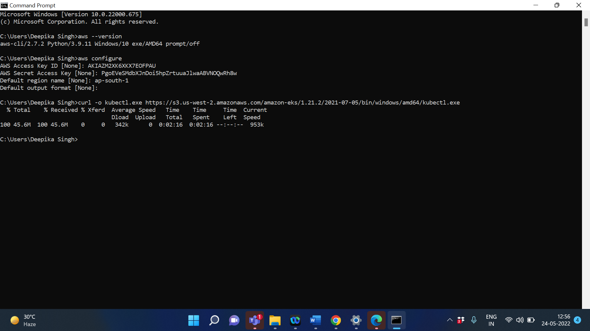

After you install kubectl, you can verify its version with the following command:

kubectl version --short –client

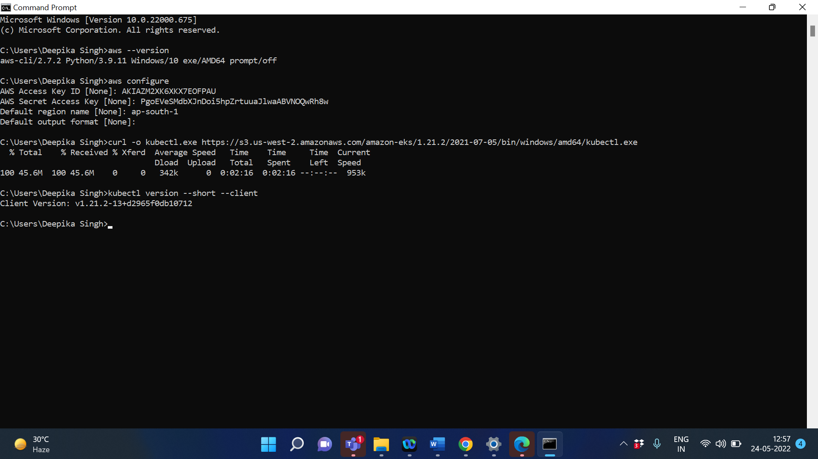

To check kubectl is workling or not:

Type- Kubectl

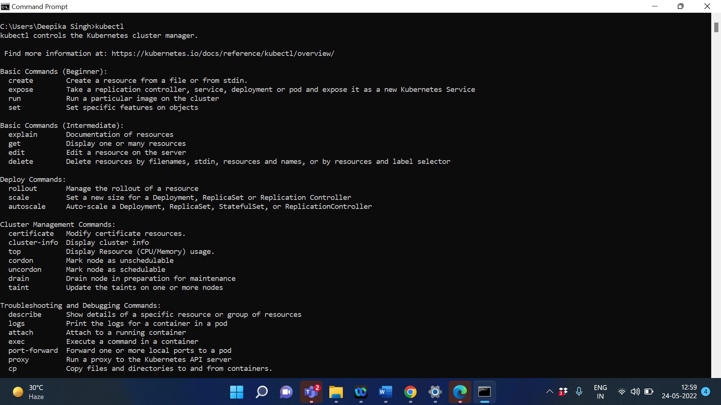

aws eks --region ap-south-1 describe-cluster --name HelloWorldCluster --query cluster.status

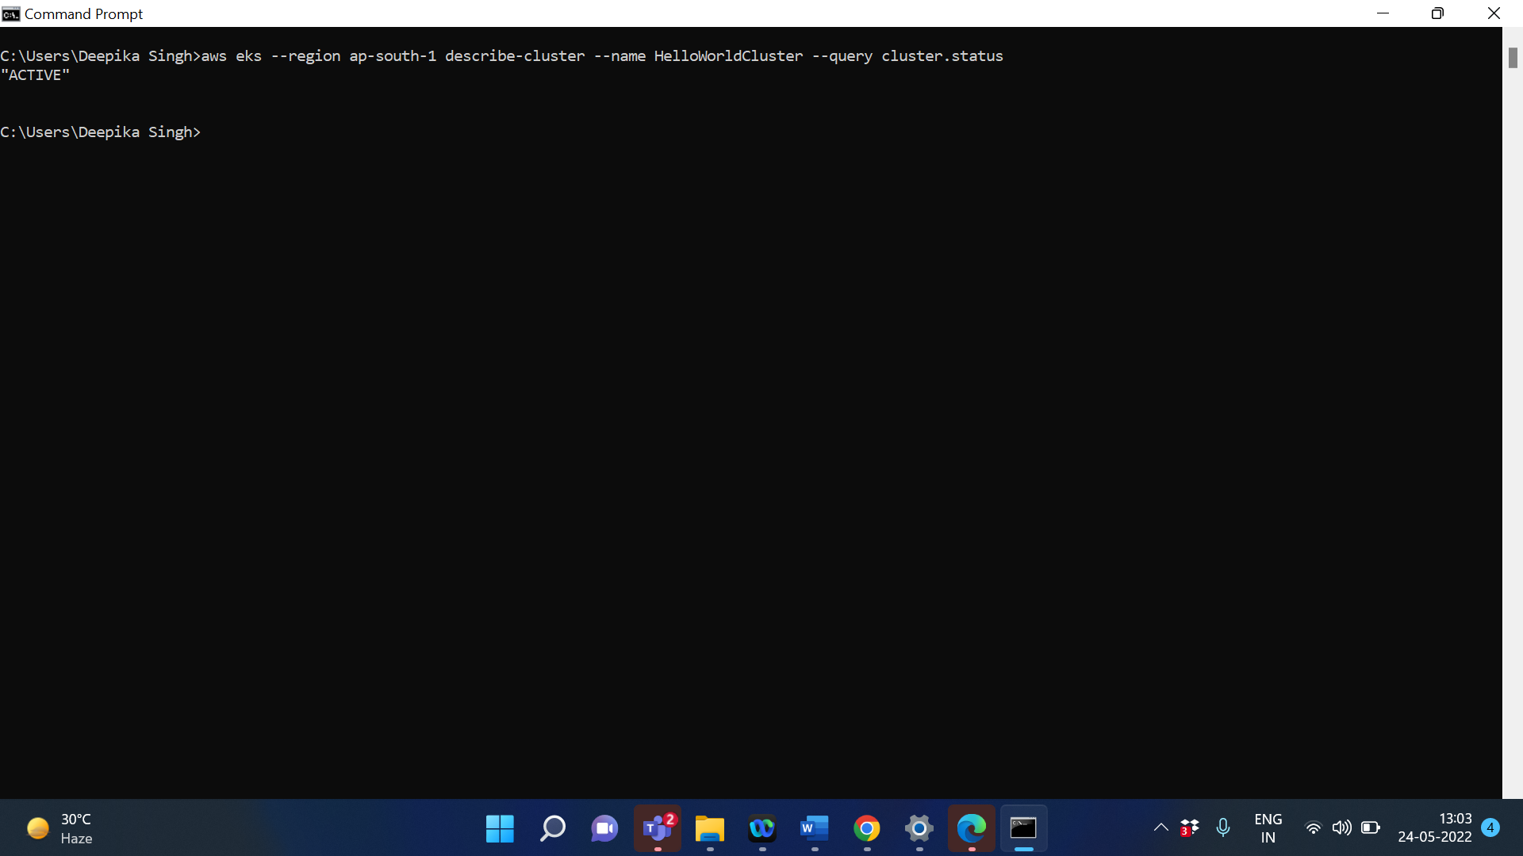

aws eks --region ap-south-1 update-kubeconfig --name HelloWorldCluster

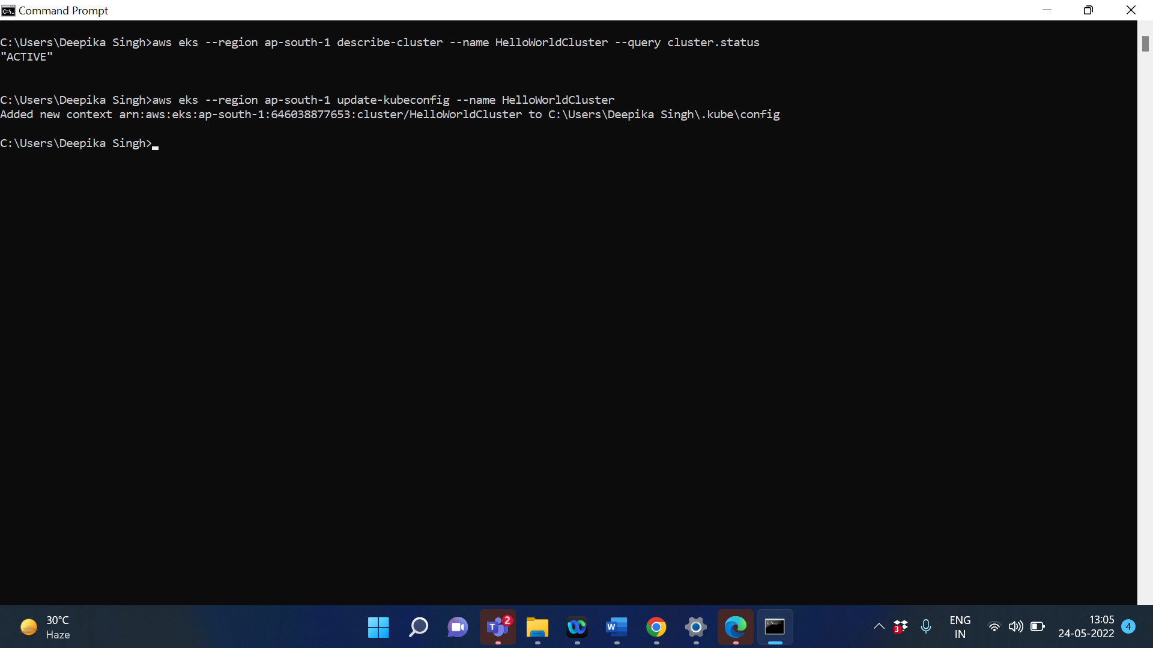

Kubectl get svc

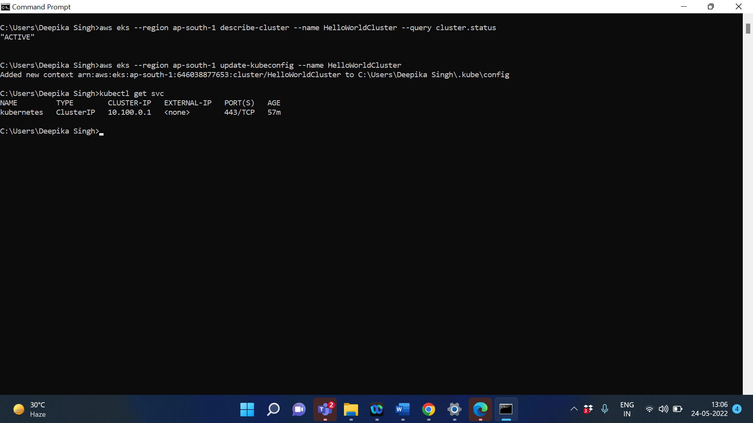

Now goto the EKS cluster

Click on HelloWorldCluster

Click on Configuration

Select Compute

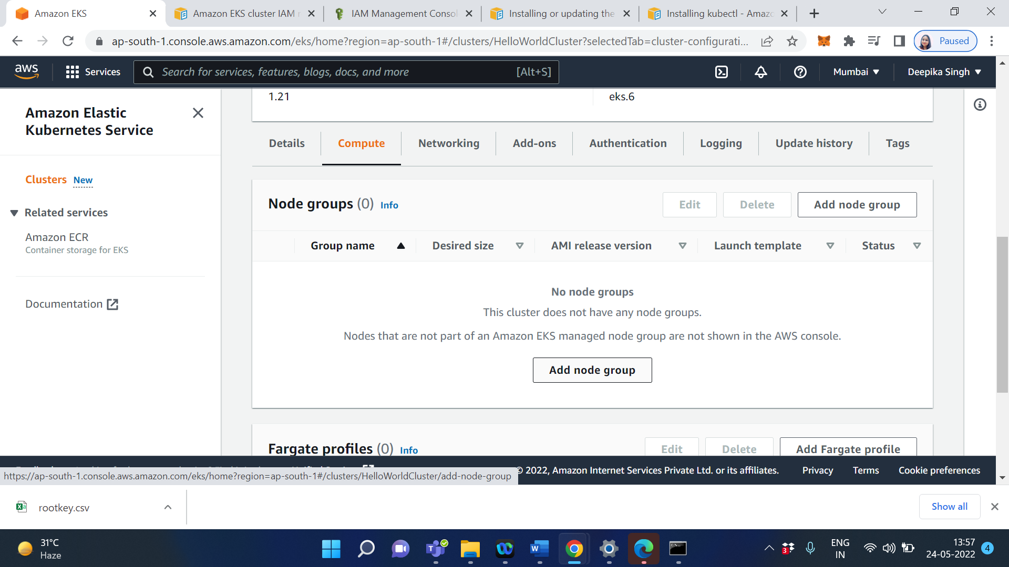

Click on add node group

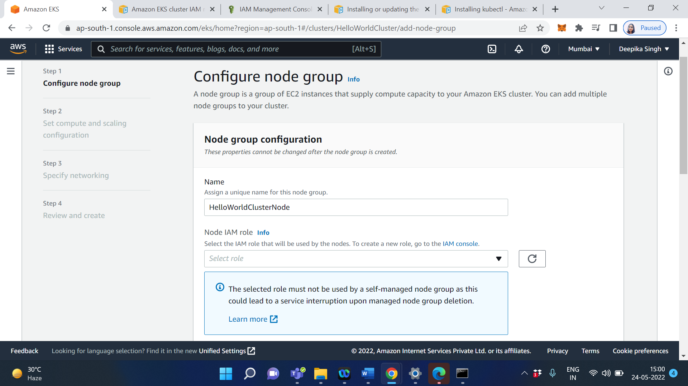

Click on IAM console to create a role

Now attach 3 role which are most important

AmazonEKS_CNI_Policy

AmazonEKSWorkerNodePolicy

AmazonEC2ContainerRegistryReadOnly

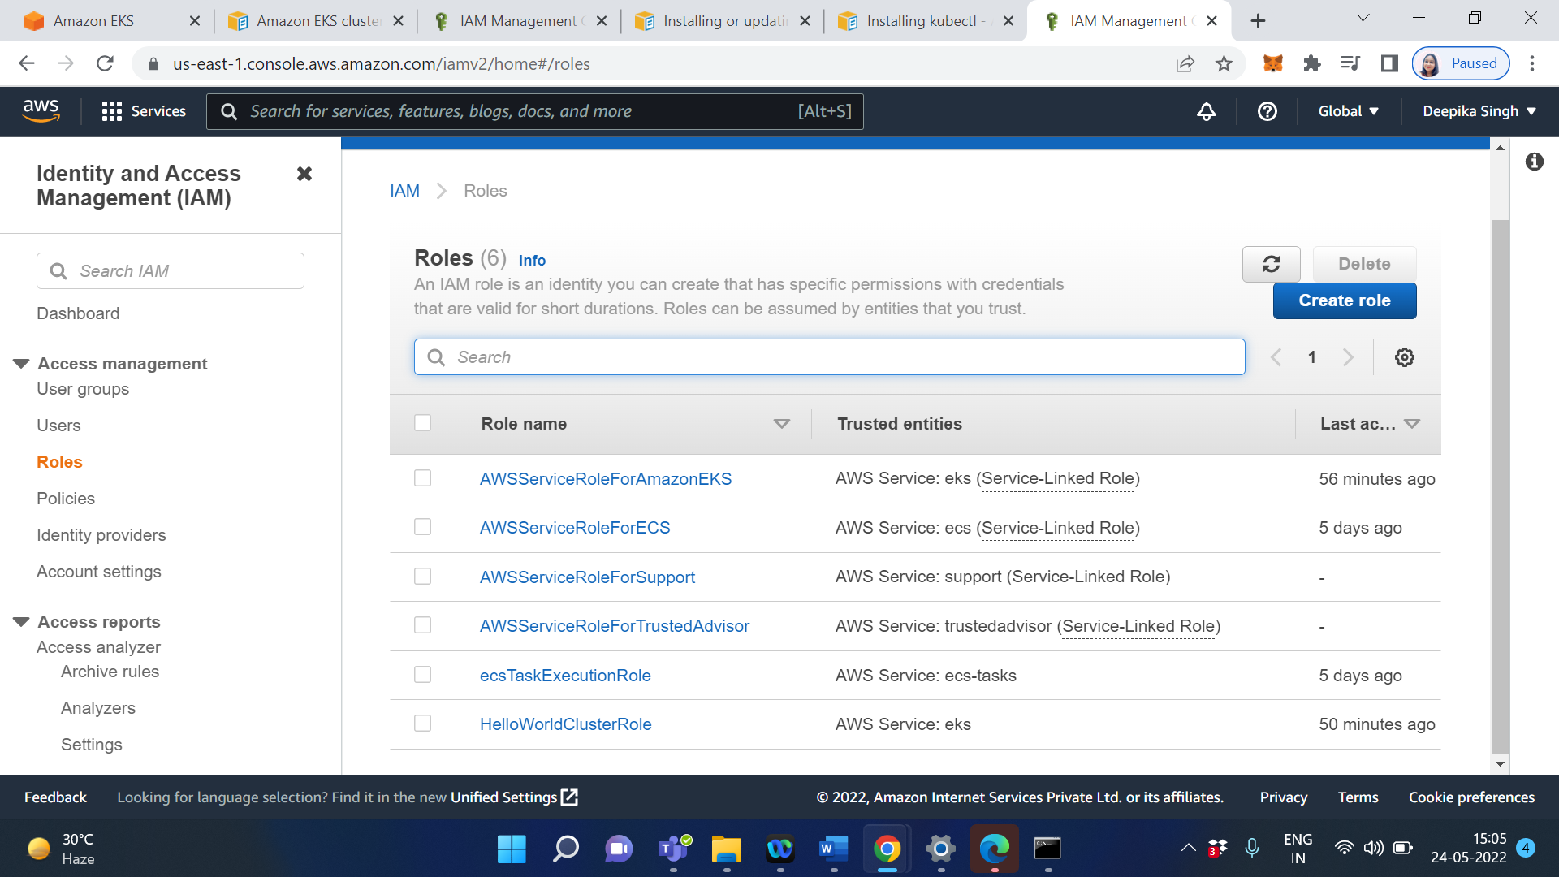

Click on Create Role

Click on AWS service

Select EC2

Click on Next

Type amazoneks in the search bar

Select AmazonEKS_CNI_Policy

Select AmazonEKSWorkerNodePolicy

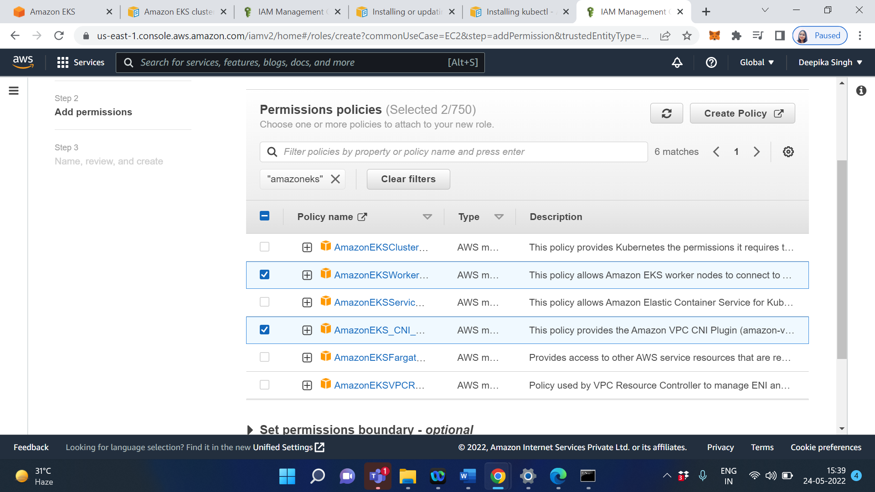

Type AmazonEC2C in the search bar

Select AmazonEC2ContainerRegistryReadOnly

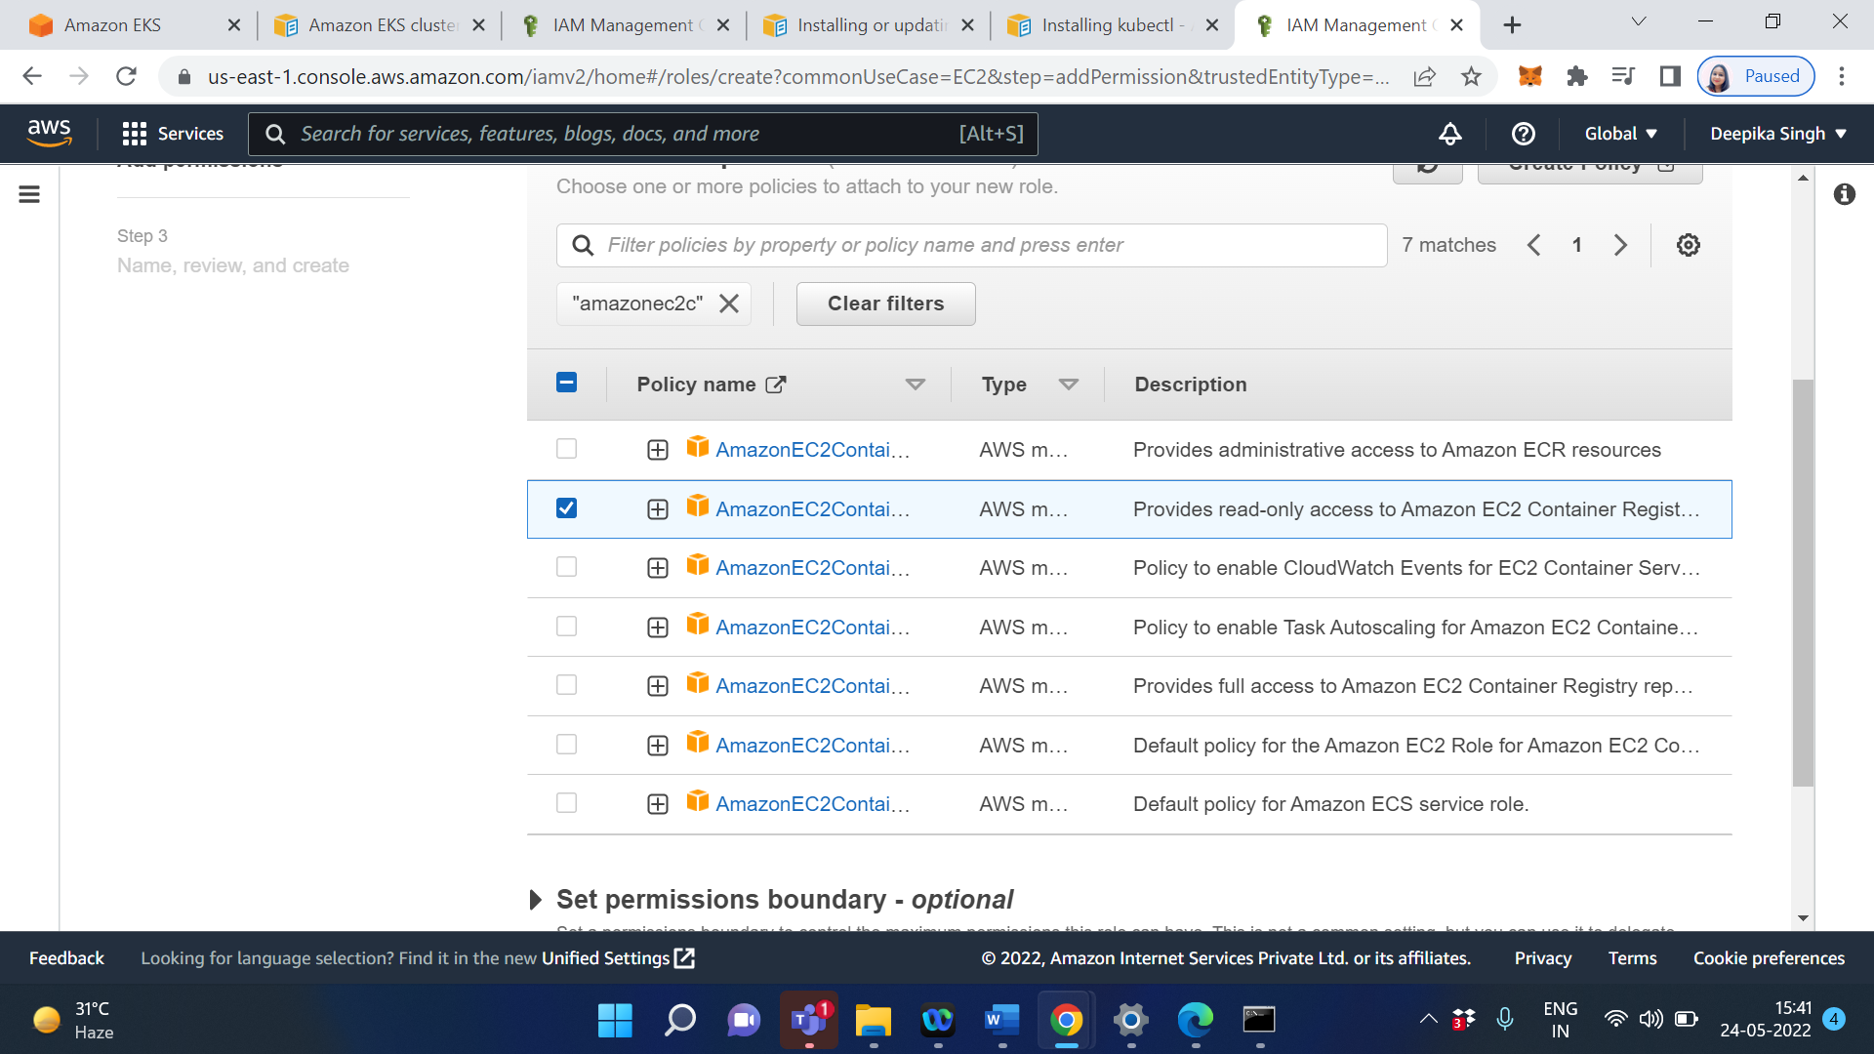

Click on Next

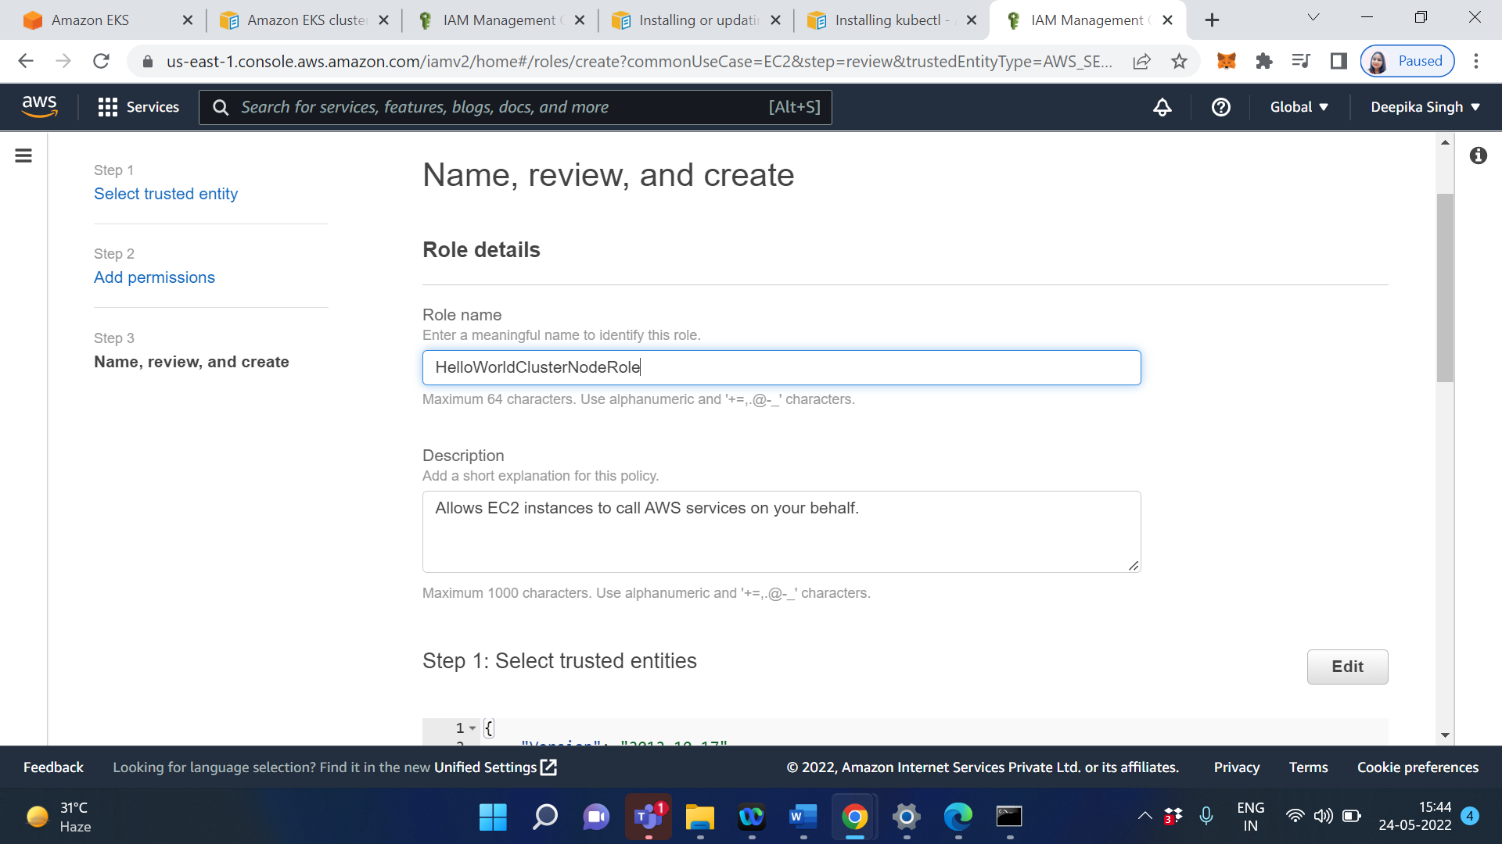

Enter the Role name

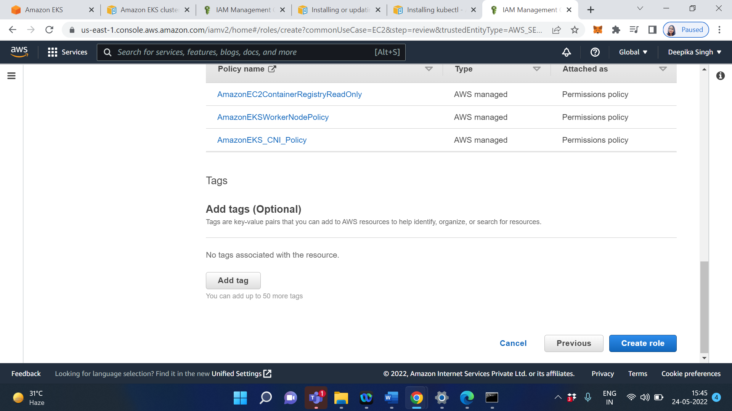

Click on Create role

Now goto the EKS->Cluster->HelloWorldCluster->Add node group->Configure node group

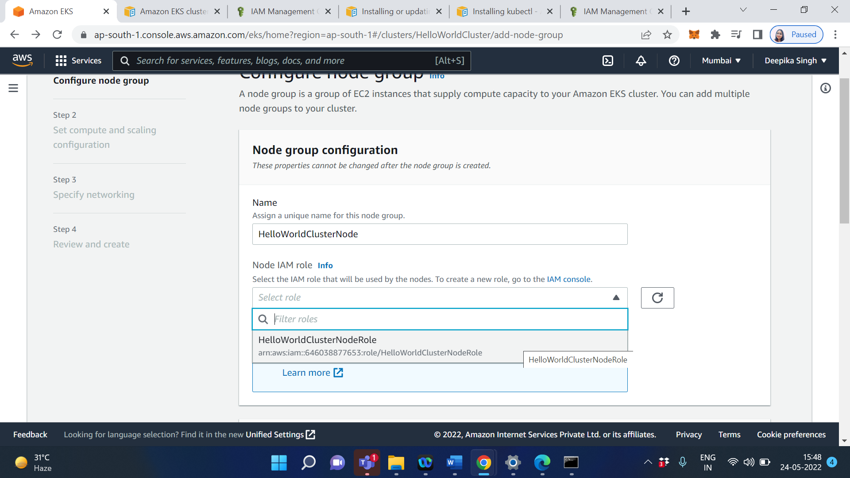

Select HelloWorldClusterNode

Click on Next

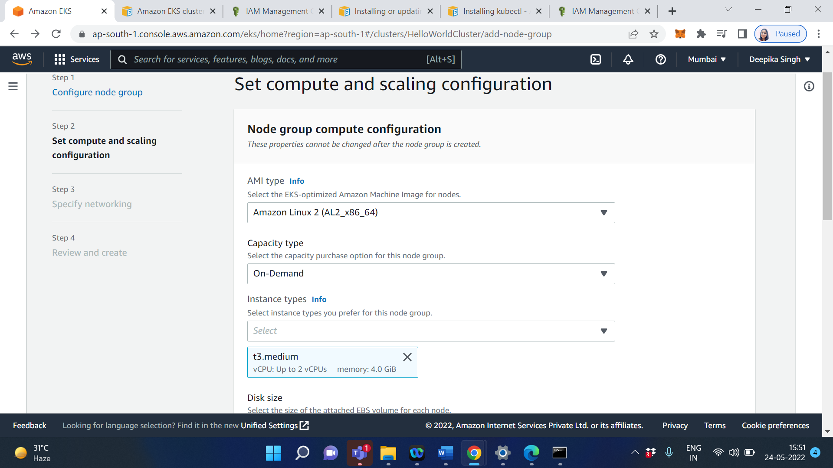

Keep everything as default

Click on Next

Enable the Configure SSH access to node

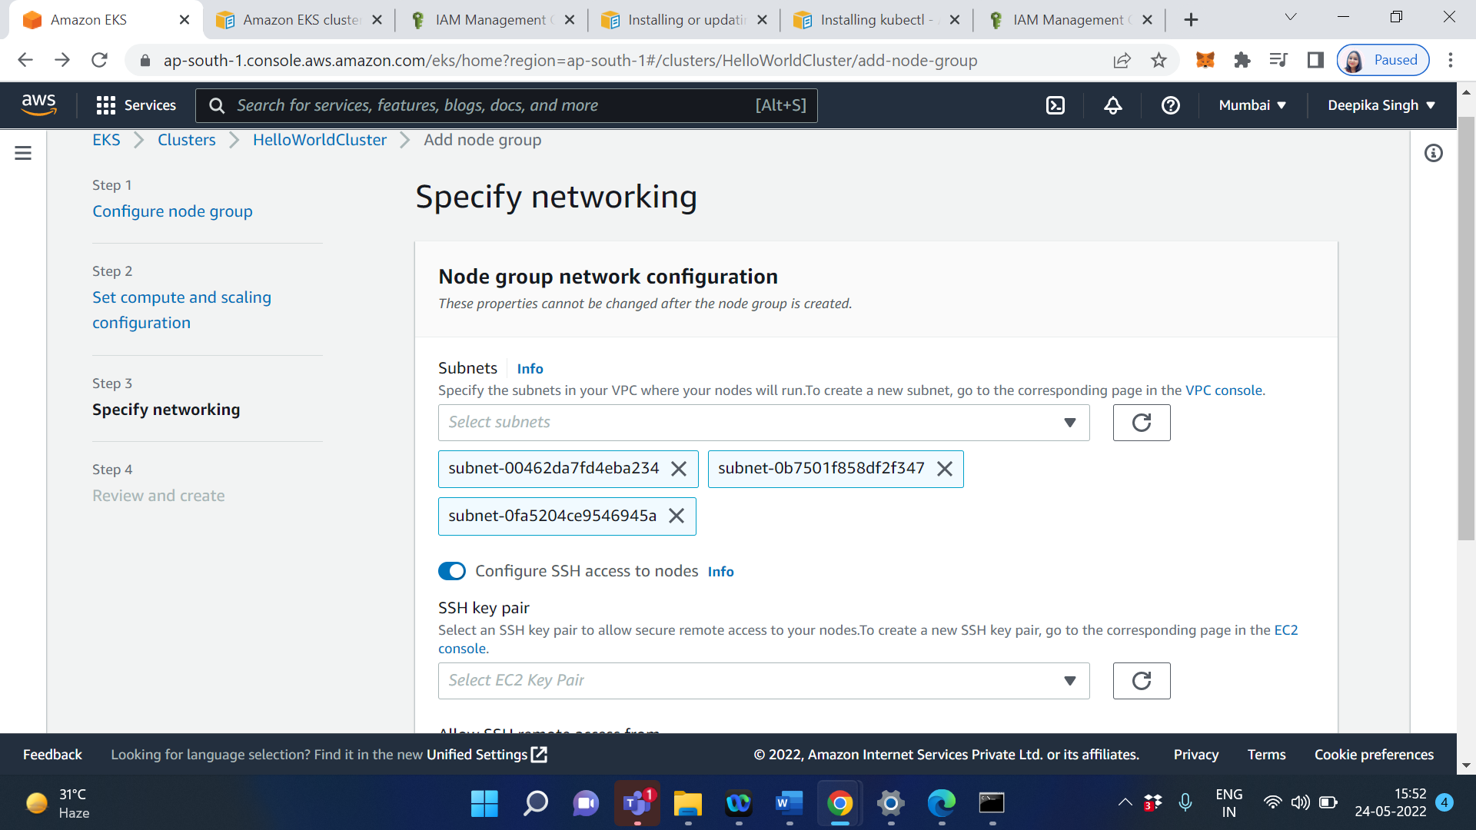

Click on EC2 console

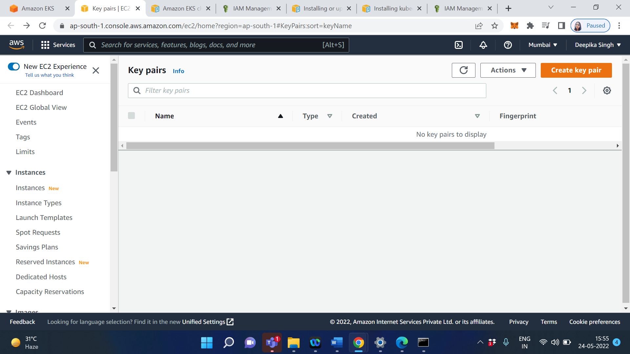

Click on Create key pair

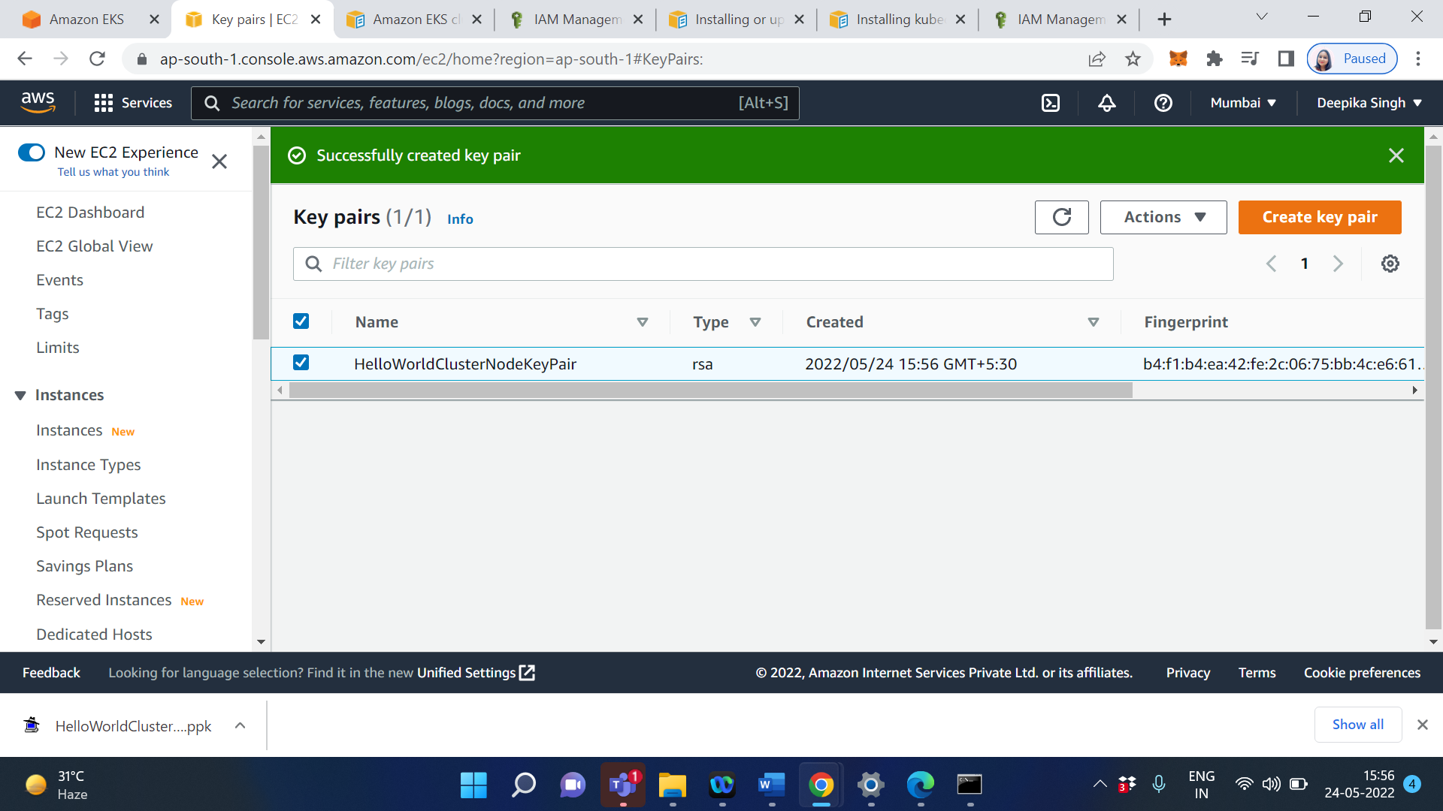

Now goto the AmazonEKS

Select key pair

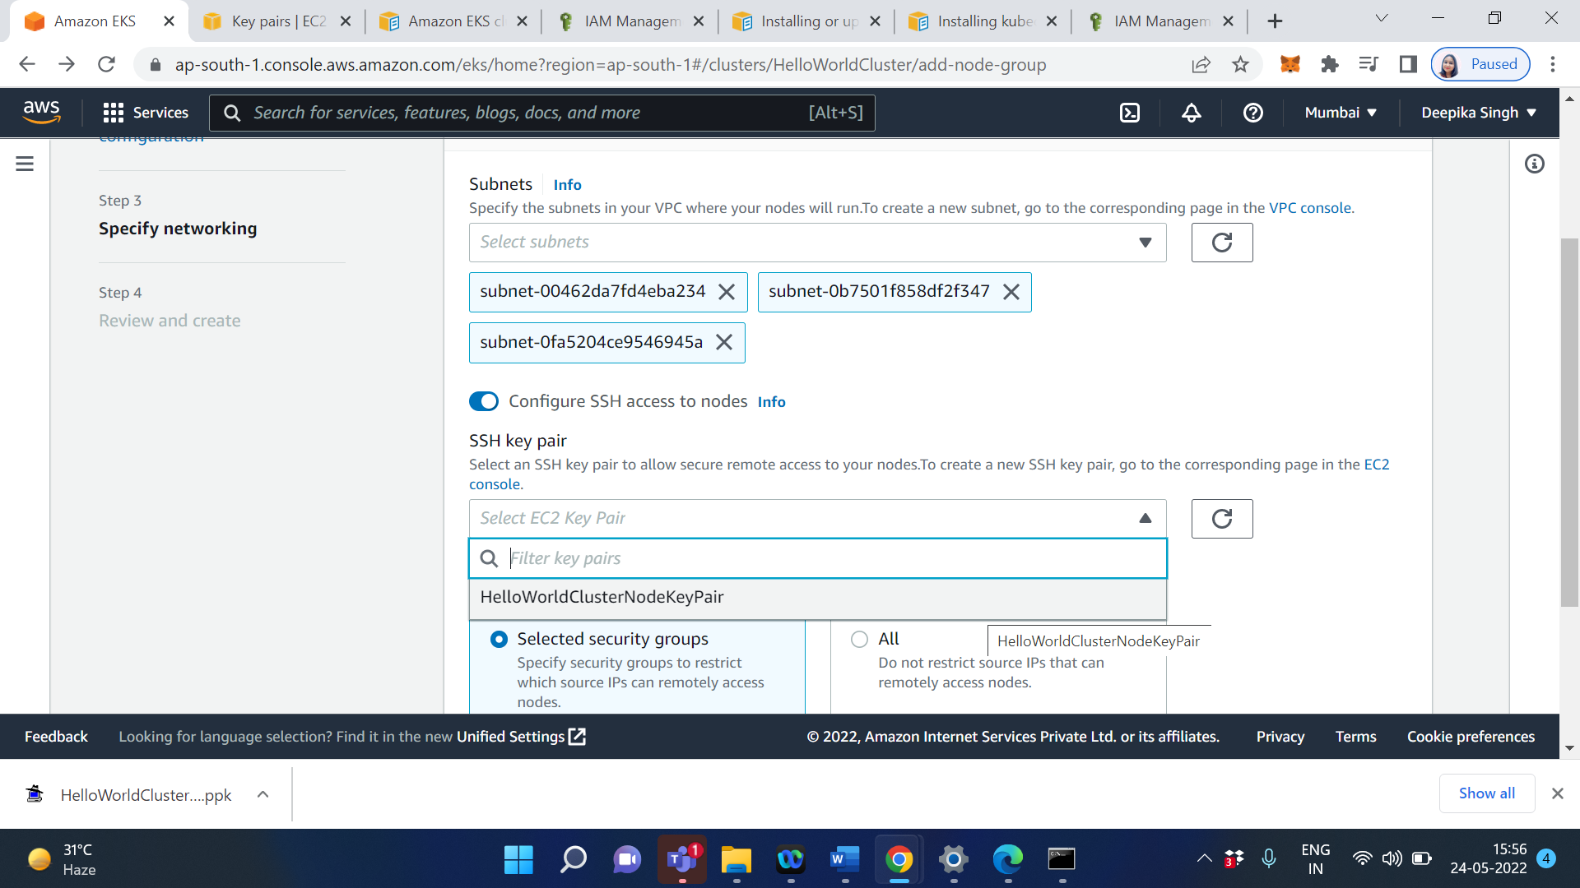

Select HelloWorldCluster security group

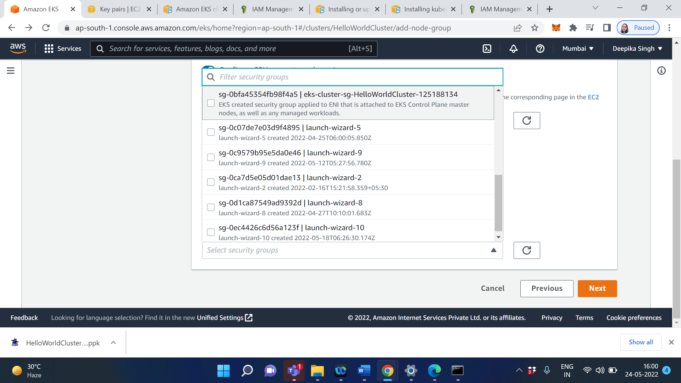

Click on Next

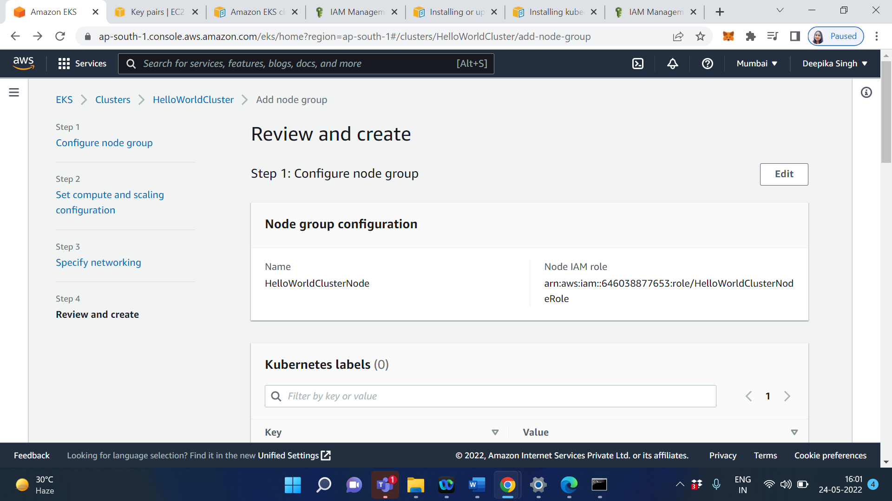

Click on Create

Now goto the AWS CLI

Type- kubectl get nodes

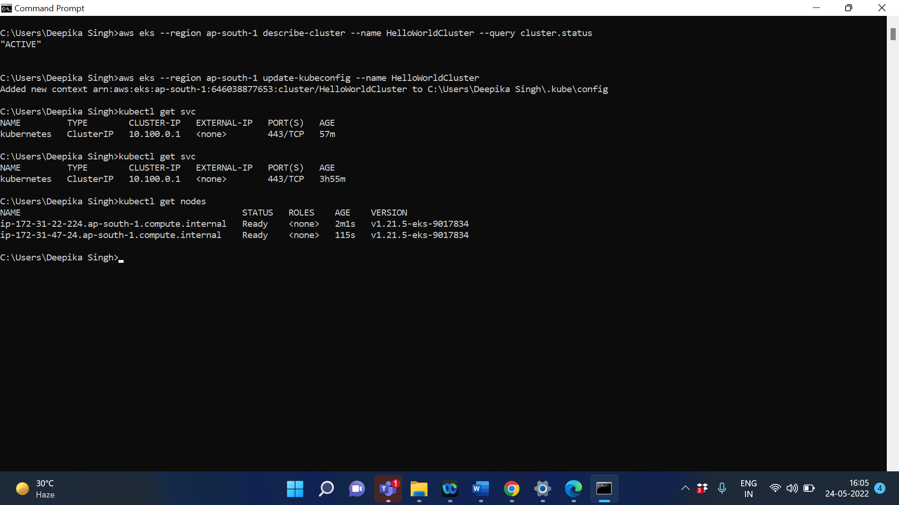

Type- kubectl get nodes –watch

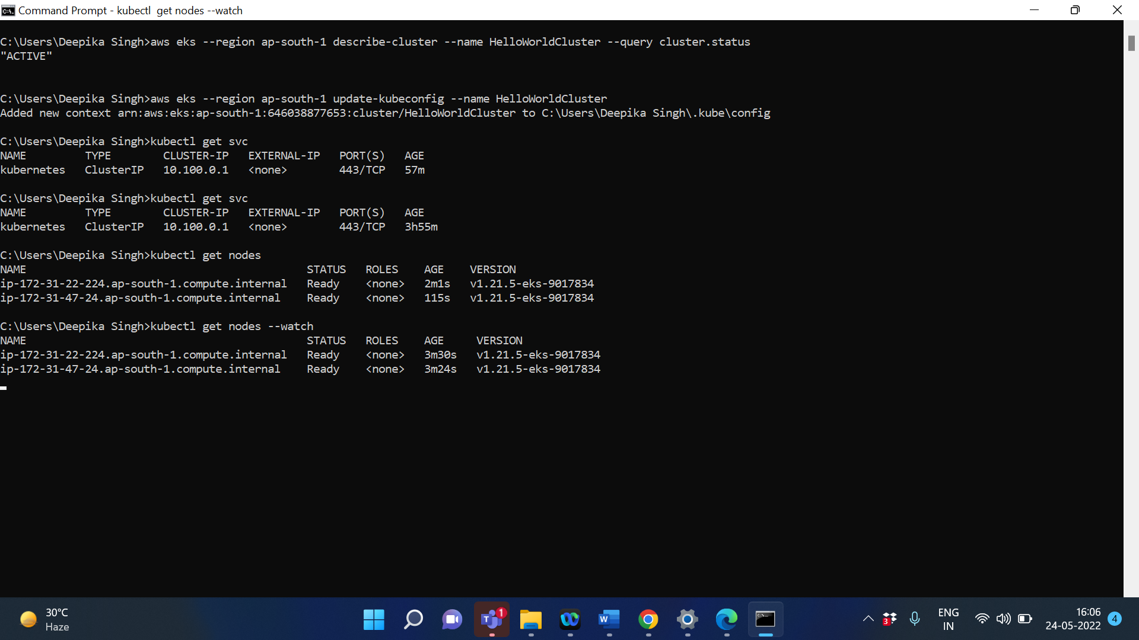

**Output/Results snippet:**



**References:**

* <https://aws.amazon.com/eks/>
* <https://docs.aws.amazon.com/whitepapers/latest/overview-deployment-options/amazon-elastic-kubernetes-service.html>
* <https://docs.aws.amazon.com/eks/latest/userguide/sample-deployment.html>